To enable Bb Collaborate in Canvas
To enable Bb Collaborate in Canvas, there are two (2) options:
1. a. Enter the course in which you want to enable Bb Collaborate
b. Click “Settings” in the main course menu (lower left)

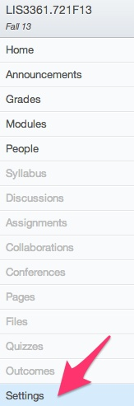

c. Click the “Navigation” tab
d. Drag the “Blackboard Collaborate” menu item to the top half of the list;
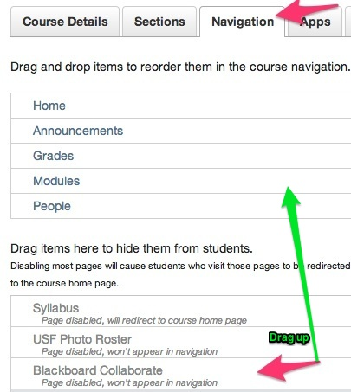

e. Scroll down > Click “Save”

2. a. Enter the course in which you want to enable Bb Collaborate
b. Click on “Modules” in the main course menu (left)
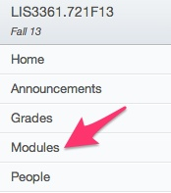

c. Click “Create a Module” OR if you already have a Module in which you’d like to add Bb Collaborate:
d. Click “Add Content”

e. In the Add field, select “External Tools”
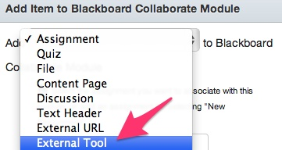

f. Select “Blackboard Collaborate.” g. Click, “Add Item”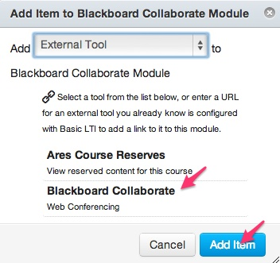
THE END

