When a Travel Request has not been submitted prior to the travel start date, a Post-Travel Authorization is required. Additional steps are required as part of the PTA process. This guide will explain the process of submitting a Post-Travel Authorization Travel Request (click the arrow to the left of each step to expand each section).

Step I: Creating a Post-Travel Authorization
To create a Post-Travel Authorization TR:
- Log in to my.usf.edu.
- Click Archivum in the Business Systems menu.
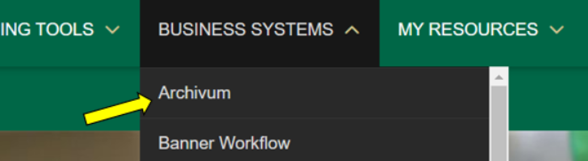
- Click Create Travel Request in the My Actions section.
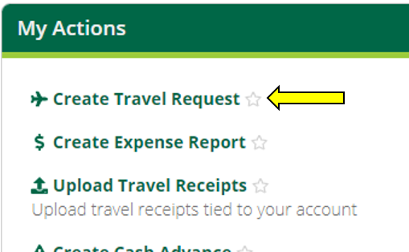
- Select Post-Travel Authorization as the Travel Request type.
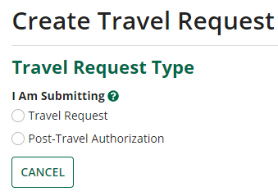
- Once the TR type is selected, click Next. Archivum will prompt you to select a profile. If you are submitting a PTA for yourself, click Myself. If you are submitting a PTA on behalf of someone else, click My Travelers, then select the traveler you are submitting the PTA for. If a traveler has more than one traveler profile, ensure the correct profile is being selected; Archivum will display department and HR supervisor information for each profile.
Myself:
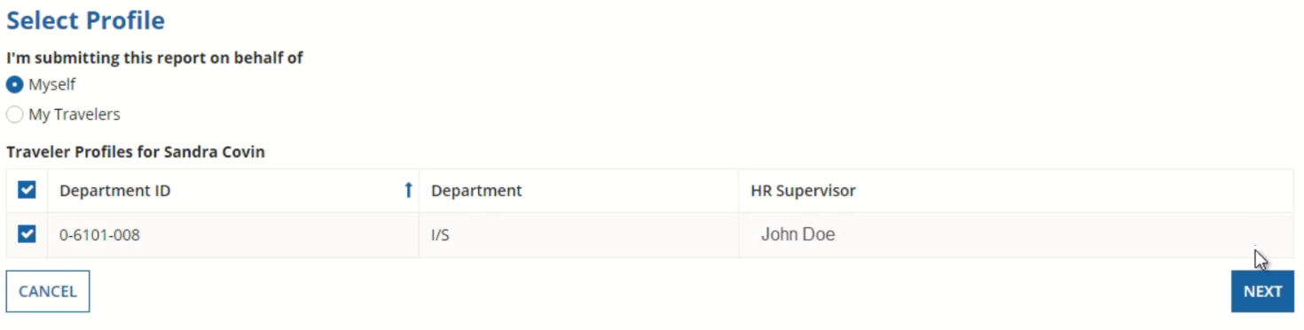
My Travelers:
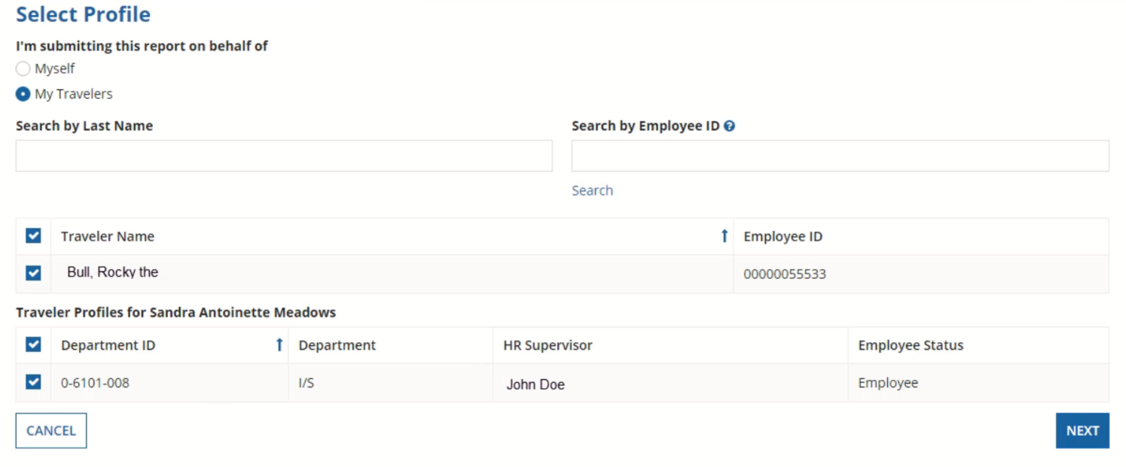
- Once a profile is selected, click Next.

Step II: Entering Travel Details
- On the Preliminary Information page, fill out the Travel Details section, which describes the travel:
  - Include a description of the travel
  - For business purpose, select the appropriate category from the drop-down menu
  - In the comment box, enter a brief overview of the trip and the reasons for traveling
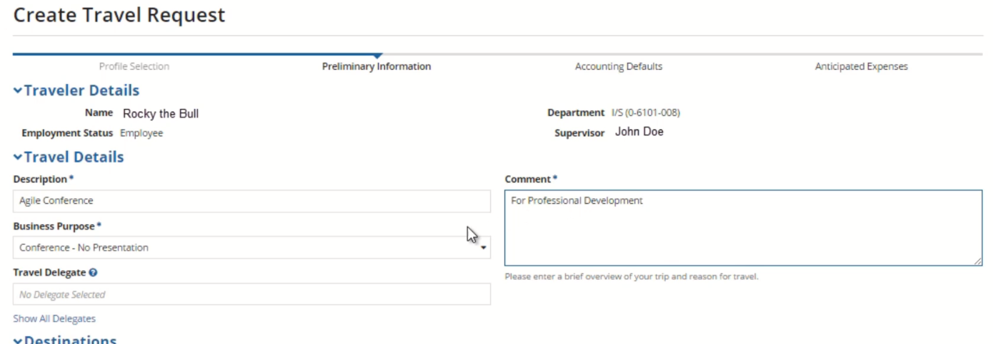
- If a separate delegate will be completing the expense information for this request, click Show all Delegates, then choose a delegate from the drop-down menu. If you are entering the expense information for this request yourself, leave this box blank.
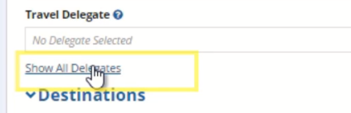
- Under Post-Travel Authorization Details, provide the following:
  - Reason for PTA – A detailed explanation of why the Travel Request was not submitted and approved before the travel dates, including why it was out of the traveler’s control.
  - Preventive Action – How this situation will be avoided in the future.
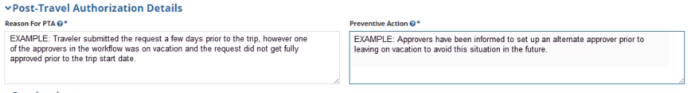
Archivum will not allow you to complete the request if either of these boxes are left blank.
- Enter the trip itinerary in the Destinations section, including:
  - Start Date – Date of arrival at the destination
  - End Date – Date of departure from the destination
  - The destination of the trip
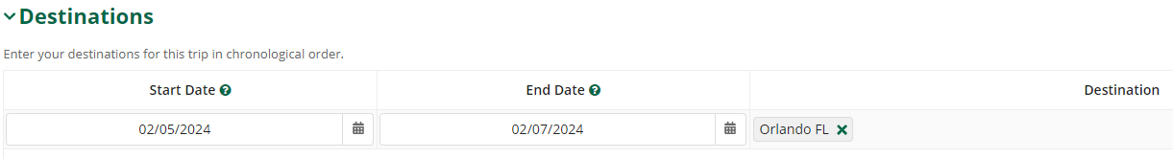
When entering the Start Date for a PTA TR, Archivum will not allow you to input today’s date, or a date in the future; the trip must begin on a past date.
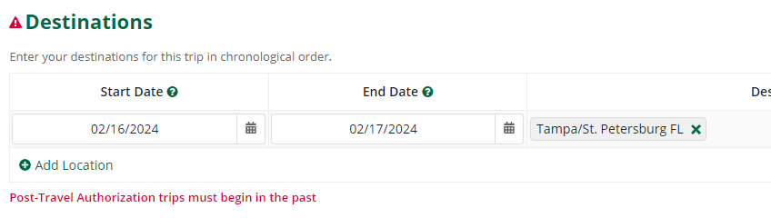
- If there are multiple destinations, click Add Location and fill out the same information (Start Date, End Date, & Destination). You will need to specify which destination is furthest in distance from Tampa by checking the box on the right.
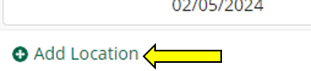
- If you are entering expense details, such as chartfields and anticipated expenses, click Enter Expense Details. If you are not entering expense details, click Submit to Supervisor. You can also Save Draft if you wish to save your progress and return to this request later.

Step III: Adding a Chartfield
On the Accounting Defaults page, you will see a display of the travel details you previously entered. If a default chartfield is already on the traveler’s profile in FAST, you will see it populated under the Chartfields section. If there is not a chartfield:
- Click Add Chartfield.
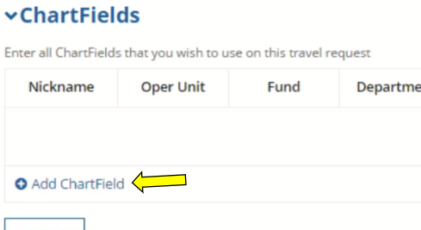
- Enter the appropriate codes for each field. Add a descriptive nickname that will help you easily identify the chartfield later.
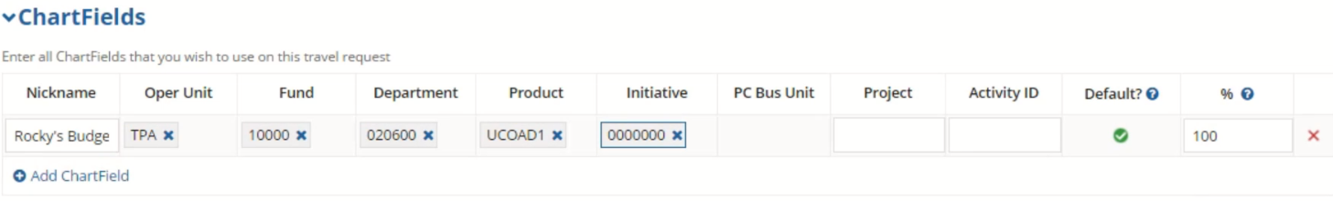
- If more than one chartfield is needed, click Add Chartfield again and repeat the process above. In this case, you will need to specify the percentage for each chartfield; they should all total 100%.
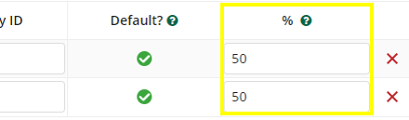
- Once you have completed the Chartfields section, click Next.

Step IV: Entering Anticipated Expenses
On the Anticipated Expenses page, you can list all Travel Expenses from the trip.
- In the top section of the page, select all expense types that apply for this trip.
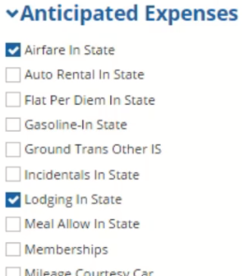
For each expense type that you select, a corresponding form will appear below in the Anticipated Expense Estimates section.
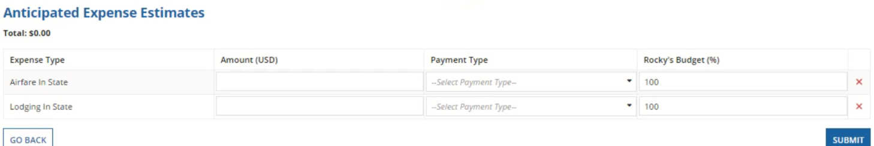
- In the Anticipated Expense Estimates section, enter the amount, payment type, and chartfield percentage for each expense type.
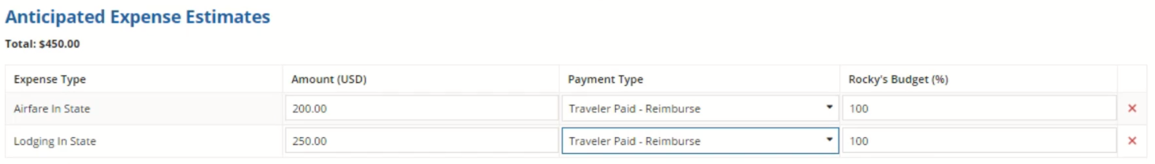
If only one chartfield was entered, the percentage will be 100% by default. If more than one chartfield was entered, the sum of chartfield distribution must equal 100%.
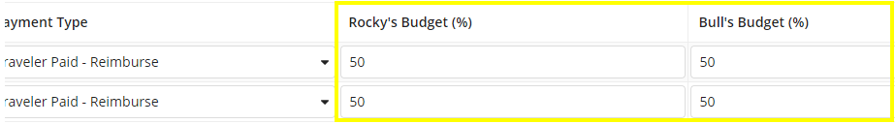
The amount of an expense cannot equal 0.
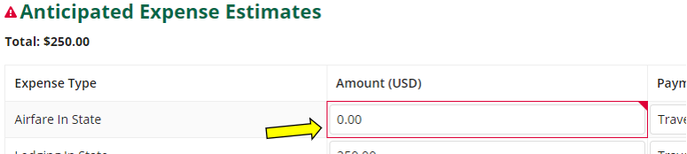
- Once all expenses have been added, click Submit.

Step V: Monitoring PTA TR Status
Following submission of a PTA TR, a Travel Request ID Number will be generated and the request will be sent to the traveler’s HR supervisor. From this point, it is the responsibility of the submitter to monitor the status of Travel transactions they have created, and to follow-up with supervisors/fiscal approvers when necessary to ensure the timely completion of these transactions. The status of a PTA TR can be monitored in Archivum.
Travel reports in Power BI, including the “Travel - Pending Status Travel Requests” report, can also be used to monitor details of PTA TRs submitted in Archivum, such as current status of the request and days since last action by a user. For more information on navigating Travel reports in Power BI, please refer to the “Quick Start Guide to Archivum Travel Reports”, and the “User Guide to Archivum Travel Reports”, both available on the Travel Training page of the Travel website.
To monitor the status of a PTA TR in Archivum:
- Open Archivum, then click Travel Records.
- On the top of the page, click the Travel Requests icon.
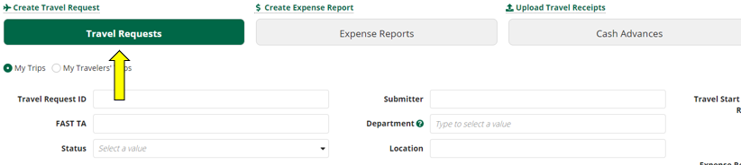
- Click My Trips if you are viewing a request you have submitted for yourself. Click My Travelers’ Trips if you are viewing a request you submitted on behalf of someone else. Then, use the search feature to find the PTA TR.
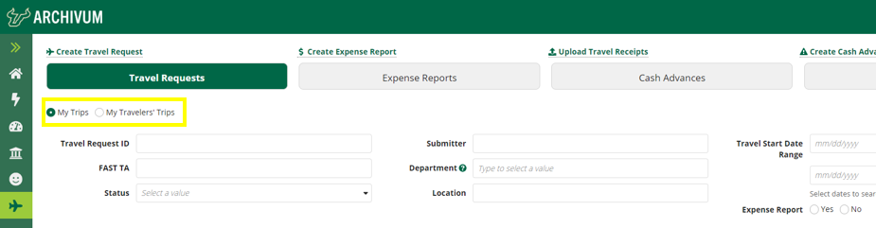
- Once you find the PTA TR you want to view, click the magnifying glass under More Info and scroll down to see PTA TR details, any pending tasks and its assignee(s), and the history of the request.
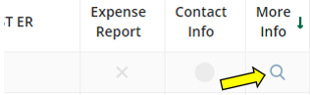

To log out of Archivum:
- Click the profile icon on the top right hand of the screen.
- Click Sign Out.

Step VI: VP Signature
Once a PTA TR receives fiscal approval, the following task will be assigned to the PTA TR submitter: “VP Signature for Travel Request…”
- Within the task, under Documents, download the unsigned Post-Travel Authorization approval document.
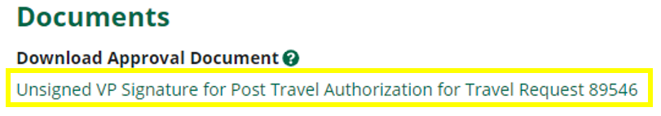
- The downloaded document is a pre-filled PDF that will display traveler and travel details, as well as the stated reason for the PTA and preventive action. The form must be signed by the appropriate VP.
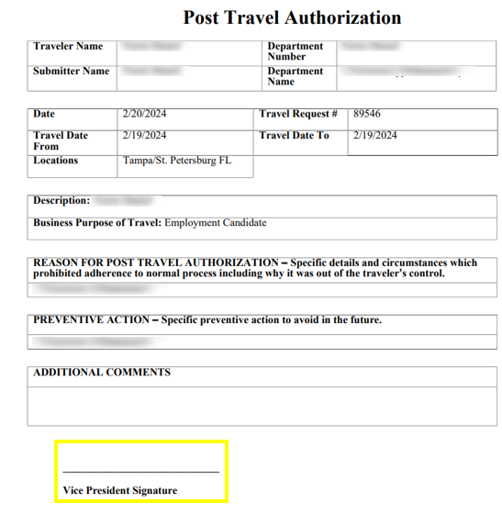
- Once the approval document has been signed, return to the VP Signature task. Under Upload Approval Document, click the Upload button, then select the signed Post-Travel Authorization document. The document must be uploaded in a PDF format.
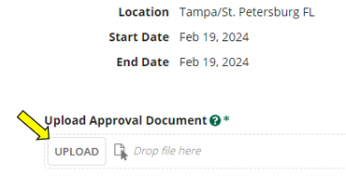
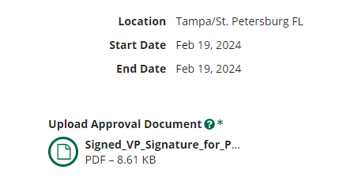
- Once the document is uploaded, click Submit. The Post-Travel Authorization Travel Request is not fully approved until the approval document has been uploaded and submitted.

