Before USF business travel occurs, a Travel Request must be submitted and fully approved in Archivum. The Travel Request acts as the traveler’s permission to travel and provides an estimate of what a specific trip will cost. This guide will explain the process of submitting a Travel Request (click the arrow to the left of each step to expand each section).

Step I: Creating a Travel Request
To create a Travel Request:
- Log in to my.usf.edu.
- Click Archivum in the Business Systems menu.
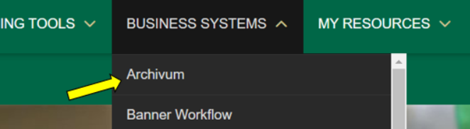
- Click Create Travel Request in the My Actions section.
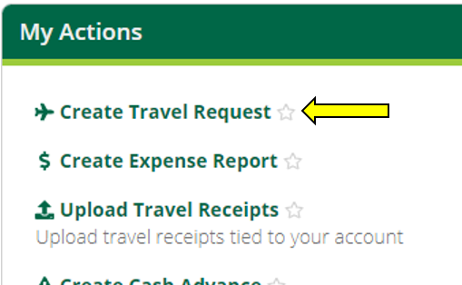
- Select the type of Travel Request.
- Select Travel Request if the travel dates will occur after the date of the request. The request must be fully submitted and approved before the travel start date.
- A Post-Travel Authorization (PTA) is only appropriate in emergency situations when a Travel Request is not fully submitted prior to the travel start date. A PTA will require a justification and VP signature. If selecting Post-Travel Authorization, refer to the Post-Travel Authorization Submission Training Guide available on the USF Travel website.
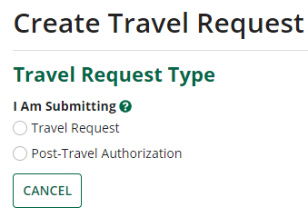
- Once the TR type is selected, click Next. Archivum will prompt you to select a profile. If you are submitting a Travel Request for yourself, click Myself. If you are submitting a Travel Request on behalf of someone else, click My Travelers, then select the traveler you are submitting the Travel Request for. If a traveler has more than one traveler profile, ensure the correct profile is being selected; Archivum will display department and HR supervisor information for each profile.
Myself:
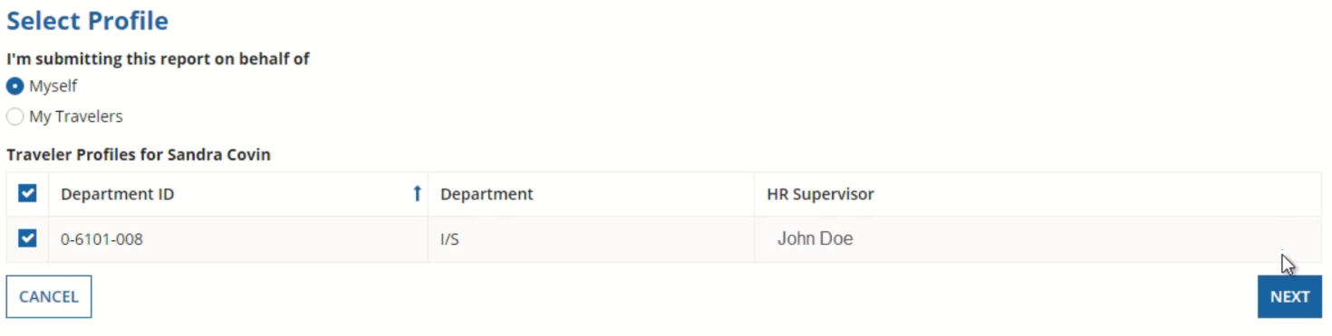

My Travelers:
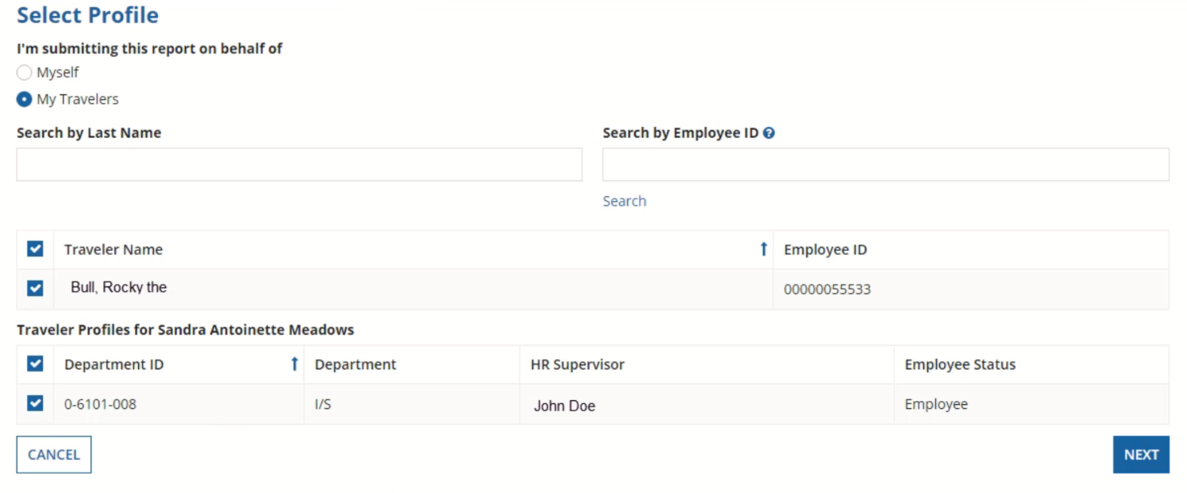
- Once a profile is selected, click Next.

Step II: Entering Travel Details
- On the Preliminary Information page, fill out the Travel Details section, which describes the travel:
  - Include a description of the upcoming travel
  - For business purpose, select the appropriate category from the drop-down menu
  - In the comment box, enter a brief overview of the trip and the reasons for traveling
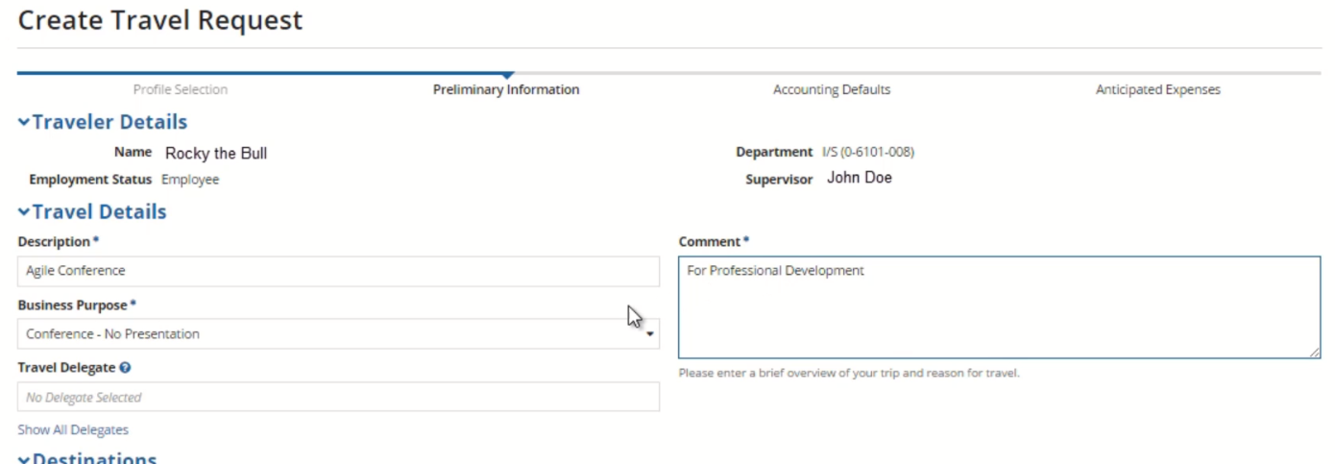
- If a separate delegate will be completing the expense information for this request, click Show all Delegates, then choose a delegate from the drop-down menu. If you are entering the expense information for this request yourself, leave this box blank.
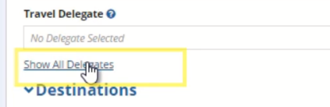
- Enter the trip itinerary in the Destinations section, including:
  - Start Date – Date of arrival at the destination
  - End Date – Date of departure from the destination
  - The destination of the trip
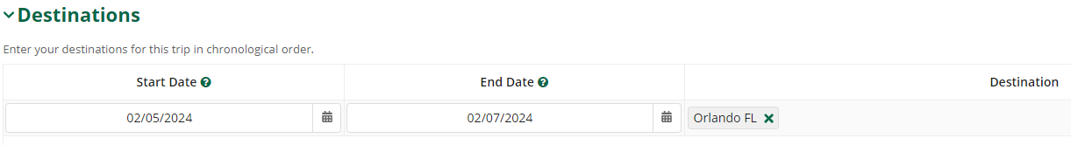
- If there are multiple destinations, click Add Location and fill out the same information (Start Date, End Date, & Destination). You will need to specify which destination is furthest in distance from Tampa by checking the box on the right.
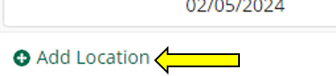
- If you are entering expense details, such as chartfields and anticipated expenses, click Enter Expense Details. If you are not entering expense details, click Submit to Supervisor. You can also Save Draft if you wish to save your progress and return to this request later.

Step III: Adding a Chartfield
On the Accounting Defaults page, you will see a display of the travel details you previously entered. If a default chartfield is already on the traveler’s profile in FAST, you will see it populated under the Chartfields section. If there is not a chartfield:
- Click Add Chartfield.
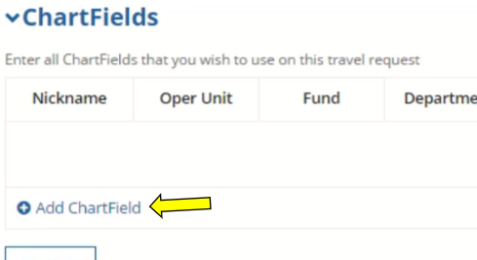
- Enter the appropriate codes for each field. Add a descriptive nickname that will help you easily identify the chartfield later.
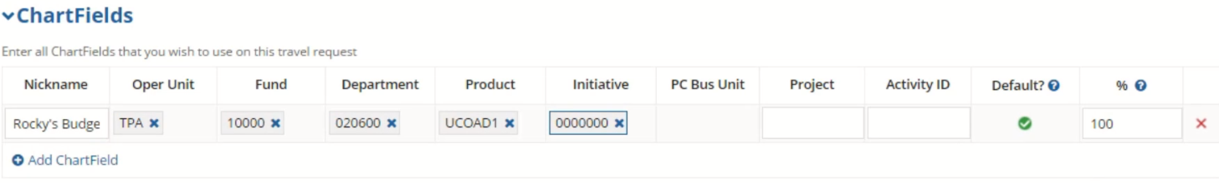
- If more than one chartfield is needed, click Add Chartfield again and repeat the process above. In this case, you will need to specify the percentage for each chartfield; they should all total 100%.
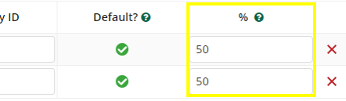
- Once you have completed the Chartfields section, click Next.

Step IV: Entering Anticipated Expenses
On the Anticipated Expenses page, you can list all anticipated Travel Expenses that are known, or can be projected, for the trip.
- In the top section of the page, select all expense types that apply for this trip.
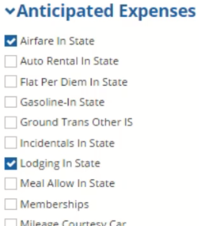
For each expense type that you select, a corresponding form will appear below in the Anticipated Expense Estimates section.
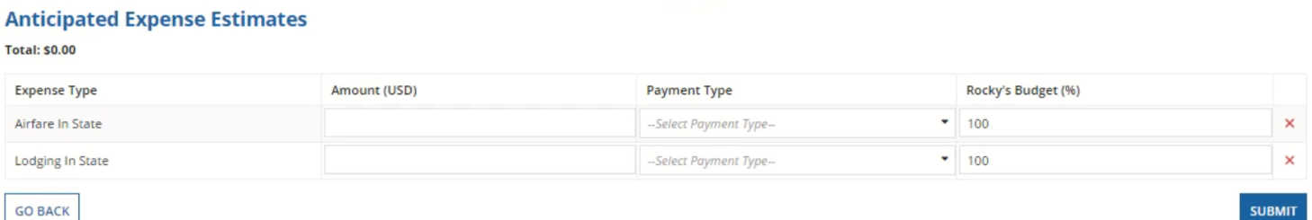
- In the Anticipated Expense Estimates section, enter the estimated amount, payment type, and chartfield percentage for each expense type.
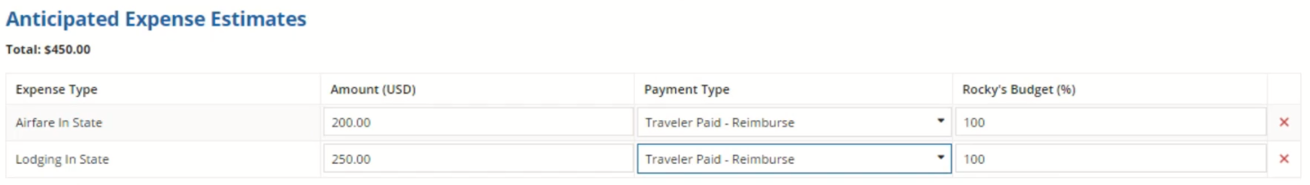
If only one chartfield was entered on the Travel Request, the percentage will be 100% by default. If more than one chartfield was entered on the Travel Request, the sum of chartfield distribution must equal 100%.
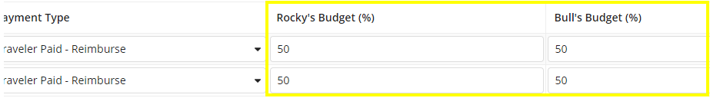
The estimated amount of an expense cannot equal 0.
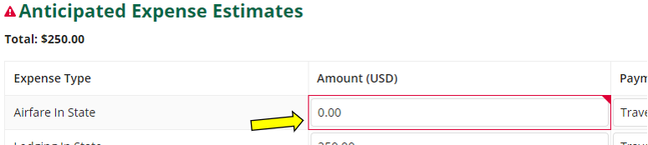
- Once all anticipated expenses have been added to the Travel Request, click Submit.

Step V: Monitoring Travel Request Status
Following submission of a Travel Request, a Travel Request ID Number will be generated and the Travel Request will be sent to the traveler’s HR supervisor. From this point, it is the responsibility of the submitter to monitor the status of Travel transactions they have created, and to follow-up with supervisors/fiscal approvers when necessary to ensure the timely completion of these transactions. The status of a Travel Request can be monitored in Archivum.
Travel reports in Power BI, including the “Travel - Pending Status Travel Requests” report, can also be used to monitor details of Travel Requests submitted in Archivum, such as current status of the TR and days since last action by a user. For more information on navigating Travel reports in Power BI, please refer to the “Quick Start Guide to Archivum Travel Reports”, and the “User Guide to Archivum Travel Reports”, both available on the Travel Training page of the Travel website.
To monitor the status of a Travel Request in Archivum:
- Open Archivum, then click Travel Records.
- On the top of the page, click the Travel Requests icon.
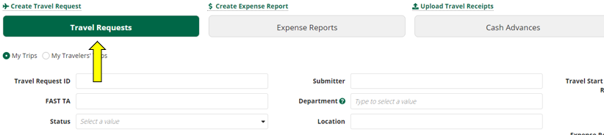
- Click My Trips if you are viewing a Travel Request you have submitted for yourself. Click My Travelers’ Trips if you are viewing a Travel Request you submitted on behalf of someone else. Then, use the search feature to find the Travel Request.
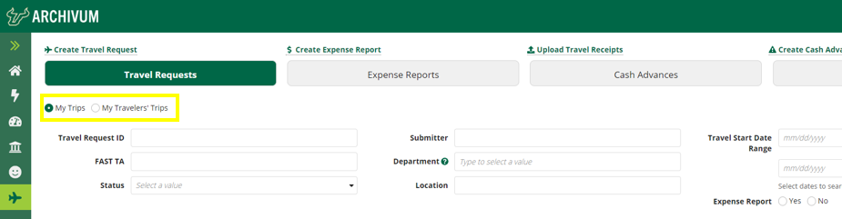
- Once you find the Travel Request you want to view, click the magnifying glass under More Info and scroll down to see TR details, any pending tasks and its assignee(s), and the history of the request.
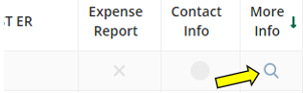

To log out of Archivum:
- Click the profile icon on the top right hand of the screen.
- Click Sign Out.

Step VI: Travel Request converted to a Post-Travel Authorization
When a Travel Request has not been fully approved prior to the travel start date, the Travel Request will be returned to the submitter and converted to a Post-Travel Authorization. Additional steps that are required as part of the PTA process are outlined below:
- On the Preliminary Information page, under Post-Travel Authorization Details, provide the following:
  - Reason for PTA – A detailed explanation of why the Travel Request was not submitted and approved before the travel dates, including why it was out of the traveler’s control.
  - Preventive Action – How this situation will be avoided in the future.
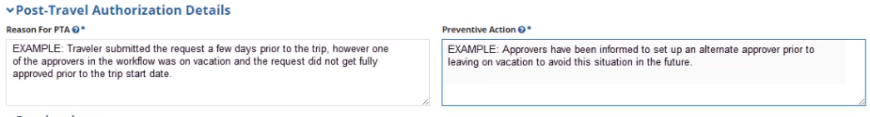
Archivum will not allow you to complete the request if either of these boxes are left blank.
- If you need to edit the Start Date for a PTA TR, Archivum will not allow you to input today’s date, or a date in the future; the trip must begin on a past date.
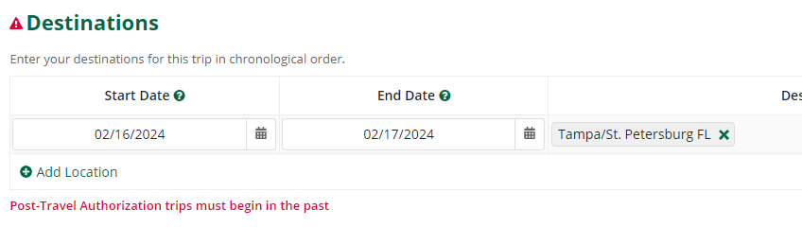
- From here, the process of submitting a PTA TR is the same as the submission process for a Travel Request. Following submission, the PTA TR will be sent to the traveler’s HR supervisor. The status of a PTA TR can be monitored by following the instructions in Step V of this document, “Monitoring Travel Request Status.” As mentioned previously, it is the responsibility of the submitter to monitor the status of travel transactions, including PTA TRs, they have created.
- Once a PTA TR receives fiscal approval, the following task will be assigned to the TR submitter: “VP Signature for Travel Request…”
- Within the task, under Documents, download the unsigned Post-Travel Authorization approval document.
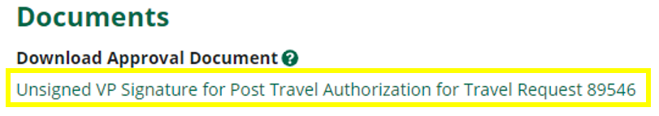
- The downloaded document is a pre-filled PDF that will display traveler and travel details, as well as the stated reason for the PTA and preventive action. The form must be signed by the appropriate VP.
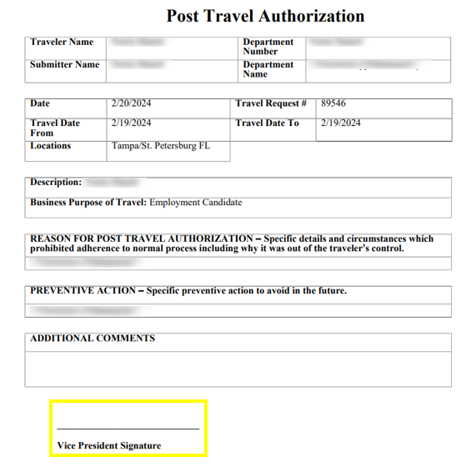
- Once the approval document has been signed, return to the VP Signature task. Under Upload Approval Document, click the Upload button, then select the signed Post-Travel Authorization document. The document must be uploaded in a PDF format.
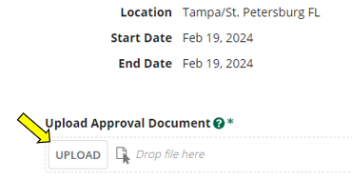
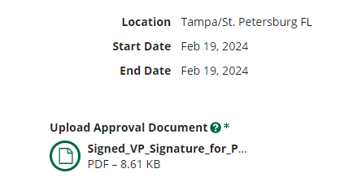
- Once the document is uploaded, click Submit. The Post-Travel Authorization Travel Request is not fully approved until the approval document has been uploaded and submitted.

Step VII: Foreign Travel Requests
Per Florida Statute section 1010.36, any employment-related foreign travel and employment-related foreign activities engaged in by all faculty, researchers, and research department staff must be screened and pre-approved by a Research Integrity Officer (RIO). All Travel Requests to foreign locations require RIO approval after fiscal approval and will be fully approved only after the required final approval from the RIO.
After fiscal approval of a foreign Travel Request, the TR will be directed to the traveler to answer questions, and review and acknowledge USF Policies and Directives. In cases where the traveler is not an employee, the task will be sent to the submitter; the submitter must upload the signed attestation from the traveler.
These additional steps to the Travel Request process are below:
- After fiscal approval of a foreign Travel Request for a USF employee, the traveler will be assigned a “Submit Additional Information” task.
- Within the task, the traveler will be asked to answer, review, and acknowledge the following:
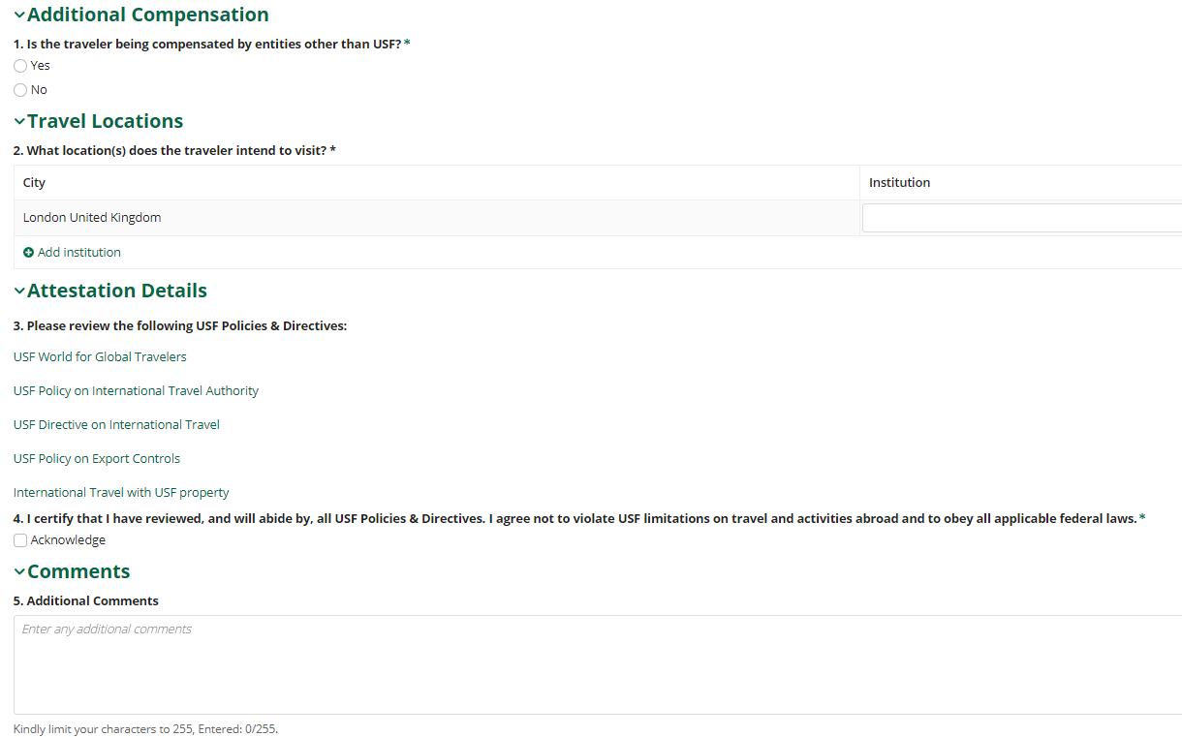
- Once the required fields have been completed, the traveler can click Submit in the bottom right.
- After submission, the Travel Request will be directed to the Research Integrity Officer (RIO) for final approval. The Travel Request will be fully approved only after the required RIO approval.
If the traveler is not an employee:
- After fiscal approval, the “Submit Additional Information” task for the Travel Request will be assigned to the TR submitter.
- Within the task, the submitter will answer and review the following:
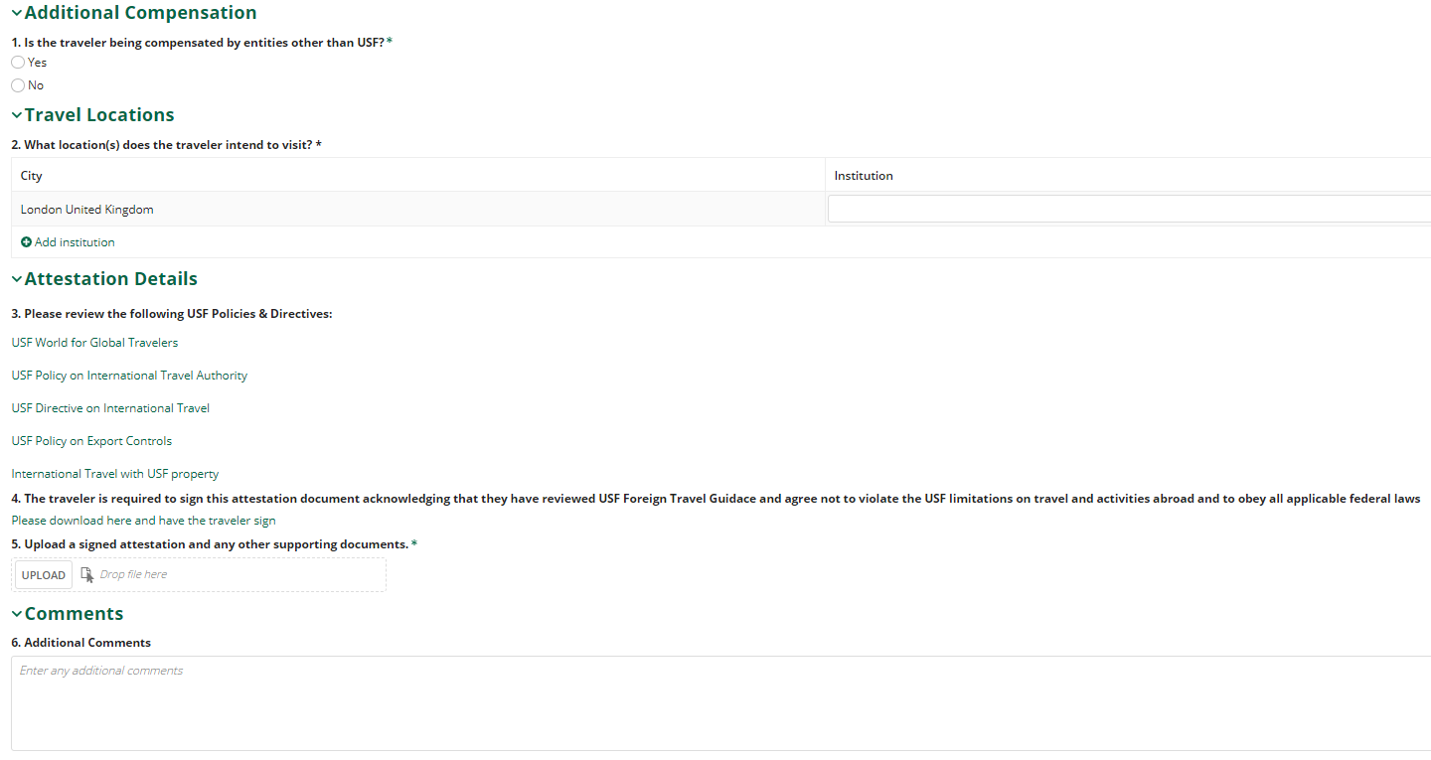
- The traveler is required to sign this attestation document. The submitter must upload the signed document (and any other supporting documents) using the Upload button.
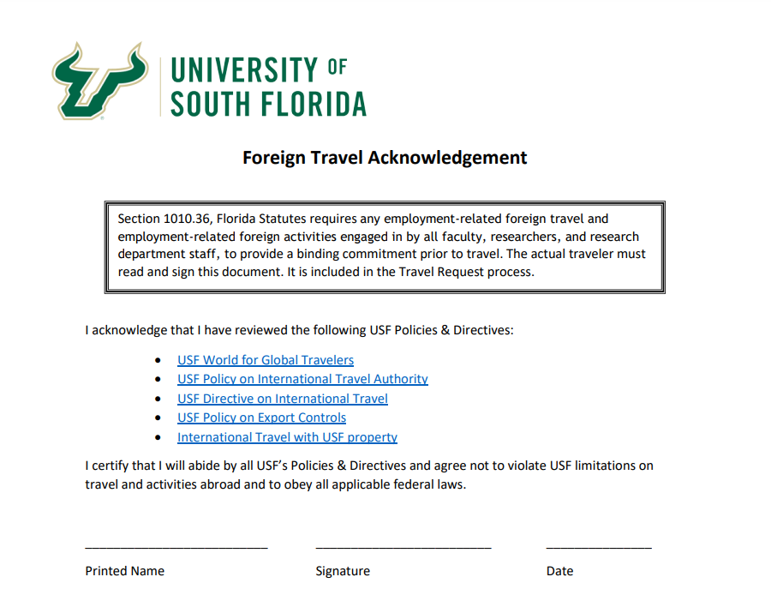
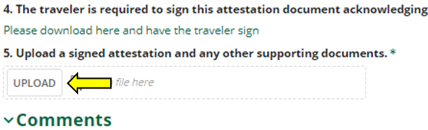
- Once the signed attestation has been uploaded and all required fields are complete, the submitter can click Submit in the bottom right. The Travel Request will be directed to the RIO for final approval.

Adding Contact Information:
- For foreign Travel Requests, contact information must be provided. Locate the Travel Request, then click the yellow icon in the Contact Info column.
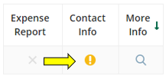
- A form will expand below that will allow input of emergency contact information. Required fields are marked by an asterisk (*). Once the form is complete, click Save.
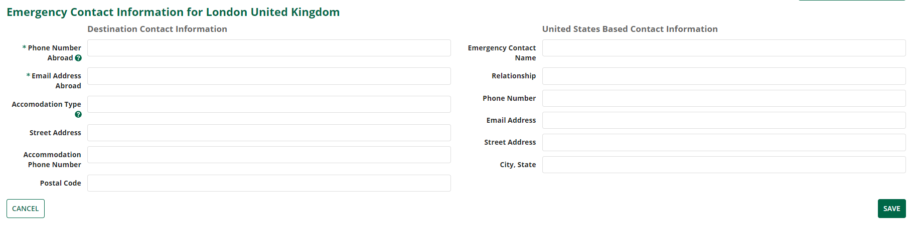
- Once contact information has been provided, the Contact Info icon will turn green.
