Bank Cards with a Magnetic Stripe
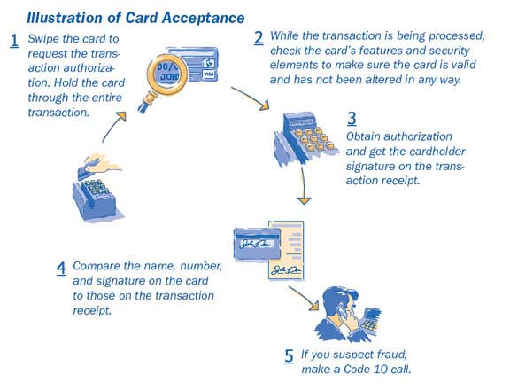
It Pays to Swipe the Stripe

On the back of every credit and debit card, you’ll find a magnetic stripe. It contains the cardholder name, card account number, and expiration date, as well as special security information designed to help detect counterfeit cards. When the stripe is swiped through the terminal, this information is electronically read and relayed to the card issuer, who then uses it as crucial input for the authorization decision.

Swipe the card to request the transaction authorization.
Hold the card through the entire transaction.

Verifying the Account Number

Most Point of Sale terminals also allow merchants to verify that the account number embossed on the front of the card is the same as the account number encoded on the card’s magnetic stripe. How you check the numbers depends on your POS terminal. In some cases, the magnetic stripe

number is displayed on the terminal or printed on the sales receipt. In others, the terminal may be programmed to check the numbers electronically. In such instances, you may be prompted to enter the last four digits of the embossed account number, which will then be matched against the last four digits of the account number on the magnetic stripe.

Only the last four digits of the account or credit card number should be printed on a transaction receipt. If the numbers don’t match, you will receive a “No Match” message. In such instances, you should notify your Supervisor discreetly, and they will decide whether or not it is necessary to make a Code 10 call.

If a Card Won’t Read When Swiped

In some instances, when you swipe a card, the terminal will not be able to read the magnetic stripe or perform an authorization. When this occurs, it usually means one of three things:

- The terminal’s magnetic-stripe reader is dirty or out-of-order.
- The card is not being swiped through the reader correctly.
- The magnetic stripe on the card has been damaged or demagnetized.

Damage to the card may happen accidentally, but it may also be a sign that the card is counterfeit or has been altered.

If a card won’t read when swiped, you should:

- Check the terminal to make sure that it is working properly and that you are swiping the card correctly.
- Wipe down the magnetic strip to remove any debris that may be interfering with the card reader and swipe a second time.

- If the terminal is okay, take a look at the card’s security features to make sure the card is not counterfeit or has not been altered in any way (see Card Features and Security Elements).

- If the problem appears to be with the magnetic stripe, follow store procedures. You may be allowed to use the terminal’s manual override feature to key-enter transaction data for authorization, or you may need to make a call to your voice-authorization center.

- For key-entered or voice-authorized transactions, make an imprint of the front of the card. The imprint proves the card was present at the point of sale and protects your business from potential chargebacks if the transaction turns out to be fraudulent. The imprint can be made either on the sales receipt generated by the terminal or on a separate manual sales receipt form signed by the customer.

Key-entered transactions are fully acceptable, but they are subject to a higher fee and are associated with higher fraud and chargebacks rates. In addition, when transactions are key-entered, the benefits associated with special security features—such as the expiration date and Card Verification Value 2 (CVV2)—are not available.

Minimize Key-Entered Transactions

These best practices can help you keep key-entered transactions at acceptably low levels and should be incorporated into your daily operations and staff training and review sessions.

Find Causes and Look for Solutions

If your key-entry rates are greater than one percent per terminal or sales associate, you should investigate the situation and try to find out why. The following chart summarizes the most common reasons for high key-entry rates and provides possible solutions.

Key-Entry Cause | Solution
Damaged Magnetic-Stripe Readers | Check magnetic-stripe readers regularly to make sure they are working.
Dirty Magnetic-Stripe Readers | Clean magnetic-stripe reader heads several times a year to ensure continued good use.
Magnetic-Stripe Reader Obstructions | Remove obstructions near the magnetic-stripe reader. Electric cords or other equipment could prevent a card from being swiped straight through the reader in one easy movement.
Spilled Food or Drink | Remove any food or beverages near the magnetic stripe reader. Falling crumbs or an unexpected spill could soil or damage the machines.
Anti-Theft Devices that Damage Magnetic Stripes | Keep magnetic anti-theft deactivation devices away from any counter area where customers might place their cards. These devices can erase a card’s magnetic stripe.
Improper Card Swiping | •Swipe the card once in one direction, using a quick, smooth motion. •Never swipe a card back and forth. •Never swipe a card at an angle; this may cause a faulty reading.

