The Self-Service option will now be available via the regular GEMS/GEMS Self-Service menu item under Business Systems when you log onto MyUSF using your NETID and Password. (The two individual links have been combined.)
Once you are in GEMS/GEMS Self-Service, click on Main Menu (your menu may look differently depending on your security permissions) then Self Service, then Payroll and Compensation to change your W-4 information.
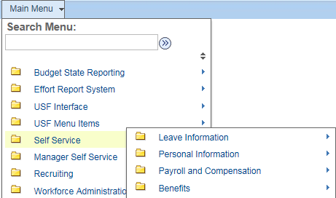
Payroll and Compensation is also where you can view your paystubs, etc.
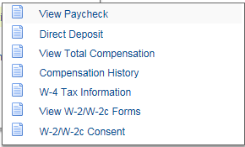
Click on W-4 Tax Information.
When you initially click on this page, all the editable fields on the page will be set to Display only. You will not be able to make any changes until you click on the USF NETID VALIDATION button as seen below.
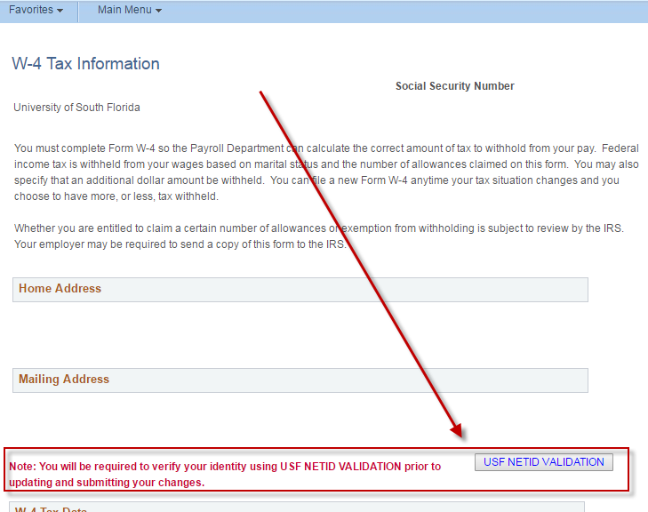

The MyUSF Login page will open in a separate browser window for authentication, and your will then be required to do the second authentication through DUO. (Pre setup required. Info at www.usf.edu/duo)

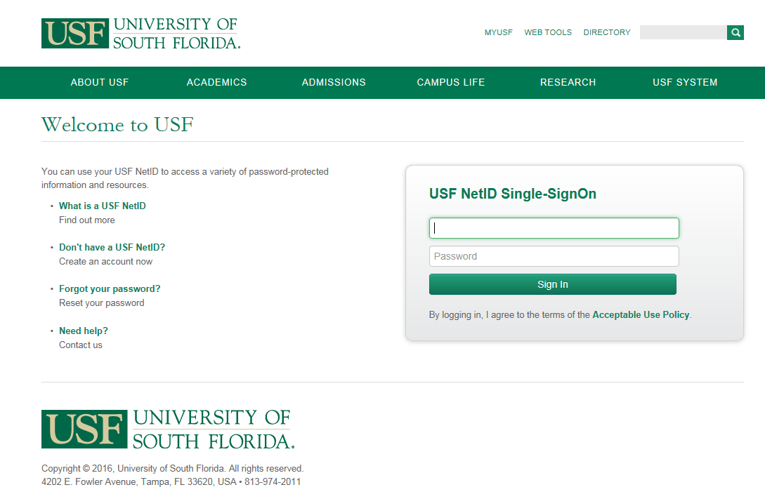

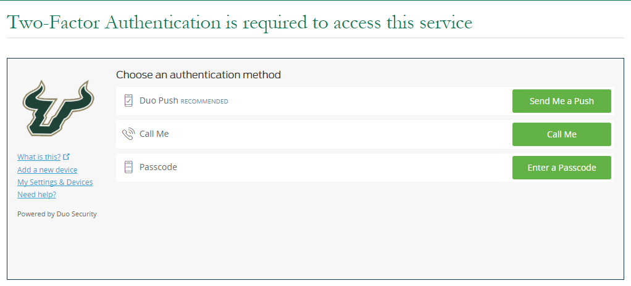

Once you successfully complete the DUO authentication, the W4 Tax Information page will appear in an editable state. Make your changes and click the submit button at the bottom of the page.
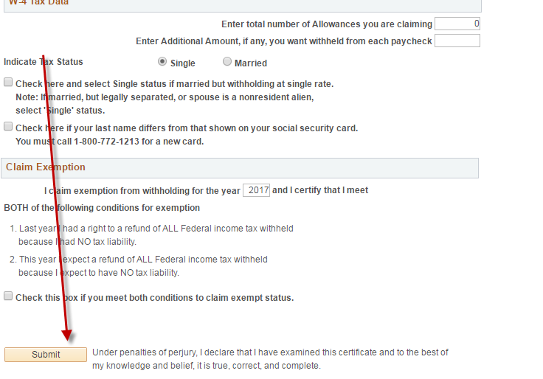
NOTE: If you select exempt (no withholding) you will get a pop-up message that tells you to renew this exemption by February 15th each year.
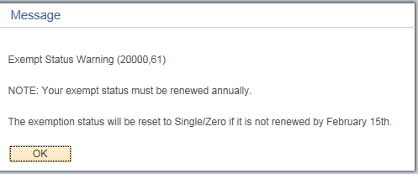
Click OK, then click Submit again.
If you try to claim allowances and then also select the Exempt box, as designed, the system will not allow this. This would also not be allowed on a paper W-4 per the IRS regulations.
You need to clear the number of allowances in order to mark the box as exempt. If do not, the warning below will appear:
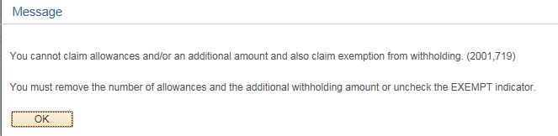

Click OK, then remove the number of Allowances and click Submit.
Successful save will be processed when 'Submit' button is selected.
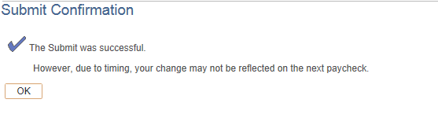
You will receive an email with regards to your changes for validation.
