Archivum Travel System
Guide: What’s new in Travel - Preview Coversheet
Introduction:
Previously when delegates or travelers create an Expense Report (ER) in the Archivum Travel system, they cannot preview the Expense Report coversheet prior to it being routed to DocuSign. Additional functionality was developed to allow submitters a preview and an opportunity to go back and make changes as required before submission of the Expense Report.
What’s New?
While selecting the DocuSign approval signature option on the Receipts page when creating ERs, you will see that the button on the bottom right reads “Preview Coversheet”.
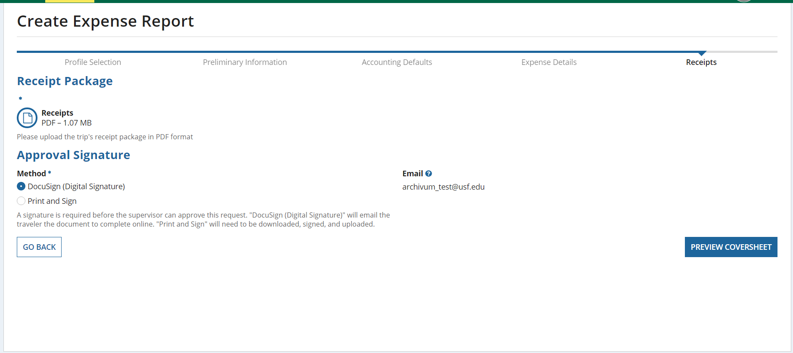
Upon clicking on it, you’ll be brought to a page where you can download the previewed coversheet.
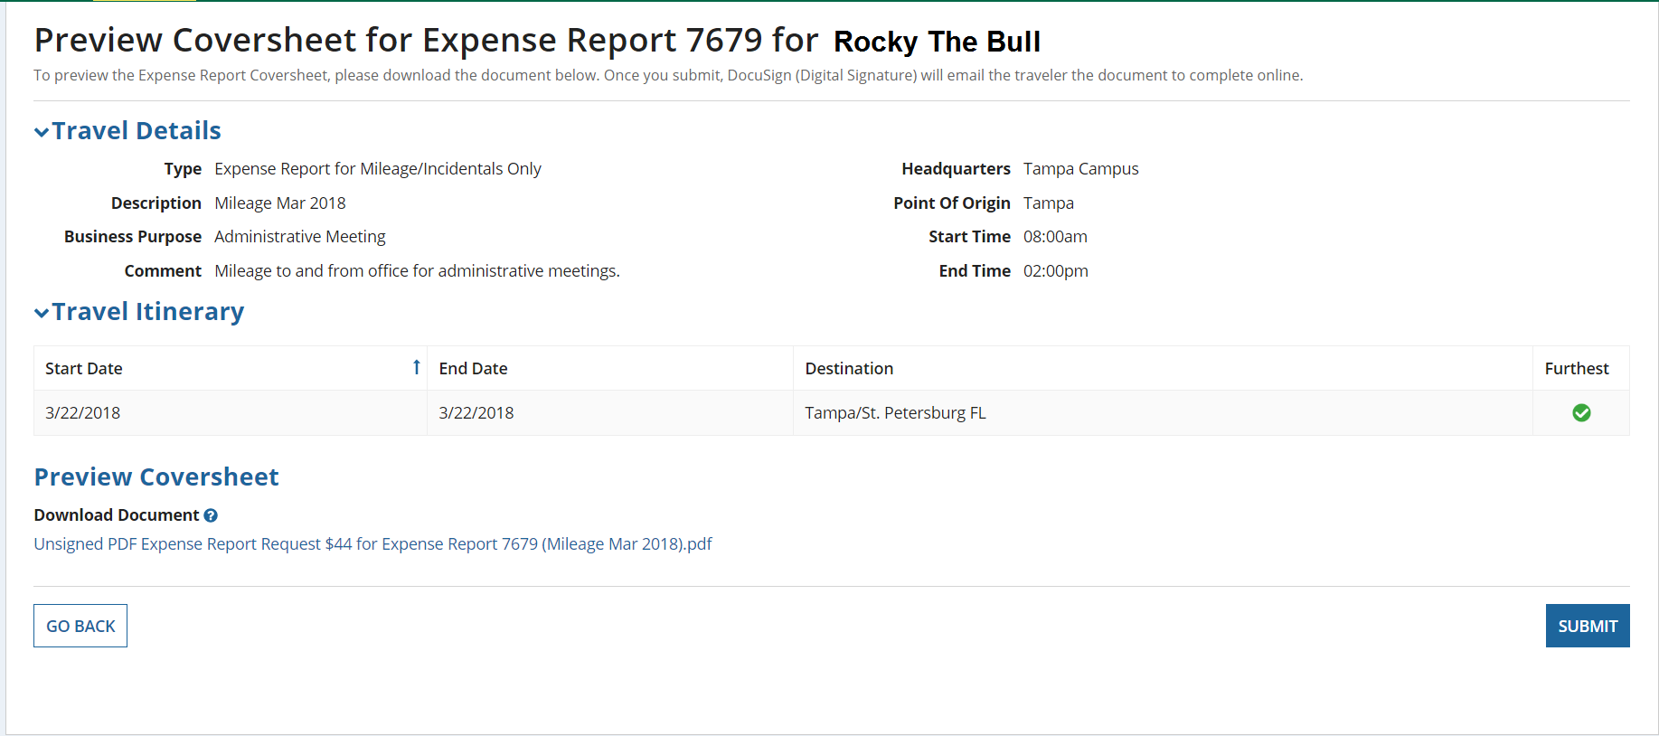
Underneath the “Preview Coversheet” section, you’ll find a link that shows the ER dollar amount, ER number and the description. The previewed coversheet is the same as the one sent to the traveler, and it is optional whether or not you view or download the document. Upon clicking on it, you’ll see the previewed coversheet in PDF form.
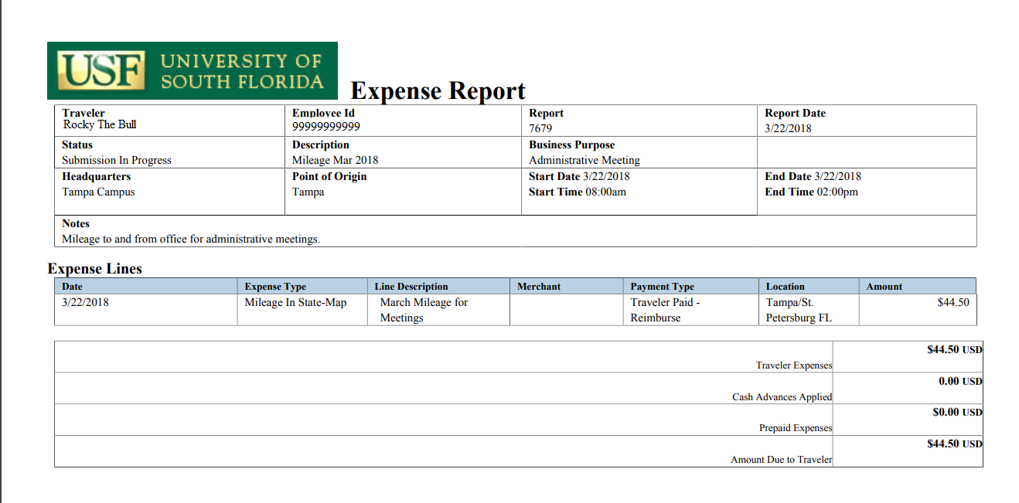

Upon clicking on Submit, Archivum Travel prompts you whether or not you are ready to send this ER to DocuSign for digital signature.
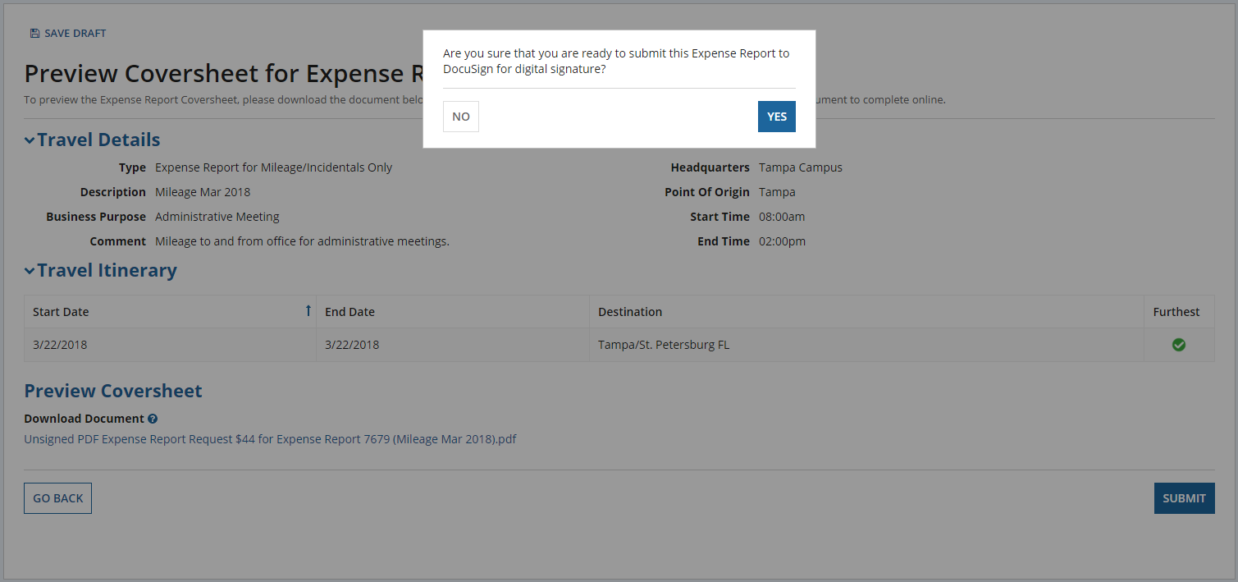
From this point on, the process is the same.
Note: Any use of the ‘Preview Coversheet’ will create a line in the Request History.
Frequently Asked Questions:
- Do I need to save the previewed coversheet or get it signed?
No, the previewed coversheet is meant for informational purposes only. It is meant to show travelers and delegates what the coversheet looks like prior to it being sent to DocuSign. It is meant to help users catch errors before the DocuSign process, such as incorrect dates, details or missing expenses.
- Is anything different with the “Print and Sign” option?
No, nothing is different about the Print and Sign option. The previewed coversheet only applies to the DocuSign method.
- Why are “Preview Coversheet” and “Preview Revised Coversheet” appearing in my ER’s request history?
An action of “Preview Coversheet” will appear in the request history if you select the DocuSign method and click on the “Preview Coversheet” button. A “Preview Revised Coversheet” action will appear in the request history if you at first click on the “Preview Coversheet” button, but decide to go back and make further changes and click on the “Preview Coversheet” button again. A different coversheet would generate with the changes you’ve made.
- After submitting the ER to DocuSign, does the traveler still need to sign via DocuSign?
Yes, electronic signatures are still required and the process after sending the coversheet to DocuSign has not changed.
- Who can I reach out to with questions?
For questions, email travelhelp@usf.edu.

