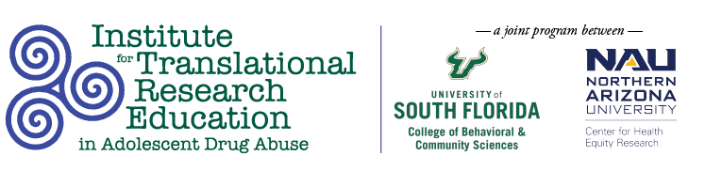

Tuesday, March 15
11:30AM

COVID-19 Impacts on School-based Substance-use Prevention Programs
Mia Said, BS; Julia Allen, BA; Caroline Recio, BA; University of South Florida, Tampa, FL; Kimberly Menendez, MS, The C.E. Mendez Foundation, Tampa, FL; Enya Vroom, PhD; University of Florida, Tampa, FL

Abstract
The Mendez Foundation (Tampa, Florida) implements an evidence-based substance use prevention program, Too Good for Drugs, in schools nation-wide. This exploratory evaluation examines how COVID-19 impacted the implementation of various evidence-based substance use prevention programs in Florida schools. The study’s aim is to evaluate how COVID-19 restrictions impacted implementation from the perceptions of school-based behavioral health practitioners and administrators. Implications for research, clinical practice, and crisis-response planning are discussed.

