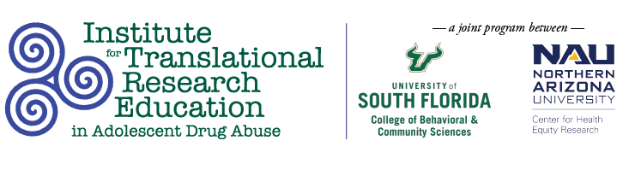
Tuesday, March 15
11:00AM

A Door-to-Door Approach: Preventing Opioid Misuse and Overdose in a Hispanic Rural Community Through Community-Based Partnerships

Cassandra Garza, Nicole Mallat, Caitlin Pike, Lacey Karpisek, Margarita Romo, Oliver Massey

Abstract
The researchers partnered with Farmworkers Self-Help to address local community concerns about substance misuse. To increase awareness about opioid use and reduce opioid overdoses, the team went door-to-door in the community distributing educational materials and Narcan. A questionnaire was administered alongside a community broker to assess awareness, understanding, and exposure to opioid misuse. This study enhances the community’s substance use-related knowledge and demonstrates the efficacy of a door-to-door service delivery model as a culturally competent practice.

