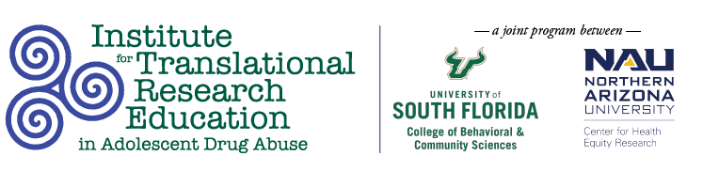

Tuesday, March 15
3:30PM

Easing the Transition: Independent Living Skills Development Curriculum for Former Foster Youth

Presenters
Kaela Desouza, BS, University of South Florida; Doreen Jean-Jacques, BS, University of South Florida; Amelia Sterenberg, OTS, Northern Arizona University

Abstract
Research indicates young adults who have experienced foster care lack imperative independent living skills. Independent living skills include several competencies such as financial management, educational pursuit, employment preparedness, and drug safety. This study evaluates the effectiveness of content expert lead life skills sessions, paired with Behavioral Skills Teaching theory in teaching life skills curriculum. Without these foundational skills, these young adults struggle to obtain positive health and wellness outcomes.

