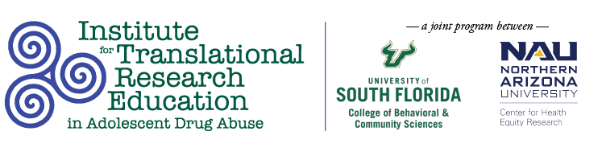
Tuesday, March 15, 2022
2:00PM

Post-Doc Panel

Title: The Essential Building Blocks of an Academic Career: Alumni Scholar Experiences at the Post-Doctoral Fellowship Level
Abstract
A post-doctoral fellowship (postdoc) is often the next step to building a solid foundation for establishing a research career in academic settings following obtaining a doctoral degree. The position provides a valuable opportunity for continued training and mentorship on the way to developing as an independent researcher. Securing a post-doc is an increasingly competitive process. A core objective of the USF Institute for Translational Research Education in Adolescent Drug Abuse (Institute) is to set scholars apart by providing targeted training and education in implementation science and adolescent behavioral health. This panel session will feature three alumni scholars who successfully obtained post-doc positions. Panelists will help de-mystify the post-doc experience by sharing how the Institute helped prepare them for competitive post-doc positions, discuss how their current positions have helped them grow as researchers, and share their current involvement in research initiatives.
Speakers
Amanda Hunter, PhD, Northern Arizona University. Dr. Hunter is a citizen of the Pascua Yaqui Tribe and was born and raised in Tucson, AZ. In 2020, she graduated with a PhD from the Health Promotion Sciences department at the University of Arizona’s Mel & Enid Zuckerman College of Public Health and has previous experience with the ITRE as a Cohort 8 Scholar. Her dissertation research involved developing, implementing, and evaluating a culturally-grounded after school program on an urban-based reservation. Dr. Hunter is currently a postdoctoral scholar with Northern Arizona University’s Center for Health Equity Research. Dr. Hunter’s research focuses on the impact of cultural engagement and cultural identity on mental and behavioral health outcomes in Indigenous youth.
Amanda Sharp, PhD, MPH, University of South Florida, and Cambridge Health Alliance. Dr. Sharp is a research analyst at the University of South Florida and a postdoctoral fellow at Cambridge Health Alliance with the Health Equity Research Lab and the Center for Mindfulness and Compassion. Dr. Sharp earned her PhD in Behavioral and Community Sciences from the University of South Florida and has previous experience with the ITRE as a Cohort 5 Scholar. Her research focuses on person-centered care, behavior change, and empathetic communication as a means for incorporating individual worldviews into operations, culture, and policies of behavioral health delivery systems. She is particularly invested in the implementation of person-centered care in strategies for treatment and harm reduction for people with opioid use disorders. She is a member of the Motivational Interviewing Network of Trainers.
Enya B. Vroom, PhD, MS, University of Florida. Dr. Vroom is an NIH NIDA Postdoctoral Fellow in the T32 Substance Abuse Training Center in Public Health in the Department of Epidemiology in the College of Public Health and Health Professions and College of Medicine at the University of Florida. Dr. Vroom earned her PhD in Behavioral and Community Sciences from the University of South Florida and has previous experience with the ITRE as a Cohort 4 Scholar. Dr. Vroom’s current research focuses on the epidemiology of substance misuse among justice-involved adolescents, with an emphasis on racial and gender disparities and the implementation of treatment services. She also has expertise in the translation, implementation, and evaluation of evidence-based school- and community-based behavioral health services.

