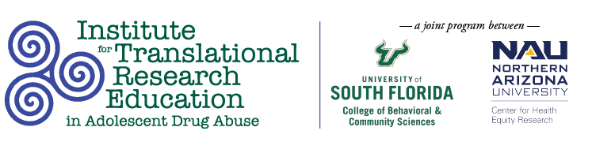

Tuesday, March 15
3:00 PM

Virtual Parent Training on Parent-Teen Communication with Emphasis on Teen Vaping

Authors
Anna Tedder, MA, MS, BCBA; Amanda Weston , PhD, Kathleen Moore, PhD, University of South Florida, Tampa, FL; Ellen Snelling, Board Chair, Cindy Grant, Executive Director, Hillsborough County Anti-Drug Alliance, Tampa, FL

Abstract
Vaping is a relatively new trend in tobacco and marijuana use among teens. Parents need to know facts and risks associated with vaping and communicate those to their teens. This evaluative study utilized a pre-and post- survey to evaluate the effectiveness of online training on increasing parent knowledge of vaping and increasing positive parent-teen communication as reported by the parent. A focus group was utilized to gather parent feedback on the content, platform, and structure of the online training.

