Risk Assessment Survey
Operational Risks: Risks impacting continuity of activities, safety and security, IT operations, physical infrastructure, process efficiency, and program effectiveness
Type of Risk | Does it apply? Yes or no? | Please describe how it does or does not  apply to your risk area. | Impact  Rating | Velocity  Rating | Likelihood Rating | Preparedness Rating
Business Continuity Risk: Risks associated with an inability to return to normal operations after a disruptive incident slows or stops part or all operations. | Choose an item. | Click or tap here to enter text. | Choose an item. | Choose an item. | Choose an item. | Choose an item.
Data Governance and Quality Risk: Risks associated with inadequate oversight, controls, and usage of data and IT systems. | Choose an item. | Click or tap here to enter text. | Choose an item. | Choose an item. | Choose an item. | Choose an item.
Employee Training Risk: Risks associated with inadequate or ineffective employee training for their role in our organization. | Choose an item. | Click or tap here to enter text. | Choose an item. | Choose an item. | Choose an item. | Choose an item.
IT Change, Incident, and Services Risk: Risks associated with IT services such as end-user services, change and incident management, application development and maintenance, and server administration | Choose an item. | Click or tap here to enter text. | Choose an item. | Choose an item. | Choose an item. | Choose an item.
IT Infrastructure Risk: Risks associated with IT infrastructure such as end-of-life assets, infrastructure complexity, unsupported infrastructure, and device failures. | Choose an item. | Click or tap here to enter text. | Choose an item. | Choose an item. | Choose an item. | Choose an item.
Logical Access, Cybersecurity, and Vulnerability Management Risk: Risks associated failing to protect the confidentiality, integrity, and availability of IT assets of our institution from potential threats. | Choose an item. | Click or tap here to enter text. | Choose an item. | Choose an item. | Choose an item. | Choose an item.
Personnel Issues or Workplace Violence Risk: Risks associated with personnel issues or workplace violence. | Choose an item. | Click or tap here to enter text. | Choose an item. | Choose an item. | Choose an item. | Choose an item.
Process Risk: Risks associated with operational failures resulting in business processes not being achieved. | Choose an item. | Click or tap here to enter text. | Choose an item. | Choose an item. | Choose an item. | Choose an item.
Property, Plant, and Equipment Risk: Risks associated with failing to construct or maintain property, plant, and equipment owned or controlled by the University to meet its mission. Additionally, this risk includes the tracking and monitoring of all physical assets. | Choose an item. | Click or tap here to enter text. | Choose an item. | Choose an item. | Choose an item. | Choose an item.
Purchasing Risk: Risks associated with the procurement processes for obtaining services, products, or resources. | Choose an item. | Click or tap here to enter text. | Choose an item. | Choose an item. | Choose an item. | Choose an item.
Recruitment, Hiring, and Retention Risk: Risks associated with failing to attract, onboard, and retain individuals with the skills, knowledge, and experience needed to fulfill organizational objectives and obligations | Choose an item. | Click or tap here to enter text. | Choose an item. | Choose an item. | Choose an item. | Choose an item.
Research and Laboratory Safety Risk: Risks associated with research and laboratory a safety. | Choose an item. | Click or tap here to enter text. | Choose an item. | Choose an item. | Choose an item. | Choose an item.
Safety and Security Risk: Risks associated with failing to protect individuals from danger, harm, or injury when utilizing buildings or properties owned or controlled by our institution. | Choose an item. | Click or tap here to enter text. | Choose an item. | Choose an item. | Choose an item. | Choose an item.
Student Mental Health and Wellness Risk: Risks associated with student wellbeing and ensuring appropriate services are in place to address student mental health and wellness needs. | Choose an item. | Click or tap here to enter text. | Choose an item. | Choose an item. | Choose an item. | Choose an item.
Terrorism Risk: Risks associated with extreme threats of violence to the institution from terrorist acts or groups. | Choose an item. | Click or tap here to enter text. | Choose an item. | Choose an item. | Choose an item. | Choose an item.
Vendor/Third-Party Risk, Purchasing, and Oversight Risk: Risks associated with the use of vendors or third-parties. | Choose an item. | Click or tap here to enter text. | Choose an item. | Choose an item. | Choose an item. | Choose an item.
Other: Click or tap here to enter text. | Choose an item. | Click or tap here to enter text. | Choose an item. | Choose an item. | Choose an item. | Choose an item.

Compliance Risks: Risks impacting compliance with legal, regulatory, contractual, policy, accreditation, NCAA, and other requirements.
Type of Risk | Does it apply? Yes or no? | Please describe how it does or does not  apply to your risk area. | Impact  Rating | Velocity  Rating | Likelihood Rating | Preparedness Rating
Breach of Contract Risk: Risks associated with failure to meet contractual requirements leading to adverse consequences. | Yes | This applies to… | Moderate | Moderate | Major | Somewhat Prepared
Compliance with Laws and Regulations Risk: Risks associated with violating laws and regulations which may result adverse consequences. | Choose an item. | Click or tap here to enter text. | Choose an item. | Choose an item. | Choose an item. | Choose an item.
Conflict of Commitment Risk: Risks associated with activities interfering with an employee's full and faithful performance of their professional or institutional responsibilities or obligations which are not mitigated. | Choose an item. | Click or tap here to enter text. | Choose an item. | Choose an item. | Choose an item. | Choose an item.
Conflicts of Interest Risk: Risks associated with unresolved conflicts between an employee's private interests and the public interests of our institution. | Choose an item. | Click or tap here to enter text. | Choose an item. | Choose an item. | Choose an item. | Choose an item.
Data Privacy Risk: Risks associated with inadequately protecting data controlled or owned by our institution in accordance with the law and best practices. | Choose an item. | Click or tap here to enter text. | Choose an item. | Choose an item. | Choose an item. | Choose an item.
Employment Practices Risk: Risks associated with violating employment law and human resources standards. | Choose an item. | Click or tap here to enter text. | Choose an item. | Choose an item. | Choose an item. | Choose an item.
Research Contract and Grant Violations Risk: Risks associated with violating grant-related requirements and research funding agreements. | Choose an item. | Click or tap here to enter text. | Choose an item. | Choose an item. | Choose an item. | Choose an item.
Other: | Choose an item. | Click or tap here to enter text. | Choose an item. | Choose an item. | Choose an item. | Choose an item.

Financial Risks: Risks impacting resources, financial structure, ability to meet future financial needs, and financial reporting
Type of Risk | Does it apply? Yes or no? | Please describe how it does or does not  apply to your risk area. | Impact  Rating | Velocity  Rating | Likelihood Rating | Preparedness Rating
Accounts Payable Risk: Risks associated with errant, late, or missed payments; missed accruals or errant forecasting; or lack of audit trails. | Choose an item. | Click or tap here to enter text. | Choose an item. | Choose an item. | Choose an item. | Choose an item.
Accounts Receivable/Bad Debt Risk: Risks associated with untimely, incomplete, or inaccurate payment by students, patients, vendors, and third-parties for services rendered to them by our institution. | Choose an item. | Click or tap here to enter text. | Choose an item. | Choose an item. | Choose an item. | Choose an item.
Billing Accuracy Risk: Risks associated with inaccurate billing or failing to bill for services rendered by our institution. | Choose an item. | Click or tap here to enter text. | Choose an item. | Choose an item. | Choose an item. | Choose an item.
Budgetary Resource Management Risk: Risks associated with failing to allocate and manage departmental budgets to ensure effective and efficient resources to meet operational objectives. | Choose an item. | Click or tap here to enter text. | Choose an item. | Choose an item. | Choose an item. | Choose an item.
Capital Risk: Risks associated with potential losses of part or all institutional investments, including liquidity risk, where the institution is unable to meet its financial demands. | Choose an item. | Click or tap here to enter text. | Choose an item. | Choose an item. | Choose an item. | Choose an item.
Financial Performance Risk: Risks associated with not meeting financial projections and pressure to meet Key Performance Indicators (KPIs). | Choose an item. | Click or tap here to enter text. | Choose an item. | Choose an item. | Choose an item. | Choose an item.
Financial Reporting Risk: Risks associated with incomplete, inaccurate, or untimely communication of financial information. | Choose an item. | Click or tap here to enter text. | Choose an item. | Choose an item. | Choose an item. | Choose an item.
Fraud, Theft, and Embezzlement Risk: Risks associated with financial losses stemming from students, employees, vendors, or other third parties, doing business with our institution, engaging in fraud, theft, or embezzlement. | Choose an item. | Click or tap here to enter text. | Choose an item. | Choose an item. | Choose an item. | Choose an item.
Pension/Retirement Obligations Risk: Risks associated with pension or retirement fund liability | Choose an item. | Click or tap here to enter text. | Choose an item. | Choose an item. | Choose an item. | Choose an item.
Philanthropy/Fundraising/Capital Campaign Risk: Risks associated with philanthropic events, fundraising goals and initiatives or capital campaigns efforts. | Choose an item. | Click or tap here to enter text. | Choose an item. | Choose an item. | Choose an item. | Choose an item.
Other: Click or tap here to enter text. | Choose an item. | Click or tap here to enter text. | Choose an item. | Choose an item. | Choose an item. | Choose an item.

Reputational Risks: Risks impacting our public image, brand, external opinions, prominence, and standing of our University.
Type of Risk | Does it apply? Yes or no? | Please describe how it does or does not  apply to your risk area. | Impact  Rating | Velocity  Rating | Likelihood Rating | Preparedness Rating
Communication Risk: Risks associated with ensuring that a consistent message is shared and understood among all constituents and there is clear and consistent coordination as needed | Choose an item. | Click or tap here to enter text. | Choose an item. | Choose an item. | Choose an item. | Choose an item.
Emerging Issues Risk: Risks associated with potential issues in their earliest stages of development | Choose an item. | Click or tap here to enter text. | Choose an item. | Choose an item. | Choose an item. | Choose an item.
Public Image Risk: Risks associated with threats to or endangerment of the institution's good name or standing which can arise from the actions of our institution, employees, or third-parties (vendors, affiliates, and guests). | Choose an item. | Click or tap here to enter text. | Choose an item. | Choose an item. | Choose an item. | Choose an item.
Other: | Choose an item. | Click or tap here to enter text. | Choose an item. | Choose an item. | Choose an item. | Choose an item.

Strategic Risks: Risks impacting our constituent relationships, ability to generate funds, and goal achievement.​
Type of Risk | Does it apply? Yes or no? | Please describe how it does or does not  apply to your risk area. | Impact  Rating | Velocity  Rating | Likelihood Rating | Preparedness Rating
Governance Risk: Risks associated with ineffective organizational structures to identify, assess, manage, and communicate risks, such as boards, board committees, delegations, management structures and related reporting. | Choose an item. | Click or tap here to enter text. | Choose an item. | Choose an item. | Choose an item. | Choose an item.
New Programs and Delivery Models Risk: Risks associated with an inability to meet community needs by effectively adapting to new academic and service offerings or programs, including program content and how they are delivered. | Choose an item. | Click or tap here to enter text. | Choose an item. | Choose an item. | Choose an item. | Choose an item.
Organizational Structure, Alignment & Direction Risk: Risks associated with changes in strategy or direction requiring significant realignment of organization structures, roles, and responsibilities, including stakeholder understanding and support of such changes. | Choose an item. | Click or tap here to enter text. | Choose an item. | Choose an item. | Choose an item. | Choose an item.
Regulatory Change Risk: Risks associated with changing laws and regulations requiring assessment of current practices and, based on the assessment, implementing a response plan. | Choose an item. | Click or tap here to enter text. | Choose an item. | Choose an item. | Choose an item. | Choose an item.
Research Risk: Risks associated with changing research practices and methodology. | Choose an item. | Click or tap here to enter text. | Choose an item. | Choose an item. | Choose an item. | Choose an item.
Succession Planning Risk: Risks associated with identifying key leadership roles and developing a human capital strategy to ensure continuity in the event of leadership departures. | Choose an item. | Click or tap here to enter text. | Choose an item. | Choose an item. | Choose an item. | Choose an item.
Variability in Customer Volume and Funding Availability Risk: Risks associated with significant changes that may lead to insufficient revenue and/or funding that challenges underlying assumptions of strategic forecasts or may cause a material variance from the forecasts. | Choose an item. | Click or tap here to enter text. | Choose an item. | Choose an item. | Choose an item. | Choose an item.
Other: | Choose an item. | Click or tap here to enter text. | Choose an item. | Choose an item. | Choose an item. | Choose an item.

Impact Rating Scales by Risk Type
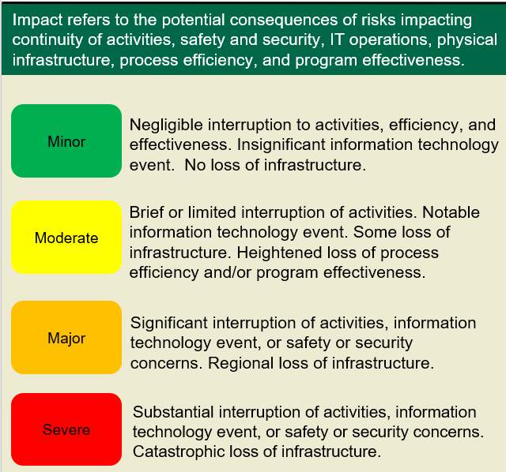
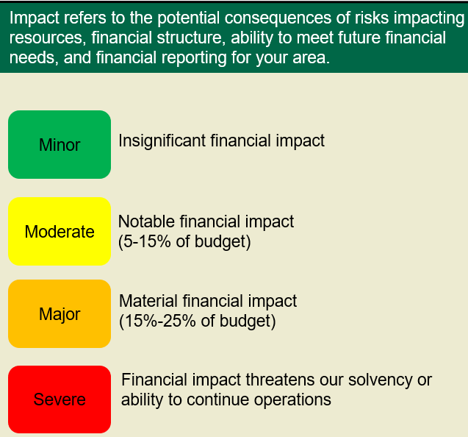
Operational Risk
Financial Risk
Compliance Risk
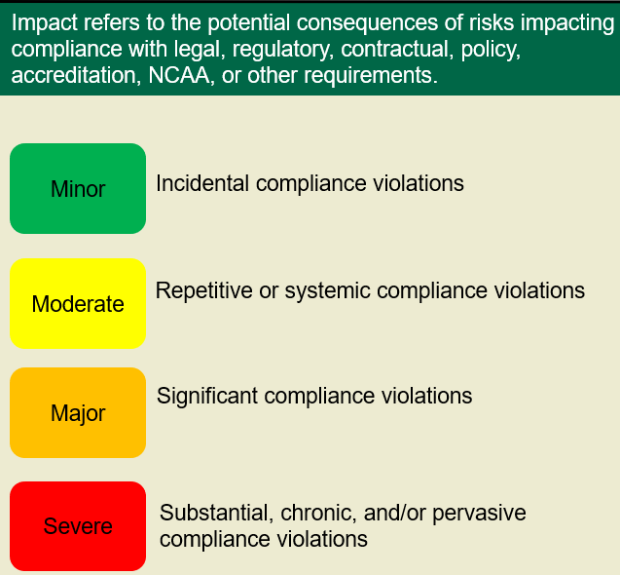
Strategic Risk
Reputational Risk
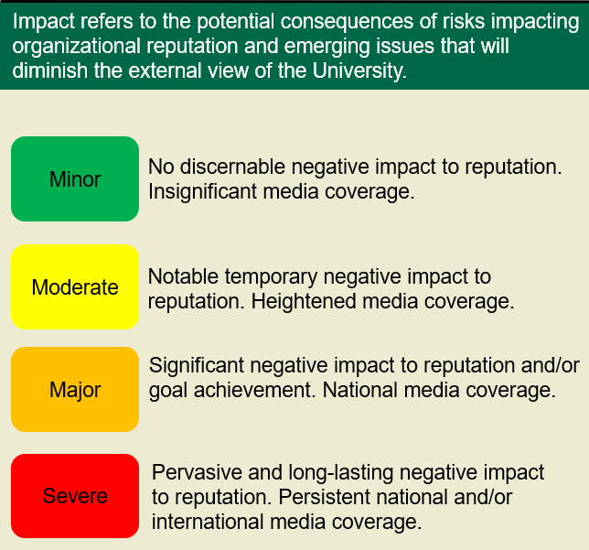
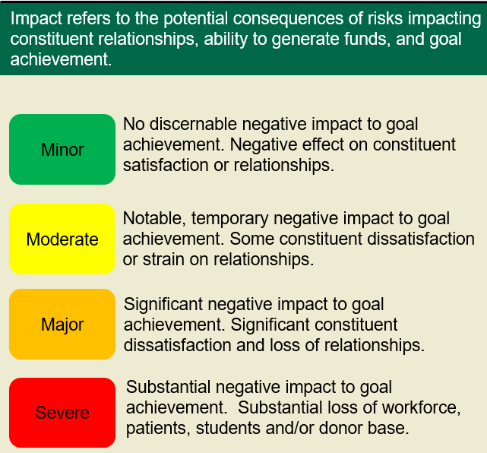

Velocity, Likelihood & Preparedness Rating Scales
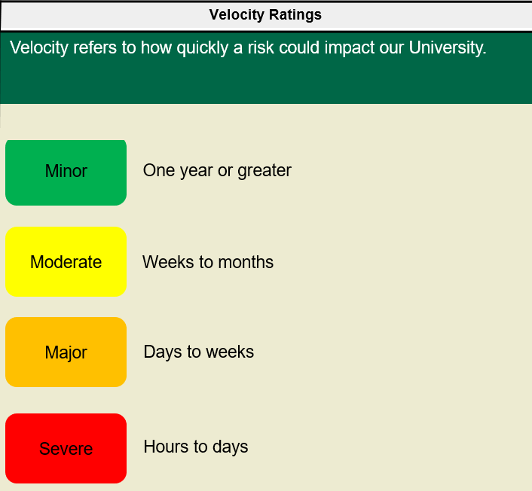
These scales apply to all risk types
