Center for Student Involvement

Graduate Advisor
(Campus Activities Board)

The University of South Florida Center for Student Involvement (CSI) empowers students to author their own experiences through diverse, social, cultural, and educational programs that engage students, develop leaders, build traditions, and cultivate University pride. CSI consists of the following functional areas: Campus Traditions Board (Homecoming and USF Week), Campus Activities Board, University Lecture Series, Centre Gallery, and volunteer student involvement consultants. This Center programs an average of 125 events each year and strives to bring quality events to campus fostering student involvement and engagement. In just one semester, CSI can average over 25,000 attendees at events hosted by the various student programming boards. The Center for Student Involvement consists of approximately thirty, paid, student leaders, five graduate program advisors, three professional staff advisors, office assistants, and volunteers.

The Graduate Advisor (GA) for Campus Actives Board will be responsible for the enhancement, advising, mentoring and leadership development of the Bulls Nite Out Directors, as they work to ensure maximum involvement and engagement from the student body leading to student academic and personal success, while fostering a lifeline affinity to the university. Bulls Nite Out is a weekly late night program that encompasses a variety of activities for the enjoyment of students. In addition to providing direction and oversight of these programs, GAs teach students how to execute contracts, work with vendors, and how to lead other students.

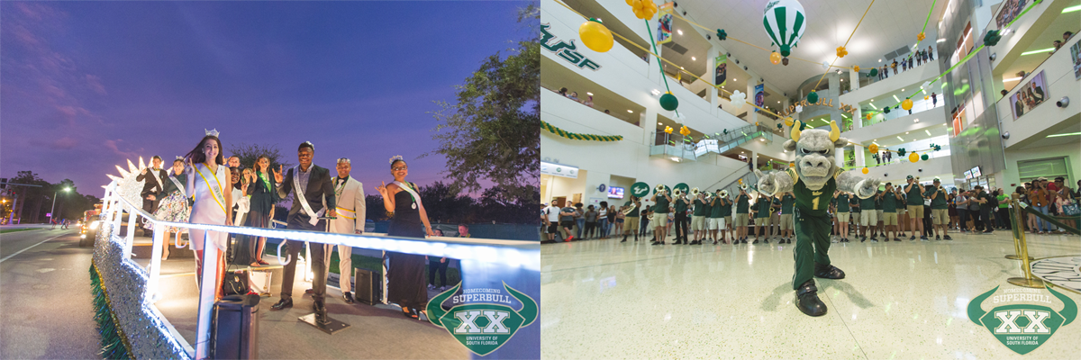

Center for student involvement
getinvolved@usf.edu | 813-974-1001 | involvement.usf.edu

Duties/Responsibilities

- Support and model the vision and goals of the Center for Student Involvement.
- Create, enhance, and sustain collaborative partnership with key campus organizations and departments to create successful co-curricular involvement and programming opportunities for students at Bulls Nite Out events.
- Support and model the vision and goals of the Center for Student Involvement.
- Promote student programming through the planning and staffing of weekly events.
- Act as a resource to students in all aspects of program development.
- Work collaboratively with other Program Advisors and department staff to provide an effective plan for building community on campus.
- Assess and enhance Bulls Nite Out events with the consideration of students.
- Sustain and enhance current Bulls Nite Out program through collaboration, assessment, and program upkeep.
- Advise students on event planning and management, contract negotiation, assessment of activities, and leading peer student groups.
- Support Student Affairs initiates by serving on committees, attending events and working with other departments to achieve mission, values, and goals of Student Affairs.
- Advise volunteer student led boards and committees.
- Participate in CSI development and staff trainings and event staffing rotation.
- Other duties as assigned.

Expected Learning Outcomes

- Be able to identify and implement strategies for enhancing a campus community through student engagement and involvement.
- Learn the process involved with developing advising relationships with student leaders.
- Become experienced in training, developing, and assessing student leaders.
- Will become proficient in planning and implementing, and assessing campus wide events that focus on meeting the needs of a diverse student population.
- Obtain an understanding of skills and be able to teach student leaders the skills needed to work with and engage a diverse student population.
- Expand knowledge and be able to teach student leaders how to budget, market and negotiate contracts for campus wide events.
- Obtain experience working in a fast paced environment as a team with professional staff, fellow Graduate Assistants and student workers.

