Center for Student Involvement

Graduate Advisor
(Fraternity/Sorority Life)

The University of South Florida Center for Student Involvement (CSI) empowers students to author their own experiences through diverse, social, cultural, and educational programs that engage students, develop leaders, build traditions, and cultivate University pride. CSI consists of the following functional areas: Campus Traditions Board (Homecoming and USF Week), Campus Activities Board, University Lecture Series, Centre Gallery, and volunteer student involvement consultants. This Center programs an average of 125 events each year and strives to bring quality events to campus fostering student involvement and engagement. In just one semester, CSI can average over 25,000 attendees at events hosted by the various student programming boards. The Center for Student Involvement consists of approximately thirty, paid, student leaders, five graduate program advisors, three professional staff advisors, office assistants, and volunteers.

The Graduate Advisor (GA) for Fraternity/Sorority Life will be responsible for the enhancement, advising, mentoring, and leadership development of members in the fraternity and sorority life community. This GA will work to ensure members are excelling in student academic and personal success, while fostering a lifeline affinity to the university. This Graduate Advisor will also be responsible for assisting in creating, implementing, and sustaining student involvement and engagement initiatives. In addition to providing direction and oversight of these programs, GAs teach students how to model their values, lead their peers, and ways to embody their fraternal values within the USF community.
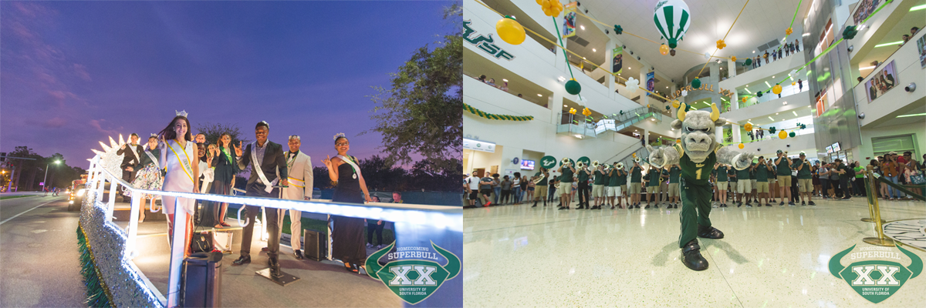

Center for student involvement
getinvolved@usf.edu | 813-974-1001 | involvement.usf.edu

Duties/Responsibilities

- Support and model the vision and goals of the Center for Student Involvement.
- Plan, execute, and promote National Hazing Prevention Week, Values Celebration Week, and Burgers & Beats fall kickoff event.
- Oversee organization’s social event training, registration, and review process.
- Co-advise 1-2 student led councils.
- Assist in planning, recruitment, and attends Bulls Service Break with FSL members.
- Co-facilitate Chapter Officer Kickstart and Chapter Leader Orientation.
- Create, enhance, and sustain collaborative partnerships with campus organizations and departments to create successful co-curricular involvement and programming opportunities for students.
- Provide support to FSL staff for day-to-day community management.
- Advise students on event planning and management, contract negotiation, assessment of activities, and leading peer student groups.
- Support Student Affairs initiates by serving on committees, attending events and working with other departments to achieve mission, values, and goals of Student Affairs.
- Participate in CSI development and staff trainings and event staffing rotation
- Other duties as assigned.

Expected Learning Outcomes

- Be able to identify and implement strategies for enhancing a campus community through student engagement and involvement.
- Learn the process involved with developing advising relationships with student leaders.
- Become experienced in training, developing, and assessing student leaders.
- Will become proficient in planning and implementing, and assessing campus wide events that focus on meeting the needs of a diverse student population.
- Obtain an understanding of skills and be able to teach student leaders the skills needed to work with and engage a diverse student population.
- Gain advising experience in facilitating student-centered and value-based learning.
- Graduate Advisor will have a working knowledge of policies, procedures, and processes of chapters, councils, and department.
- Obtain experience working in a fast paced environment as a team with professional staff, fellow Graduate Advisor, and student workers.

