Hong-Wei Yen (顏宏偉)
Professor of Chemical & Materials Engineering, Tunghai University, Taiwan
Email: hwyen@thu.edu.tw

Education
Doctor of Philosophy (Biosystems Engineering), Clemson University, SC, USA, 2004.
Master of Science (Chemical Engineering), National Tsing-Hua University, Taiwan, 1995.
Bachelor (Chemical Engineering), Tunghai University, Taiwan, 1993.

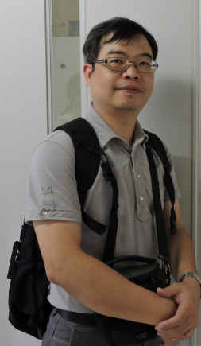
I received my doctoral degree from Biosystems Department, Clemson University, USA in 2004. After then, I started my academic career in Tunghai University, Taiwan. My research background is in the field of fermentation technology, especially focusing on the development of renewable bioenergy, such as ethanol, butanol, as well as the microbial oil production from microorganism. Before coming to the state for my phD, I have worked in a pharmaceutical company for over 4 years. Due to the industrial working experience, my research is not only focusing on the theoretical exploration, but always try to bridge the academic study and the industry production. In the past few years, we also tried to combine the cultivation of microalgae and other high-value compounds production process to mitigate the carbon emission at a cost-effectiveness way. I always believe a good development toward the sustainability is going to have the profits earned from this path. From 2016 to 2018, I also served as the dean of international office of Tunghai University. During the term of being a dean of international office, we set up a Taiwan Education Center (TEC) in Jakarta, Indonesia and I became the director of the center to recruit many students from Indonesia to Taiwan, and help to bridge the research cooperation between Taiwan and Indonesia. Working in the administration office is a interesting experience to me, just like doing research in the laboratory.

