Lindsey Geiger, PE, ENV SP, LEED AP BD+C  Director, Education  Institute for Sustainable Infrastructure  1275 K Street, NW Suite 750  Washington DC, 20005 | 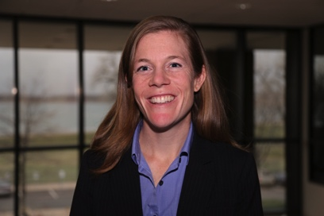

Lindsey Geiger is the Director of Education at the Institute for Sustainable Infrastructure. She oversees educational programming including the Envision Sustainability Professional credential, continuing education courses, and training for Envision verifiers and ISI trainers. Ms. Geiger coordinates and ensures consistency across all educational materials, events, and policies.

Her professional experience includes managing community-driven infrastructure improvement projects; developing sustainability standards and impact measurement benchmarks; educating stakeholders on best practices in green building and infrastructure. Lindsey draws her experience from the non-profit sector as well as the engineering and construction industries.

Ms. Geiger holds a bachelor’s degree in civil engineering from the University of Virginia in Charlottesville, VA, and a master’s degree in environmental engineering from Michigan Technological University in Houghton, MI. She is a Professional Engineer (PE), registered in Colorado, and has earned two sustainability credentials: Envision Sustainability Professional (ENV SP) and Leadership in Energy and Environmental Design Accredited Professional Building Design and Construction (LEED AP BD+C).

