Dr. Ilissa Ocko’s Bio
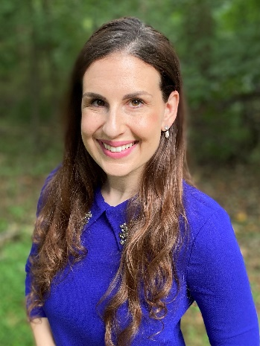

Dr. Ilissa Ocko is a Senior Climate Scientist and Barbra Streisand Chair of Environmental Studies at Environmental Defense Fund, where she pursues research on the climate impacts of different types of greenhouse gases and the benefits of various mitigation strategies. She works with economists, lawyers, and policy experts to find the most practical, long-lasting strategies to benefit our climate in both the near- and long-term. Dr. Ocko is committed to communicating climate change science to non-experts using plain language and powerful visuals, and is an avid designer of science graphics. She earned a Ph.D. in Atmospheric and Oceanic Sciences from Princeton University, and a B.S.E. in Earth System Science and Engineering from the University of Michigan. Dr. Ocko also holds a certificate in environmental policy from the Princeton School of Public and International Affairs.


