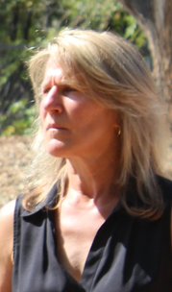
Maya K. van Rossum

Maya K. van Rossum is the Founder of Green Amendments For the Generations, a grassroots non-profit organization inspiring a nationwide movement to secure constitutional recognition and protection of environmental rights in every state and ultimately at the federal level. van Rossum is also the Delaware Riverkeeper, leading the watershed-based advocacy organization, the Delaware Riverkeeper Network, for 30 years in its efforts to protect the health of the Delaware River and its tributaries. Since launching Green Amendments For The Generations, in addition to increasing use of amendments in Pennsylvania and Montana, a constitutional amendment has been passed in New York, with Green Amendments also advancing in 11 additional states. A skilled activist, attorney, strategist and community organizer, she has testified multiple times, by invitation, before US Congressional Committees; was named among Philadelphia Business Journal’s Power 100 in 2019; One Of The “10 Most Influential People of 2015” When It Comes to Energy Issues by SNL Energy; and is author of, The Green Amendment, Securing Our Right to a Healthy Environment, in which she coined and defined the term “Green Amendment” and which was selected as the 2018 Living Now Evergreen Awards GOLD Winner in the Nature Conservation category. A second edition of the book is set to be released November 1, 2022.

