Setting up for Success: Bb Collaborate
#1 tip – Be patient. Give yourself plenty of time PRIOR to the start of the session to set up (approx. 30 minutes). It is possible that there are several updates to install, files to download, and/or the need to re-start your computer.
Sources for Help:
Bb Collaborate Support Portal
Bb Collaborate Help Desk OR 1 (877) 382-2293
USF IT 1.866.974.1222 OR help@usf.edu

On the computer you will be accessing the session on:
Recommended Browser: Firefox, download here: http://www.mozilla.org/en-US/firefox/new/
Ensure you have the most recent version of JAVA – check here: https://www.java.com/verify
If you are using a MAC, download the Bb Collaborate Launcher App: (1 time only)
https://na-downloads.elluminate.com/bcl/BlackboardCollaborateLauncher

Accessing the session in canvas:
You may find the Bb Collaborate link in your Canvas course in 1 of 2 places:
Main Course Menu | Modules
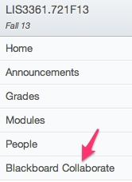 | 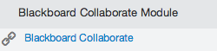

In Canvas, click the purple icon to join the session:

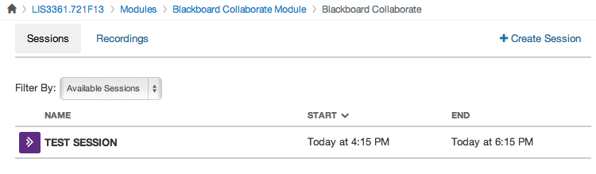

First time users:
STEP 1: Checking System Requirements

You will be taken to a web page, to re-check your system requirements, including JAVA (as mentioned above). Follow the instructions if it is indicated you lack a requirement or need an update
STEP 2: Configuring your system
We provide a Configuration Room that you can use to test your connection, settings, and configure your audio. This step is optional and is intended for sessions hosted on Blackboard Collaborate servers. To test your configuration for sessions hosted at your Organization's site, please contact your Administrator.
v12.5 Configuration Room (North America)
v12.5 Configuration Room (Europe)
Note: When joining a Blackboard Collaborate web conferencing session for the first time you may see a security dialog box asking to confirm the application's digital signature. Click "Run" to continue.
STEP 3: Training and Resources
Online Orientation

STEP 4: View our Support Portal
Additional information is available through our Support Portal.

Once in the session:
Check your audio:
Navigate to “Tools” > “Audio Set-up Wizard”