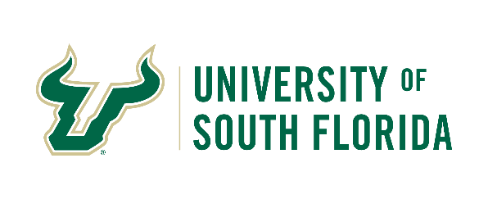

**Travel Department**



**Business Meals on Travel**

USF travelers are reimbursed meal allowances pursuant to F.S. 112.061(6) (a-c) for domestic travel and at the published Department of State rate for the destination area for foreign travel.

Employee travelers under certain circumstances may be reimbursed for a reasonable business meal with non-USF employees necessary to conduct USF business. The following guidelines apply.

* Must be agenda driven with clear university business purpose for the meal
* Must be for two or more persons and include guests not on university travel
* Must be limited to $50 per person inclusive of tip
* Tips should not exceed 20% of the subtotal cost
* Alcoholic beverages are not reimbursable
* Must not claim meal allowance for the same meal

|  |
| --- |
| **Required Back-up**  Agenda showing substantive and bona fide business discussion with a clear business purpose, number of attendees and location.  Itemized receipt for the meal either in restaurant, catered or delivered |