You may enroll in direct deposit AFTER HR has entered your information into GEMS.

Go to www.usf.edu, and click on MyUSF

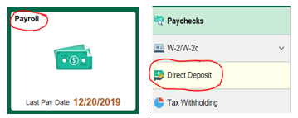
Sign in with your NETID

(the links to create yout NETID are to the left of the sign-in boxes)
Click on Business Systems > GEMS **. You will be directed to the Employee Self Service Portal where you will need to click on the Payroll Tile, then Direct Deposit on the left-hand menu once you click the tile.
**If GEMS does not appear, please call IT Helpdesk at
(813) 974-1222, or email Help@usf.edu.

When you are first hired, and enter the Direct Deposit page for the first time, it is important to note that you may enter up to three distributions. These can be at multiple financial institutions, as well as checking and/or savings accounts.
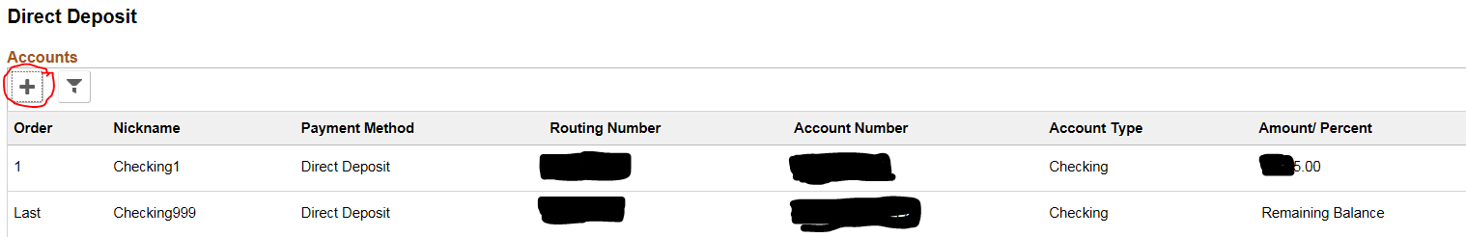
To add an account, click the + button.

Direct Deposit Page
Nickname: Enter a nickname for your account. (ie My Checking Account or Wells Fargo Checking)
Payment Method: There is only one default value available of Direct Deposit
Routing Number: This number can be found at the bottom of a blank check (not a deposit slip) or by contacting your bank or financial institution.
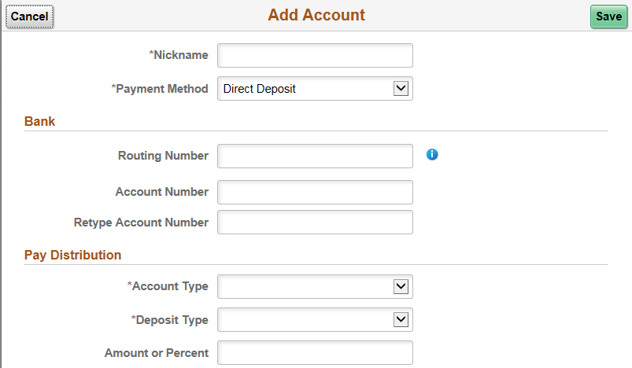
Note: Routing Number is also called an ABA or Transit Number and is nine digits long. You MUST have this number to set-up your Direct Deposit.
Account Number: Available on the bottom of a blank check (see image at right) or from your financial institution.
Account Type: Choose Checking or Savings.
Deposit Type: Select Amount or Balance of Net Pay.
Amount: If you chose Balance of Net Pay, leave the amount field blank. If you are setting up another account with a specified Amount, enter the amount you wish to have deposited. Example: 5, 10, 50, 100, 200, 250, etc.

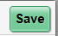 Then click the Save button.

Review, Edit or Delete Direct Deposit
If you have already set up direct deposit information online, your account information will appear in the Direct Deposit Details. (note you can only make changes once to direct deposit in 24 hours, if you save then leave the screen, you will need to wait until the next day to make any additional changes)
- To review account information, click the forward or ‘greater than’ arrow (circled below) corresponding to the accout you are changing. 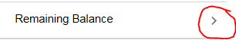
- To edit the information click on the beside the account number; or, remove or delete account information, click the button.

Edit or Change your account information

Update the Routing number, Account Number, Account type, Deposit type or Amount. Your existing account number field will be cleared out and ready for you to enter the new number once you click the .
When changes are completed, click the button, or click the 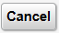button to return to Direct Deposit link to discard your changes.

Review your account information for accuracy.

