Budget Transfers for DRG Funds (BT)

Overview:
Research Initiative Accounts - Funds 183XX: Accounts funded by F&A cost distributions, residuals from fixed-price contracts and grants, and internal awards or start-up commitments.
Convenience Funds – Funds 24XXX (endowed funds) and 94XXX-96XXX (funds associated with USF Foundation, USF Research Foundation, GME House Staff, HPCC, USF Alumni Association, UMSA, and Moffitt). These Funds are set-up to correctly account for reimbursements from DSO’s or for non-project specific salary support of research related activities at USF. These funds are identified as either academic or research related.
During the reconciliation of DRG funds, it may be determined that budget changes are necessary. Accountable officers (AO) and Department Research Administrators (DRA) must understand the specific requirements of their accounts and obtain prior approval for budget changes (if required) through the Office of Research (USFRI) or the DSO.
DRG Fund Budget Transfer Request Form - A USF form required for re-allocating budget code 80000 for another chart field string within the same fund and operating unit.
Budget transfers should be processed when:
- Both chart fields contain the same fund code and operating unit.
- Transfers between different departments and colleges require approval from the Accountable Officers (or designees) from both sides of the request.
Budget transfers should not be processed when:
- Different operating units are involved. Follow the Cash Transfer (ICT) process.
- Different funds are involved – Cash resides at the fund level. Follow ICT process as transfers which involve different funds affect cash.
- Transfer involves E&G funds or Auxiliary funds.
- Transfers from an initiative for a departing PI to the college or department should not be transferred to the Office of Research (790XXX).
- Residuals from USFRI internal awards/grants in funds 18322 thru 18328. These residual funds must be returned to USFRI.

Procedure:
Complete a DRG Fund Budget Transfer form, obtain AO/DRA approvals and submit your request to Service Now via email address Budgettransf@usf.edu. To ensure timely and accurate routing of your Service Now request, please include the “To” and “From” fund numbers as well as the type of request (BT) in the subject line of the request email.
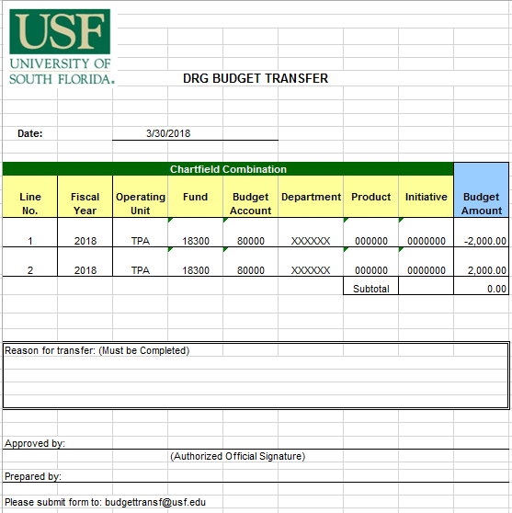

The chart field string that will have an increased RSA should have a positive number and the chart field string that will have a decreased RSA should have a negative number.

Resources:
UCO Glossary of Terminology
General Policy Research Initiative Accounts
General Policy of Departed Faculty Staff RIA
Research Cash Management Page
Journal Entry Template
UCO Training and Resources

Contact:
Please address your comments or questions to Tracy Magnan, Research Cash Management, at tmagnan@usf.edu

