Cash Transfers for DRG Funds (ICT)

Overview:
Research Initiative Accounts -Funds 183XX: Accounts funded by F&A cost distributions, residuals from fixed-price contracts and grants, and internal awards or start-up commitments.
Convenience Funds – Funds 24XXX (endowed funds), 94XXX-96XXX (USF Foundation, USF Research Foundation, GME House Staff, HPCC, Alumni Association, UMSA, and Moffitt). Funds set-up to correctly account for reimbursements from DSO’s or for non-project specific salary support of research related activities at USF. These funds are identified as either academic or research related.
During the reconciliation of DRG funds, it may be determined that cash transfers are necessary. Accountable officers (AO) and Department Research Administrators (DRA) must understand the specific requirements of their accounts and obtain prior approval for budget changes (if required) through the Office of Research (USFRI) or the DSO.
Cash Transfer Form - A USF journal entry form is required for transferring cash from one fund to another. Cash resides at the fund level. The journal mask should be ‘ICT’. On this form, the source chart field string is recorded as an expense (69800) and the receiving chart field is recorded as revenue (49800), both of these figures must equal to zero.
Cash transfers should be processed when:
- Different operating units are involved.
- Different funds are involved.
Cash transfers should not be processed when:
- Both chart fields contain the same fund code and Operating Unit (OU). Follow the budget transfer process.
- Cash transfer involves E&G funds or Auxiliary funds.
- Cash transfers from an initiative for a departing PI to the college or department should not be transferred to the Office of Research (790XXX).
- Residuals from USFRI internal awards/grants in funds 18322 thru 18328. These residual funds must be returned to USFRI.

Procedure:
Procedure:
Complete a Cash Transfer Form, obtain Accountable Officer/Designee approvals and submit your request to Service Now via email address rnsexpt@usf.edu To ensure timely and accurate routing of your Service Now request, please include the “To” and “From” chartfields as well as the type of request (ICT) in the Subject line of the email. The journal entry template may be found on the UCO web site; http://www.usf.edu/business-finance/controller/accounting-reporting/gaforms.aspx . The form document includes the template for submission, a sample illustration, and a justification page.

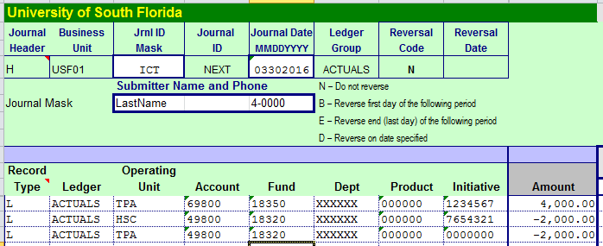

The first line in this example will result in a decrease in the budget of that chart field. The second and third lines will ultimately increase the budgets of those chart fields.
The RSA of the recipient chart field will subsequently be increased by a budget posting, based on the increased revenue, on the next business day following the posting of the cash transfer journal. Recording the expense will reduce the RSA of the donating chart field.

Resources:
UCO Glossary of Terminology
General Policy Research Initiative Accounts
General Policy of Departed Faculty Staff RIA
Research Cash Management Page
Journal Entry Template
UCO Training and Resources

Contact:
Please address your comments or questions to Tracy Magnan, Research Cash Management, at tmagnan@usf.edu

