At the completion of USF business travel, an Expense Report is required to process traveler reimbursements and to obtain required supervisor and expense manager approvals for PCard charges incurred on the trip. This guide will explain the process of submitting an Expense Report (click the arrow to the left of each step to expand each section).

Step I: Creating an Expense Report
To create an Expense Report:
- Log in to my.usf.edu.
- Click Archivum in the Business Systems menu.
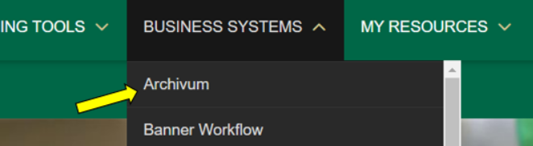
- Click the Travel icon.
- Click Create Expense Report in the My Travel Actions section.
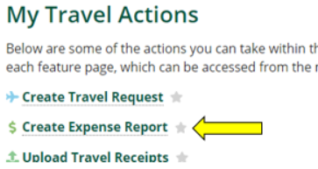
- Select the type of Expense Report:
  - Expense Report from a Travel Request/Post-Travel Authorization
  - Expense Report for Mileage/Incidentals Only
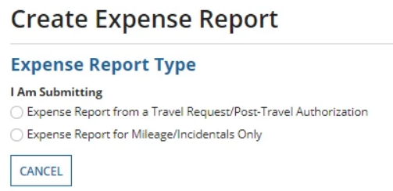
Note: if selecting Expense Report from a Travel Request/Post-Travel Authorization, skip Step 3 of this guide. If selecting Expense Report for Mileage/Incidentals Only, skip Step 2 of this guide.

Step II: Expense Report from a Travel Request/Post-Travel Authorization
- Select the option Expense Report from a Travel Request/Post-Travel Authorization.
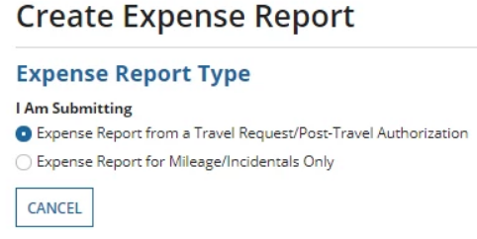
- Click My Trips. If you are submitting an Expense Report on behalf of someone else, click My Travelers’ Trips, then select the traveler you are submitting the Expense Report for.
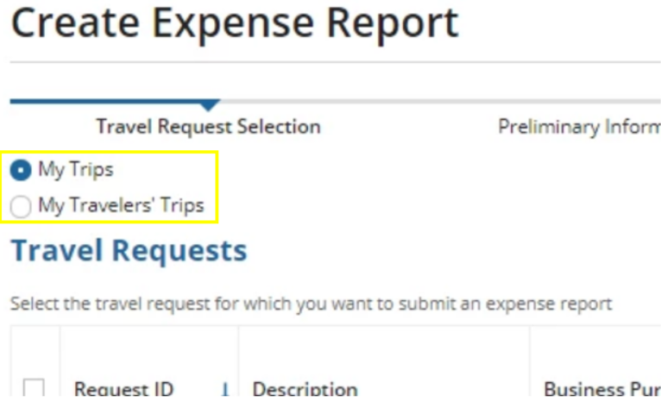
A list of approved Travel Requests for the selected traveler will appear. The Expense Report Status column on the far right will show one of three icons, displaying the status of the Expense Report associated to that particular Travel Request:
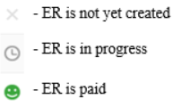
- If an Expense Report has not yet been created for a Travel Request, click the check box on the far left next to the Request ID to select that Travel Request. You will be creating an Expense Report associated to whichever Travel Request is selected.
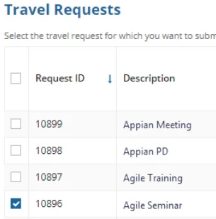
- Click Enter Preliminary Information on the bottom right to continue.
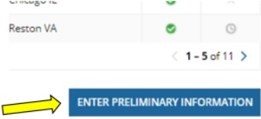
- The Preliminary Information screen pulls information in from the Travel Request. Fill in required information including Headquarters, Point of Origin, Start Time, and End Time. Required fields are marked by an asterisk (*). Hover over the question mark icons next to the required fields for additional information.
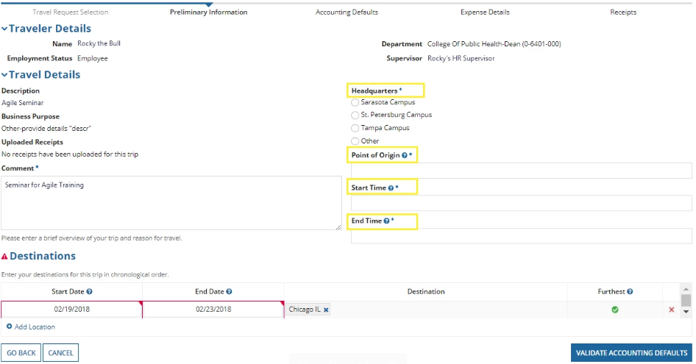
- In the Destinations section, you can edit existing destinations. You can also add additional locations by clicking Add Location, if necessary.
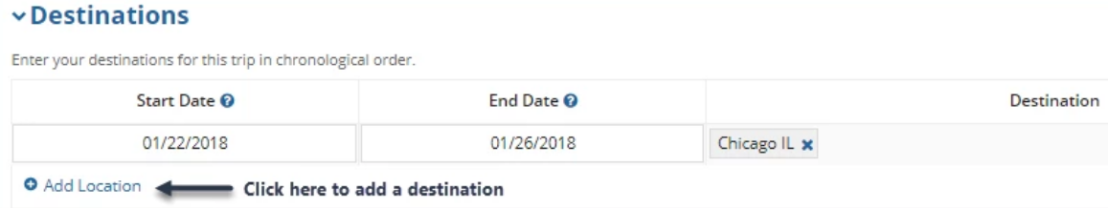
- Click Validate Accounting Defaults to continue.
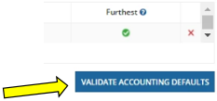
- The Accounting Defaults screen pulls in any chartfield that was entered on the associated Travel Request. You can edit existing chartfields or add additional chartfields if necessary.
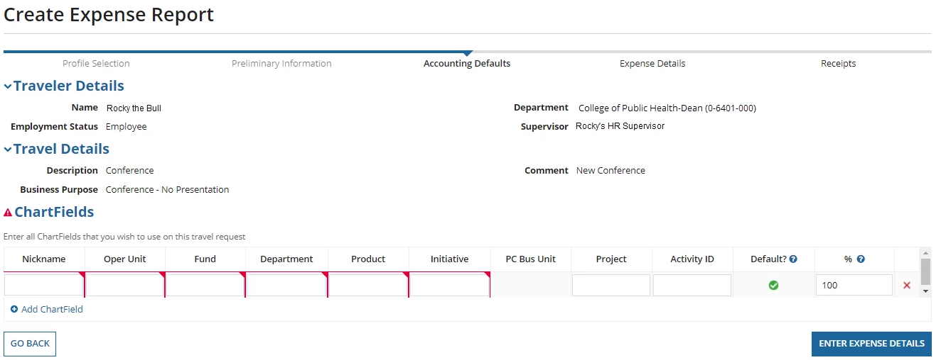
- Once the chartfield section is completed, click Enter Expense Details.
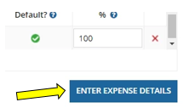

Step III: Expense Report for Mileage/Incidentals Only
- Select the option Expense Report for Mileage/Incidentals Only.
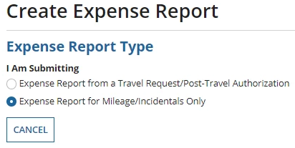
- Click Myself. If you are submitting an Expense Report on behalf of someone else, click My Travelers, then select the traveler you are submitting the Expense Report for.
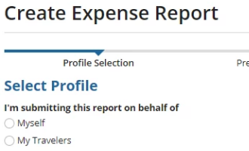
- If the check box on the far left next to Department ID is not selected for a traveler or if you have multiple options, click the appropriate check box to select the traveler’s profile.
- Check to make sure the correct supervisor is listed and then click Next. If the supervisor listed is incorrect, the supervisor for employee travelers should be updated with HR and the supervisor for non-employee travelers should be updated by submitting a new Non-Employee Profile Creation Request with the updated supervisor to the Travel Help Desk. The Non-Employee Profile Creation Request is available on the Travel website, under Travel Forms.
- On the Preliminary Information screen, fill in required information including travel details and destinations. Required fields are marked by an asterisk (*). Hover over the question mark icons next to the required fields for additional information.
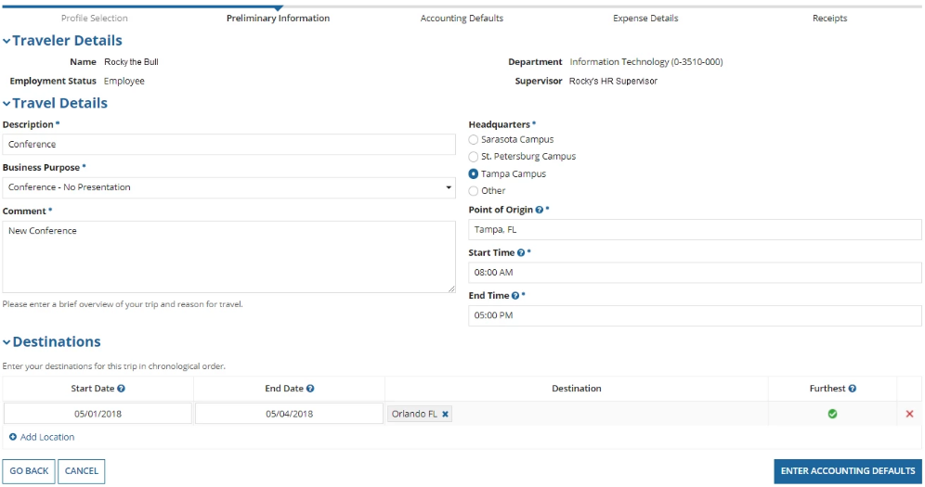
- Click Enter Accounting Defaults to continue.
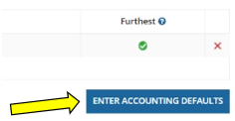
- The Accounting Defaults screen pulls in any chartfield information that is entered in the traveler’s default chartfield on their FAST profile. You can edit the existing chartfield or add additional chartfields if necessary.
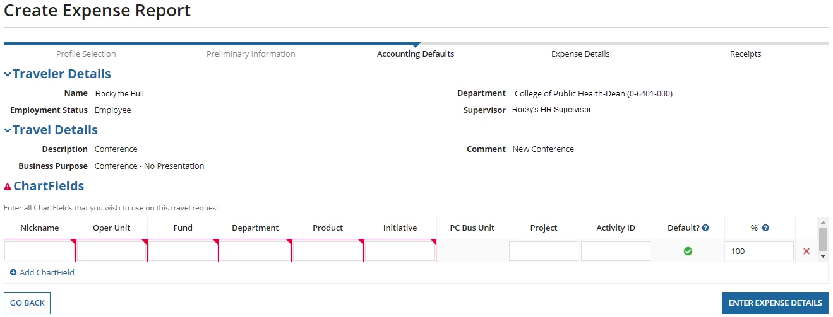
- Once the chartfield section is completed, click Enter Expense Details.

Step IV: Adding or Editing Expenses
To Add an expense:
- Click the Add New Expense(s) link.
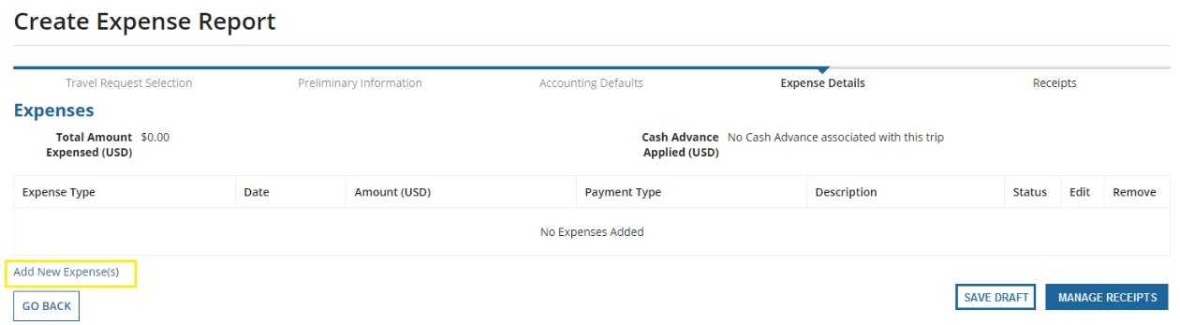
- Select Expense Type from the dropdown menu. Note – different expense types will appear depending on if the Expense Report is for Mileage/Incidentals Only OR an Expense Report from a Travel Request/Post-Travel Authorization.
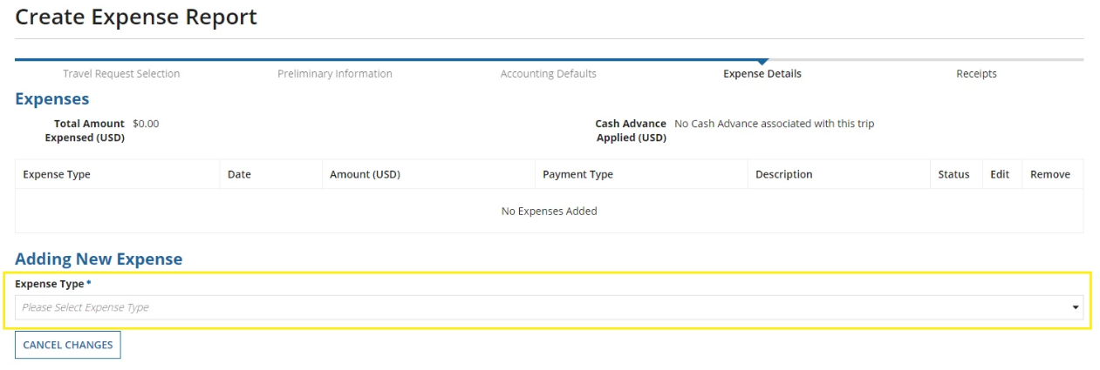
- Fill in the expense details, then click Save Expense. Note – depending on the expense type, the required details will change. Be prepared to provide the date, amount spent and payment method used in addition to other inquiries. If this was paid with a personal card, the last 4 digits of the card number will be needed.
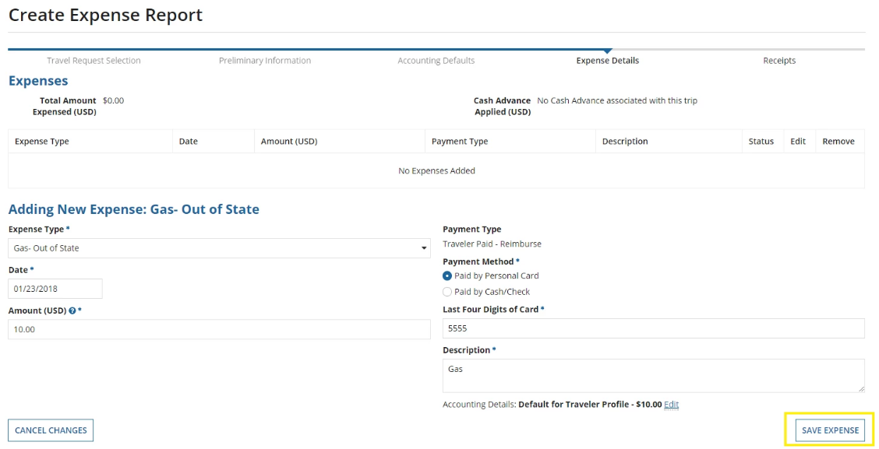

To Edit existing expenses:
- If creating an Expense Report from a Travel Request, anticipated expenses entered on the Travel Request will appear here. PCard charges associated to the Travel Request in FAST will also appear. A red status symbol means more information is required for that expense.
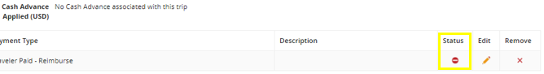
- Click the pencil icon next to the status symbol to edit the expense.
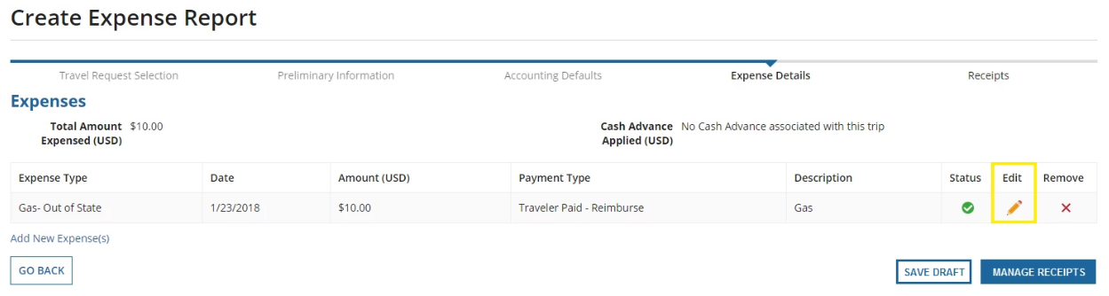
- Fill in the expense details, then click Save Expense. To change chartfield distribution amounts for an expense, click Edit next to Accounting Details in the bottom right.
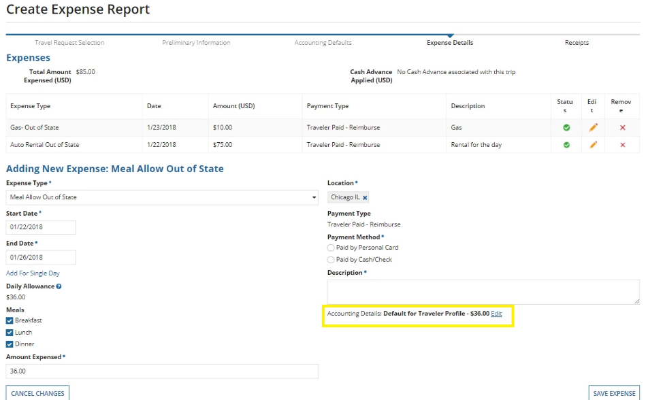

After adding and/or editing expenses, confirm all expenses have a green status icon. You will not be able to submit the Expense Report if any expense displays a red status icon; they must all be green.
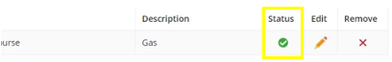
Then, click Manage Receipts.
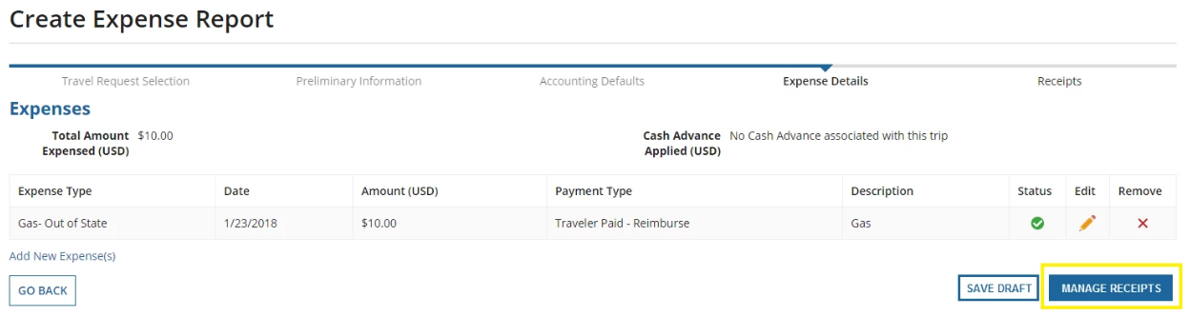

Step V: Uploading Receipts
Accompanying receipts are required for all items claimed as expenses on an Expense Report. Compile all receipts into a single PDF file to be uploaded in this section. For assistance with creating a receipt package, refer to the Expense Report Receipt Package guide on the Travel Training page of the Travel website.
To Manage Receipts:
- Click Upload.
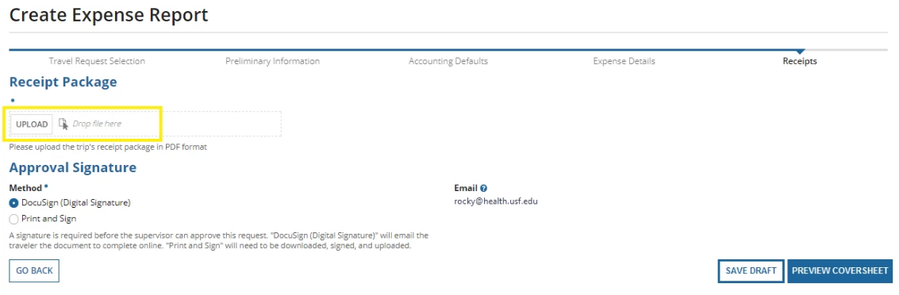
- Find and select your saved receipt package PDF file.
- Confirm the file has been uploaded. The system should list the name of the file and the file size when the upload is complete. Note – under Approval Signature, the DocuSign (Digital Signature) option will no longer appear if your receipt package file exceeds 17MB.
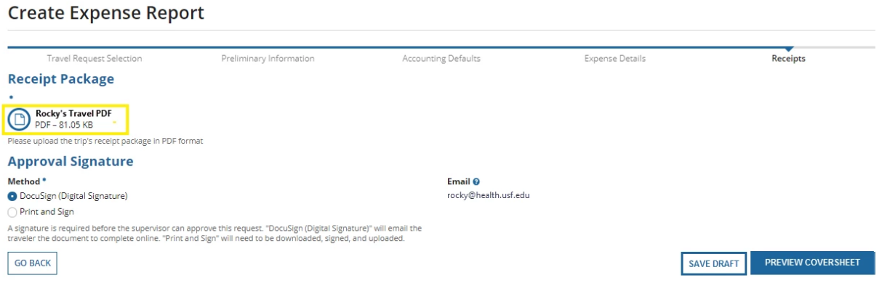

Step VI: Signing the Coversheet
Traveler signature is required before a supervisor can approve the Expense Report. You may select one of two methods for approval signature.
- Selecting DocuSign will email the traveler the document to complete online. DocuSign is only available for USF employees and students, and requires a USF NetID and Password to sign in.
- Print and Sign can be used by anyone, but is the only option for non-USF travelers. This is also the only option available if your receipt package exceeds 17MB.
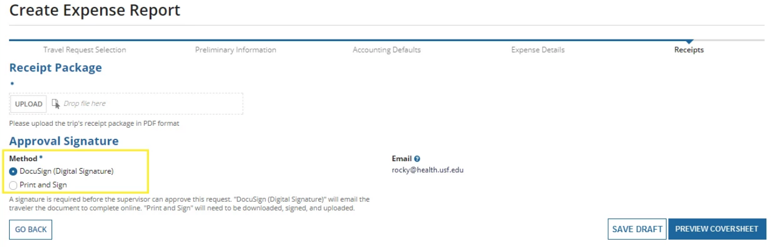
Signing with DocuSign:
- Select DocuSign (Digital Signature).
- Click Preview Coversheet.
- Download and review the coversheet by clicking the file link under Download Document.
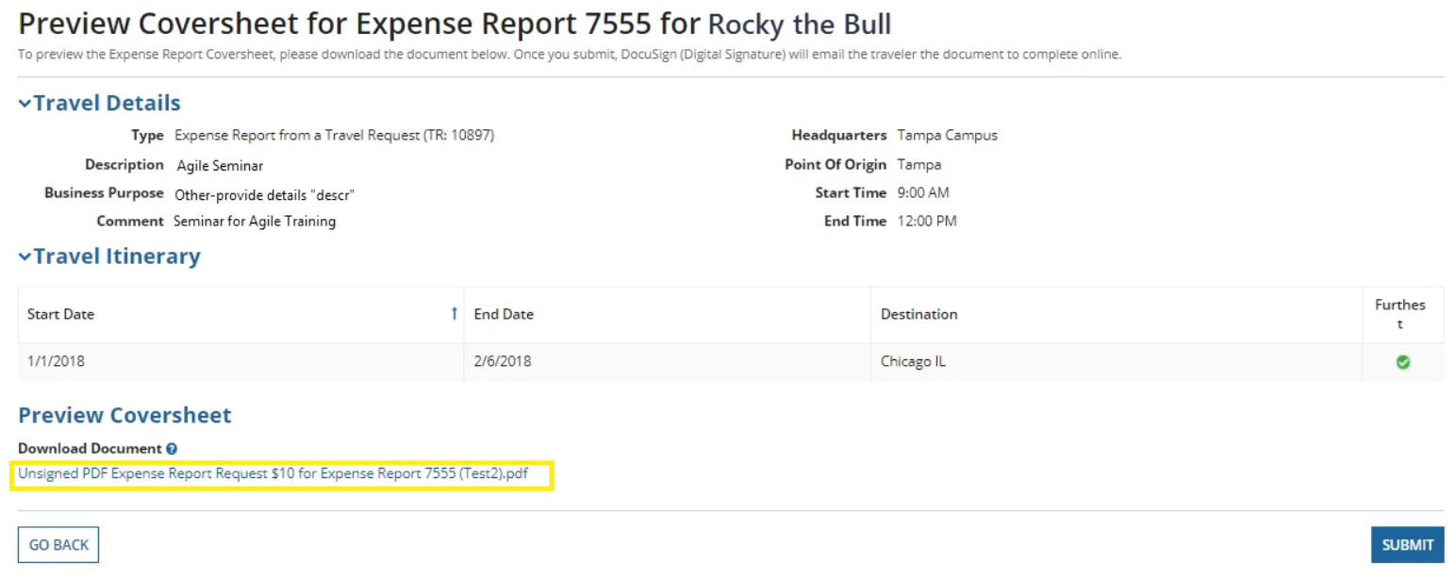
- Review the downloaded coversheet. If there are no issues with the required information, click Submit.
- A message appears asking if you are sure you are ready to submit the Expense Report. Click Yes.
- An email will be sent to the traveler’s official USF email address notifying them that they will need to review and sign the document. The traveler can review the document by clicking Review Document in this email, or by logging into DocuSign directly.
- The traveler can then sign the document. If a traveler does not agree to information contained on the coversheet, they may decline to sign, which will send the Expense Report back to the submitter to correct.
  - For more information on how to sign or send back a document in DocuSign, review the Instructions to DocuSign in Archivum Travel guide and the DocuSign section of the Frequently Asked Questions document; both of these documents are available on the Travel Training page of the Travel website.
Note - It may take up to 35 minutes after DocuSign signature for the request to show up as signed in Archivum. To check the status of the signature process, or the status of the overall Expense Report, go to the “Expense Reports” section of Archivum Travel, locate the Expense Report, and view the Request History; you may review these steps in the section of this guide titled “Step VII: Monitoring Expense Report Status.”

Signing with Print and Sign:
- Select Print and Sign.
- Download the unsigned Approval Document by clicking the file link under Download Approval Document.
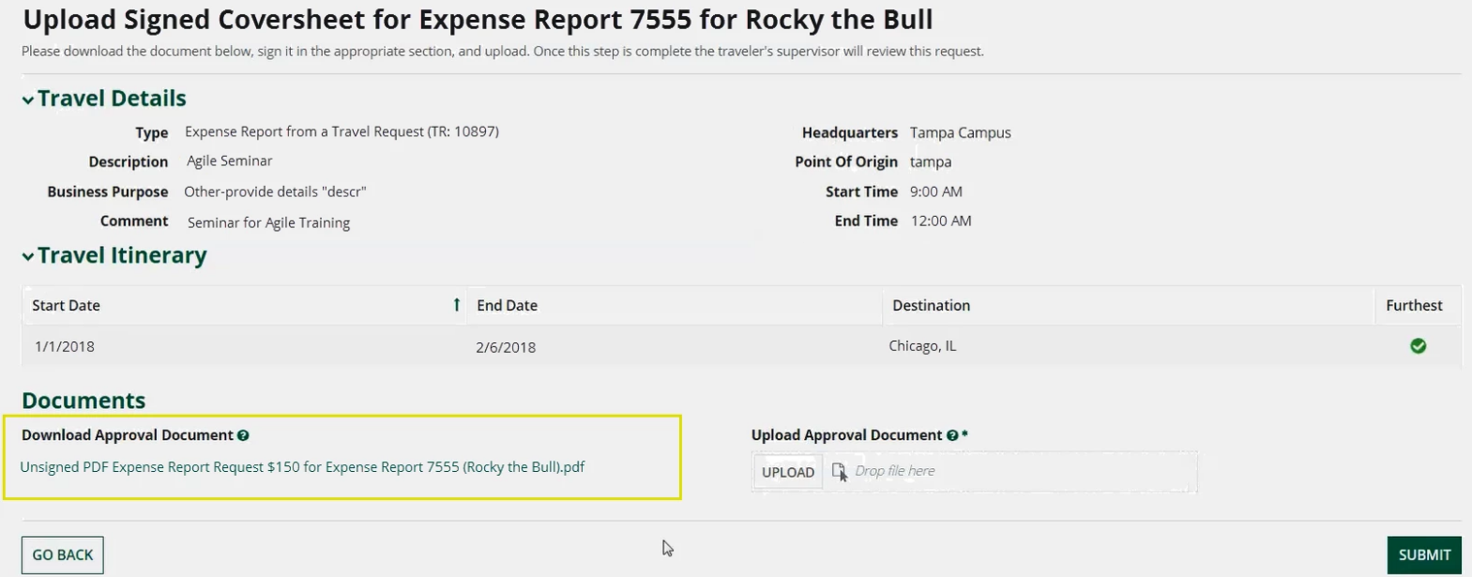
- Print the unsigned Approval Document for the traveler to sign.
- Once the traveler has signed, scan the signed document.
- Return to Archivum and upload the signed document by clicking Upload under Upload Approval Document and selecting the signed document.
- Once the signed document has been uploaded, click Submit.

Step VII: Monitoring Expense Report Status
After submitting an Expense Report, you will be redirected to Archivum Travel. It is the responsibility of the submitter to monitor the status of Travel transactions they have created, and to follow-up with supervisors/fiscal approvers when necessary to ensure the timely completion of these transactions. The status of an Expense Report can be monitored in Archivum Travel.
Travel reports in Power BI, including the “Travel - Pending Status Expense Reports” report, can also be used to monitor details of Expense Reports submitted in Archivum, such as current status of the ER and days since last action by a user. For more information on navigating Travel reports in Power BI, please refer to the Quick Start Guide to Archivum Travel Reports, and User Guide to Archivum Travel Reports, both available on the Travel Training page of the Travel website.
To monitor the status of an Expense Report in Archivum:
- Open Archivum, then click Travel.
- On the left-hand side of the page, click the Expense Reports icon.
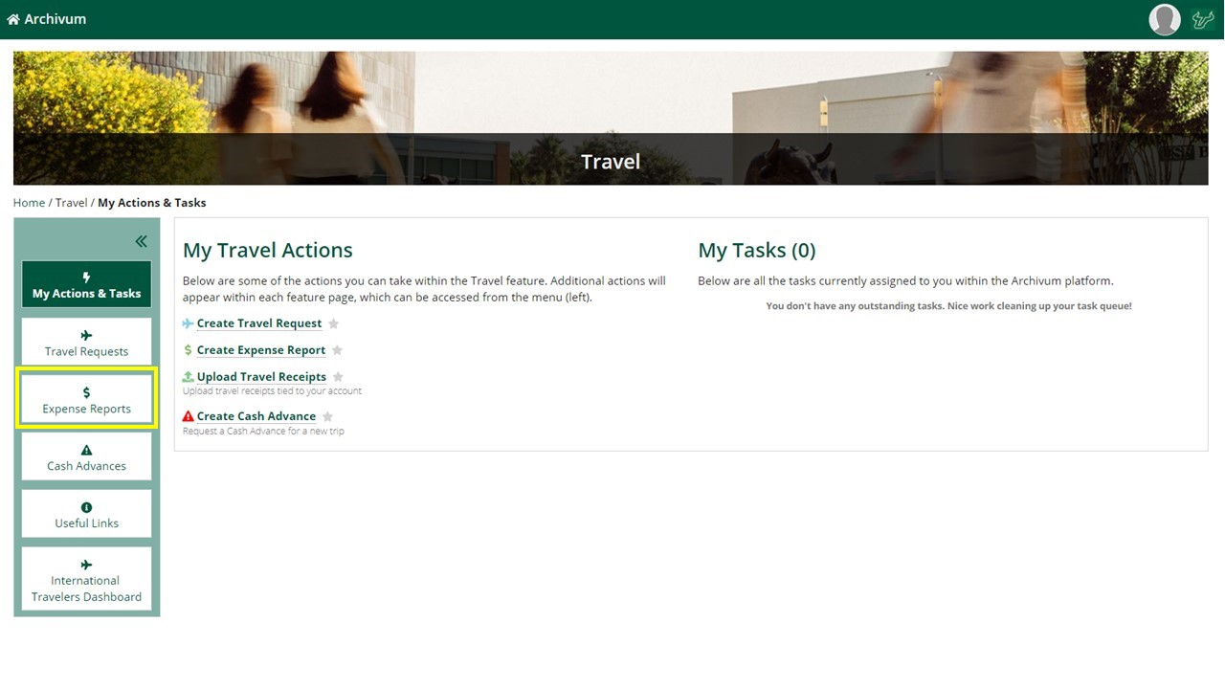
- Click My Trips if you are viewing an Expense Report you have submitted for yourself. Click My Travelers’ Trips if you are viewing an Expense Report you submitted on behalf of someone else. Then, use the search feature to find the Expense Report.
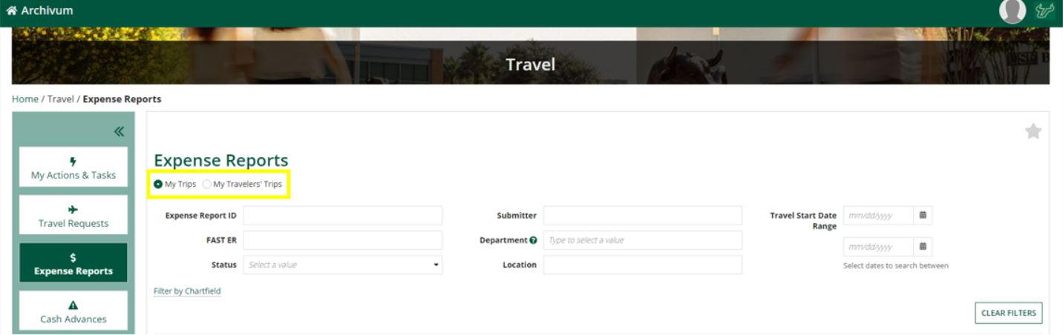
- Once you find the Expense Report you want to view, click More Info and scroll down to see ER details, any pending tasks and its assignee(s), and the history of the request.
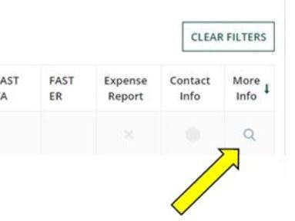

To log out of Archivum:
- Click the profile icon on the top right hand of the screen.
- Click Sign Out.

