Instructions for Electronic Submission of RETs
(Retroactive Payroll Expenditure Transfers)
Revised 02/2020

Content:

Preparing a RET
Adding query results to the RET Instructions sheet
Submitting a RET
Determining the status of the RET
Searching the Service Now system for the status of a RET not yet entered into GEMS
Reviewing RET status and transaction detail
Query to view final results in GEMS Actuals

Preparing a RET

Go to the payroll website: https://www.usf.edu/payroll click on Payroll Forms then click on Retroactive Expenditure Transfer

Instructions are provided in the top right hand corner of the RET Instructions sheet.
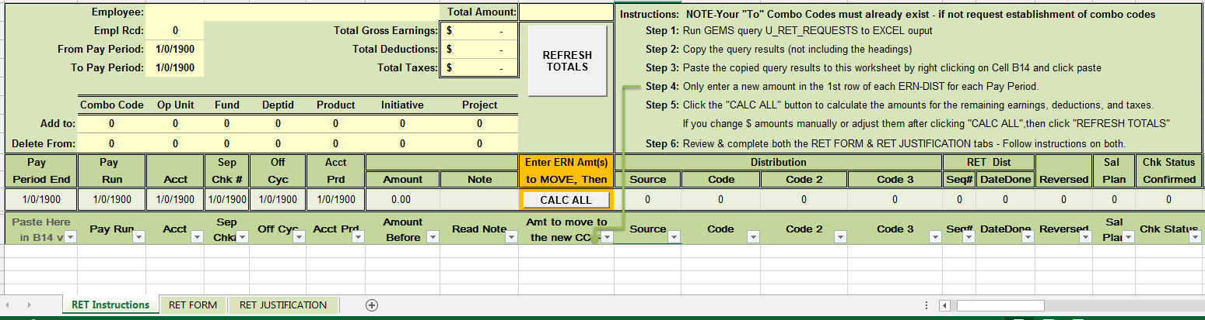

Adding query results to the RET Instructions sheet

Open GEMS. Query Manager is located on the USF GEMS User page in the Reporting Tile
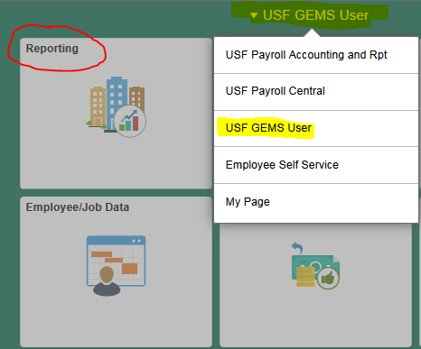
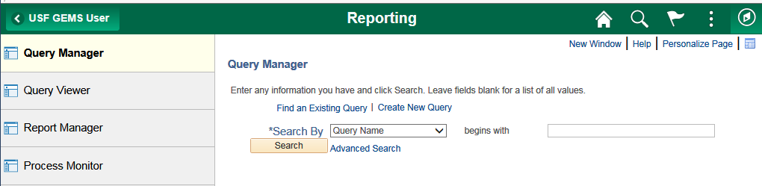

You can also use the left Navigator bar and navigate to the Query Manager.

Click on Navigator, then Reporting Tools, then Query, then Query Manager.

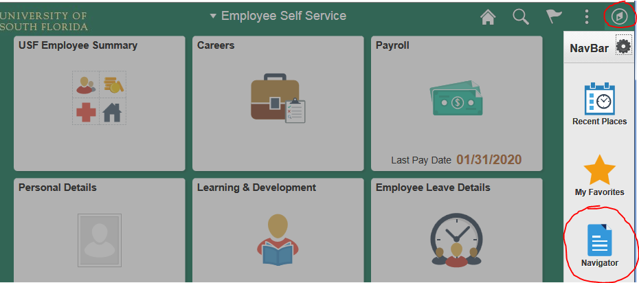

Search for the query U_RET_REQUESTS
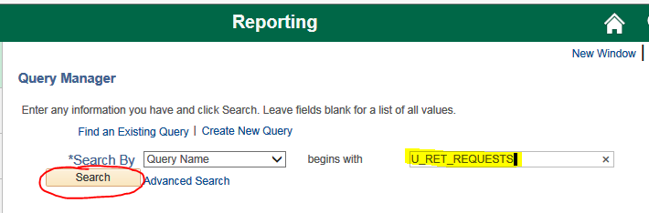

Click on Excel

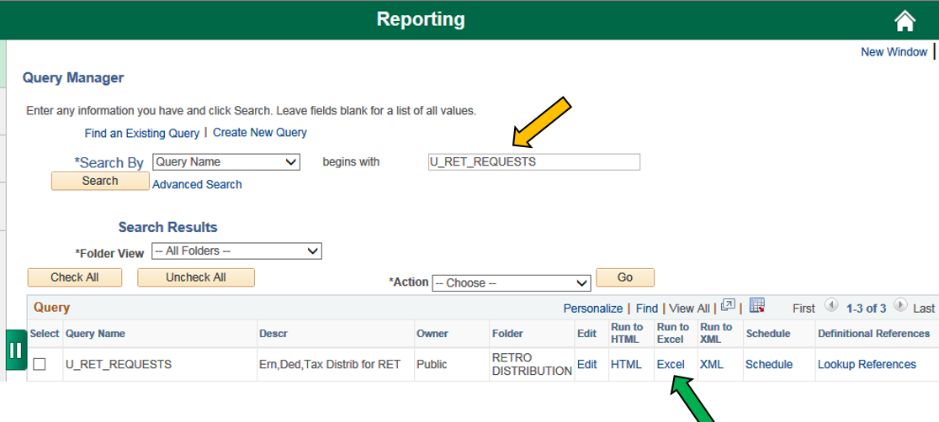

It will open the following page:

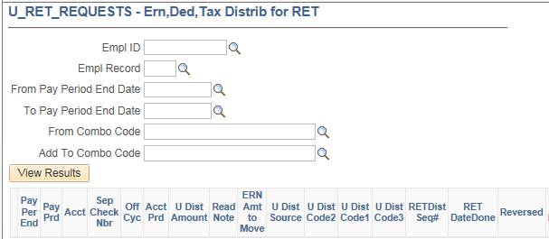

Enter the criteria for the transaction(s) you want to move.

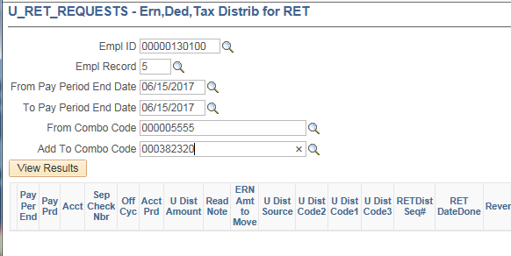

**Please note, if your request spans multiple pay periods you may need to split the pay periods and run multiple queries. (Example: If you request data from p/e 07/14/16 through p/e 06/29/17, the system may time out and not produce results. You would need to run multiple queries with 3 to 5 pay periods in each query. It is recommended that you place all of the results from the multiple queries on one of your Query results spreadsheet prior to pasting onto the RET form.

Once you have entered your criteria, click on the View Results button.
When the query is complete click Open to open the spreadsheet.

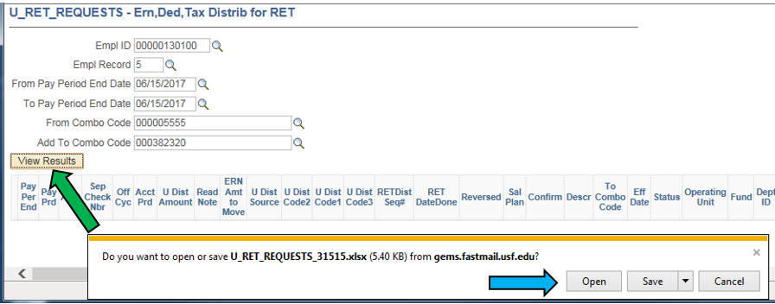

**IMPORTANT ** If the results are all positive amounts DO NOT DELETE/MANIPULATE any of the results in the query. This could cause the RET to process incorrectly. The only data that should be changed on the RET Form is the Amt to Move column (I).

If there are negative results on the query this means that previous RETs have been processed for this employee in the same “Delete From” chartfields. Click here for instructions on how to clean the query data for accurate processing.

This example is using standard query results (without negatives)

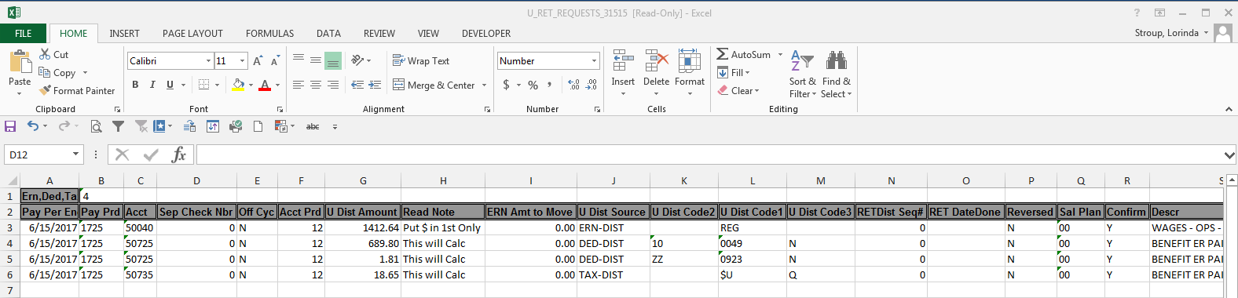

Click in cell A3 and press Ctrl + Shift + End to select the data.

Copy the selected data (Ctrl key + C).

Open the RET Template and click on the Cell B14 and paste the data (Ctrl +V) **If you cut and paste it may cause issues with the form.

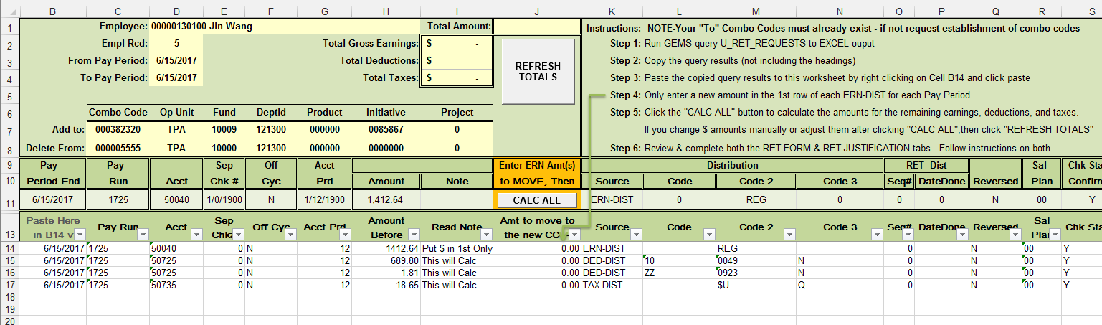

Scroll to the right in the spreadsheet until you get to the “Amount to Move” column (column J). Only enter a new amount in the 1st row of each ERN-DIST for each Pay Period. This is the only column you should be changing data.
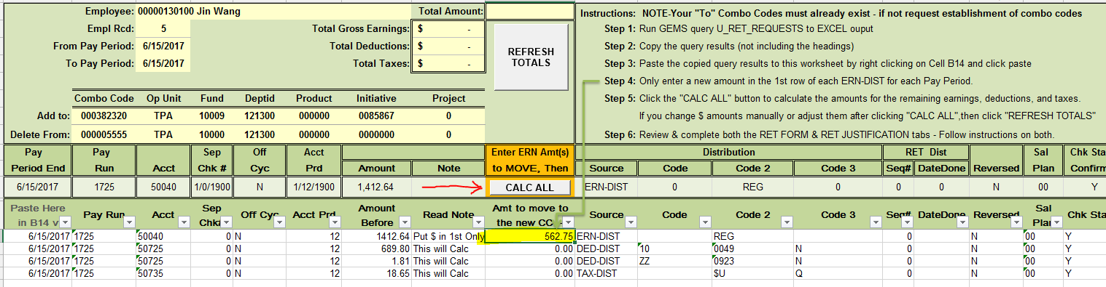
Click the "CALC ALL" button to calculate the amounts for the remaining earnings, deductions, and taxes.

You can now see the amount of deduction and taxes as well as the total amount that will be moved to the new chartfield.
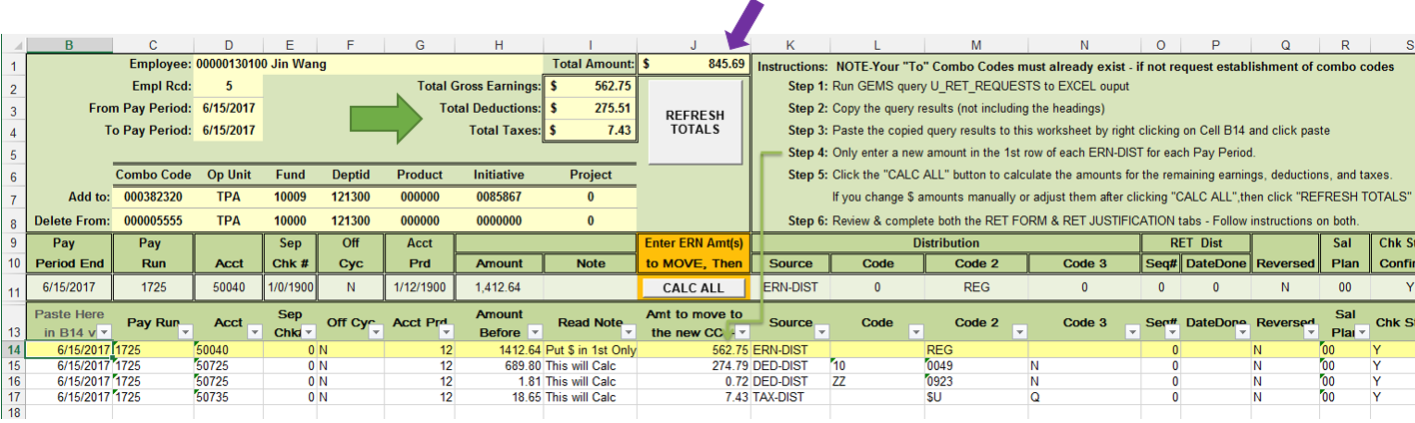
If you have multiple ERN-DIST lines, the spreadsheet allocates using percentages of earnings.

Please contact Payroll Accounting if you are having any issues with the RET form or query results. The email is UCO_Payroll_Accounting@usf.edu

Review & complete both the RET FORM & RET JUSTIFICATION tabs - Follow instructions on both.

Submitting a RET

Prepare an email to submit the RET request as follows:

- The subject line of the email must include:
[Emplid] [Last Name] from [Projectid] [Fund] to [Projectid] [Fund] [p/e date MMDDYY]-[p/e date MMDDYY]

Examples:
58598 Panzarino from 94304 to 6119139601 21000 062917

39510 Wolfe from 94004 to 94990 062719

14062 Ryan from 2500164601 20000 to 2500164602 20000 051817-062917

111359 Romero from 94586 to 6122102200 20000 051817-062917

The first two cover one pay period – the last two span multiple pay periods.
- The email should:

  - Have the appropriate subject line shown above. Auditors search Service Now for RETs using this subject line format.
  - Include a properly completed RET form attached to the email.
  - Be sent directly from an authorized signatory (Accountable Officer, Accountable Officer Designee, Principle Investigator or Requisition Manager) or have a separate PDF attached with Authorized Signatures. If a signature approval is used it MUST be an authentic signature or the form can be electronically signed using Docusign. Payroll will not accept signature stamps or digital images of a signature.

- Sponsored Award-related RETs are to be submitted to Research Financial Management (RFM) by email to: RFMRETNotify@admin.usf.edu.
Related RETs include all requests that involve deleting from or adding to a project or include funds 183XX, 20XXX – 24XXX and 94XXX – 96XXX

- Non-grant related RETs are to be submitted to University Payroll by email to: UPRRETNotify@usf.edu

All emails to the addresses for RETs will create a unique incident. Please do not send an initial email to the email addresses for a RET that does not contain the completed RET form, it will not be accepted. If you need to make an initial communication with Payroll or RFM, please contact the appropriate Payroll representative or RFM Grants Financial Administrator outside of the system.

***Please note: If your RET is emailed to the incorrect address, the approval process will be delayed.***
Once a RET is sent to one of the email addresses listed above, the sender will receive an automated response from Service Now. The email response will include a UCO Request Incident Number. This email should be saved!

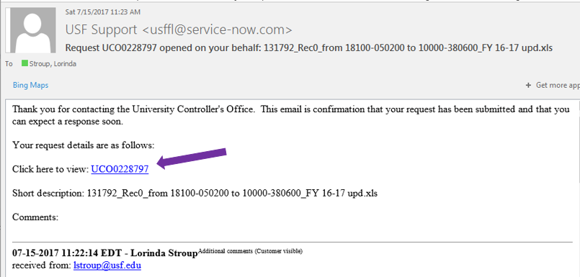

NOTE: If for any reason, you need to send additional information, the system allows you the ability to update an incident by clicking on the UCO Ticket Number provided in the email notification you received when originally submitting your request.

Determining the status of the RET

Service Now is used to track the RET from the time it is submitted until the time it is marked resolved.

The UCO Ticket number is needed to search the system to retrieve the current status. However, each time a comment is added to the RET or when it is marked Resolved, a notification email of the RET status is sent to the original sender and to those placed on the watch list in the ticket.

States of status in Service Now:
- New: The RET has been received but has not been assigned to anyone.
- Active:
- Active (substate-Updated): New information has been added either by the department or RFM staff.
- Pending (no substate):
- Pending (substate-Customer Response): There is a question or issue with the RET that needs clarification.
- Pending (substate-Review): There are certain RETS that require additional approval. The RET will be in this state until approval is received.
- In progress Pending (substate-Future work): There is another RET involved that needs to be completed prior to this one or the RET is being held due to fiscal year end closing.
- Resolved: The RET has either been denied, failed budget check, received no response when needed or has been approved and entered into GEMS. You will receive a notification email from the Service Now system when a ticket has been resolved. A GEMS Run Ctrl ID will be noted in the comment section of the ticket when the RET has processed in GEMS. If you update a resolved ticket with information that was previously requested, it is important to Reopen the UCO Request.

If you do not reopen the request it will go into Closed status and cannot be re-opened at that point.
- Closed: Occurs after the RET is Resolved. It takes three days for the status to change from “Resolved” to “Closed”. No changes can be made to the incident after an Incident is in the “Closed” status.

Searching Service Now for the status of a RET

The easiest and fastest way to check the status of a RET is to look up the incident in Service Now. There are two ways to this. The first is to simply click the link in the email response from Service Now.

Clicking the link will automatically open Service Now directly to the Incident where you will be able to see the status of the RET as well as any comments associated with the incident.

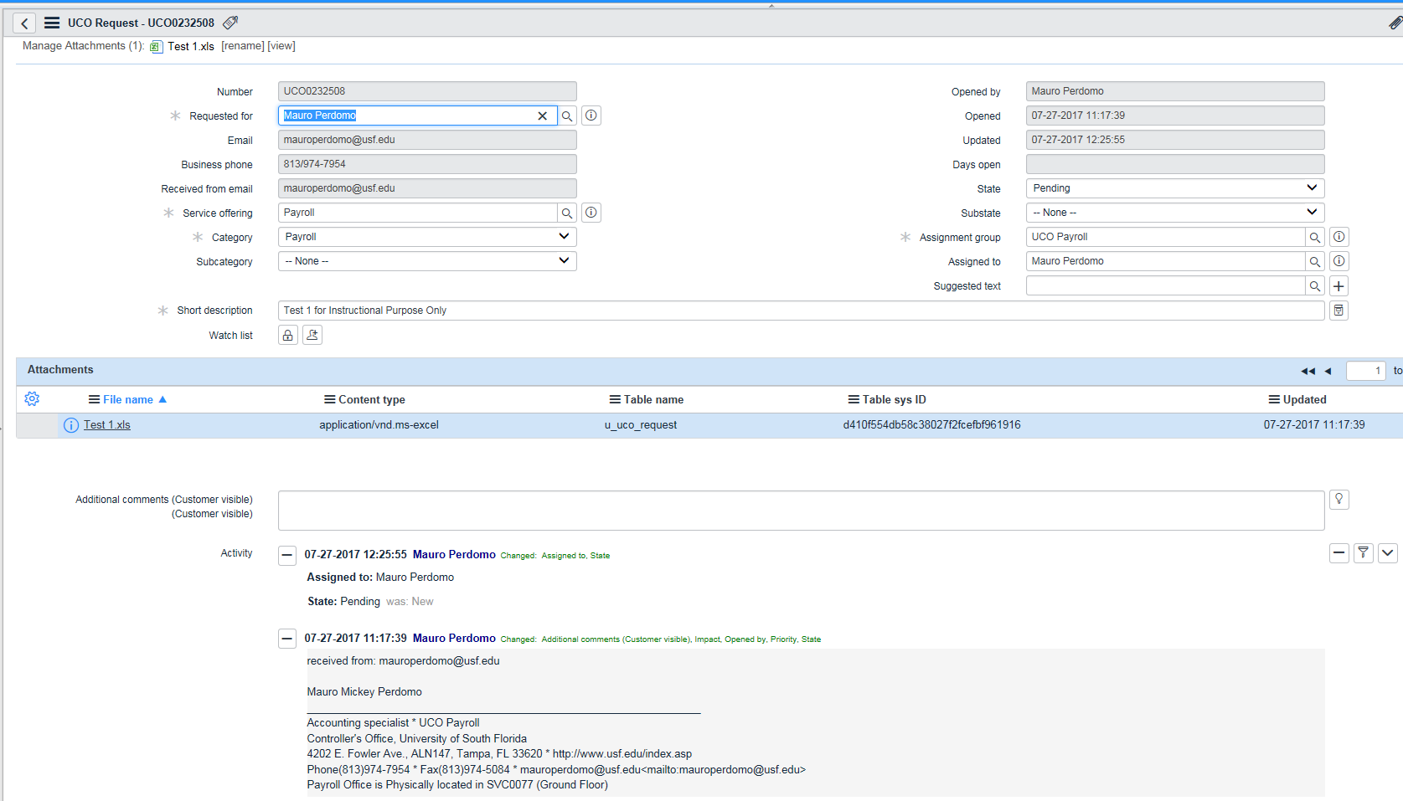

The second way is to log into Service Now and find the Self-Service and click the “My UCO Requests” link:
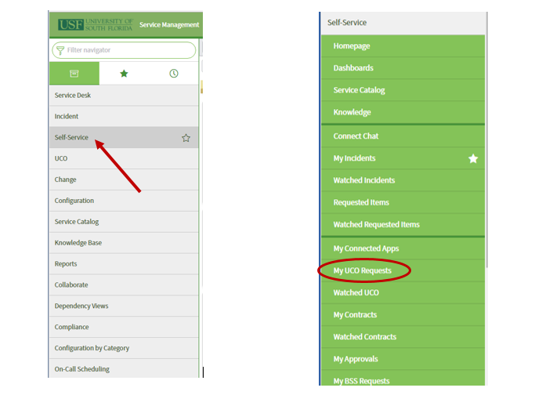

This will open a list of all the UCO Requests you have sent to UPRRETNotify@admin.usf.edu or RFMRETNotify@admin.usf.edu.

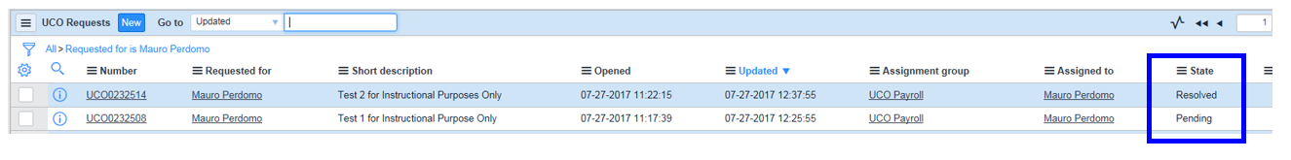
You will also be able to see all the incidents you have requested as well as the status of the incident. If you need more information on the incident simply click on the incident number and it will open the incident.

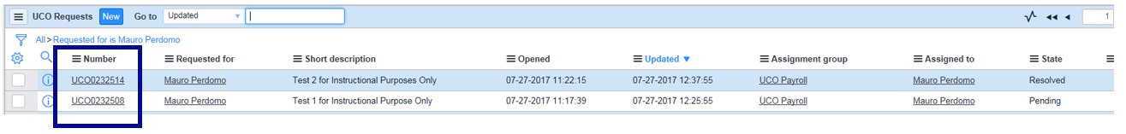

It takes three days for the status to change from “Resolved” to “Closed”. During these three days the Incident can be re-opened if the Incident was closed in error or was not resolved correctly. Remember that no changes can be made to the incident after an Incident is in the “Closed” status.

Reviewing RET status and transaction detail
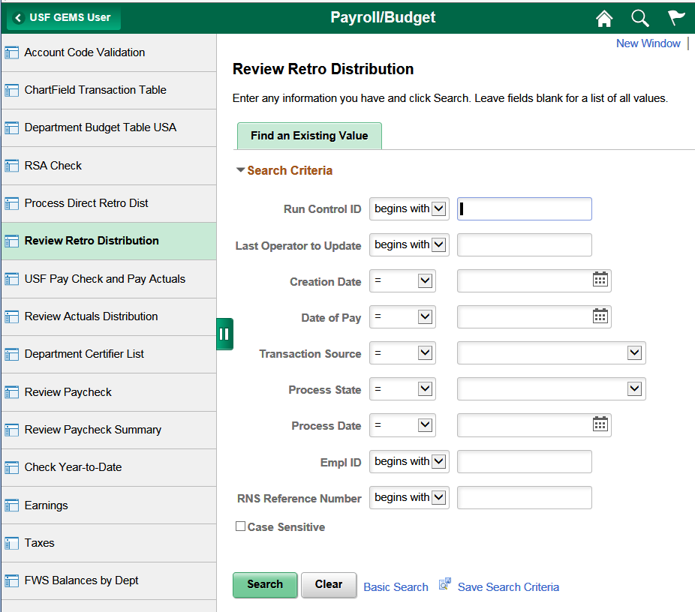
Open GEMS. Review Retro Distribution is located on the USF GEMS User page in the Payroll/Budget tile

You can also use the left Navigator bar and navigate to Review Retro Distribution.

Click on Navigator, Payroll for North America > Payroll Distribution > Commitment Accounting USA > Review Retro distribution

You can search by Employee ID, RNS Reference Number (UCOXXXXXXX) or Run Control ID #

Searching by Employee ID may produce multiple results. You can select the appropriate RNS/UCO number.

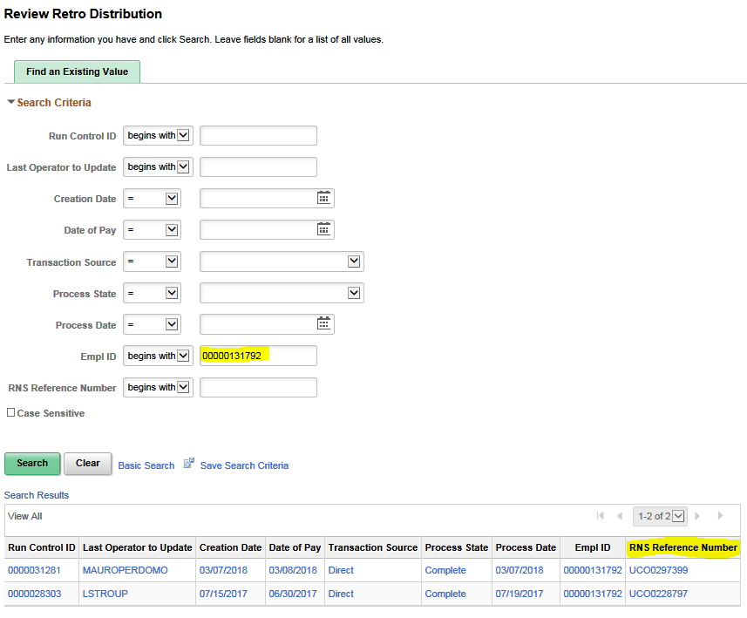

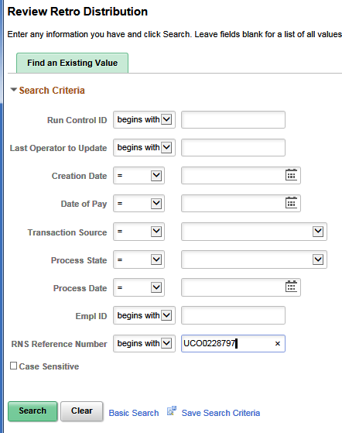
This is by RNS Reference Number (UCOXXXXXXX)

This is the result:

There are separate tabs for Earnings, Deductions and Taxes.
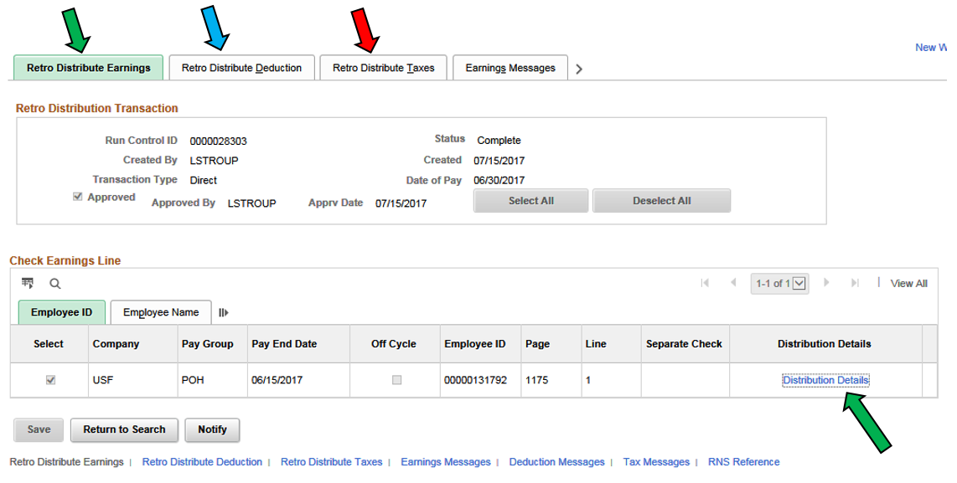

If you click on Distribution Details you get the following information

New Data is the “new” chartfield where the amounts have been moved to.

Old Data is the “old” chartfield where the charges were deleted from.

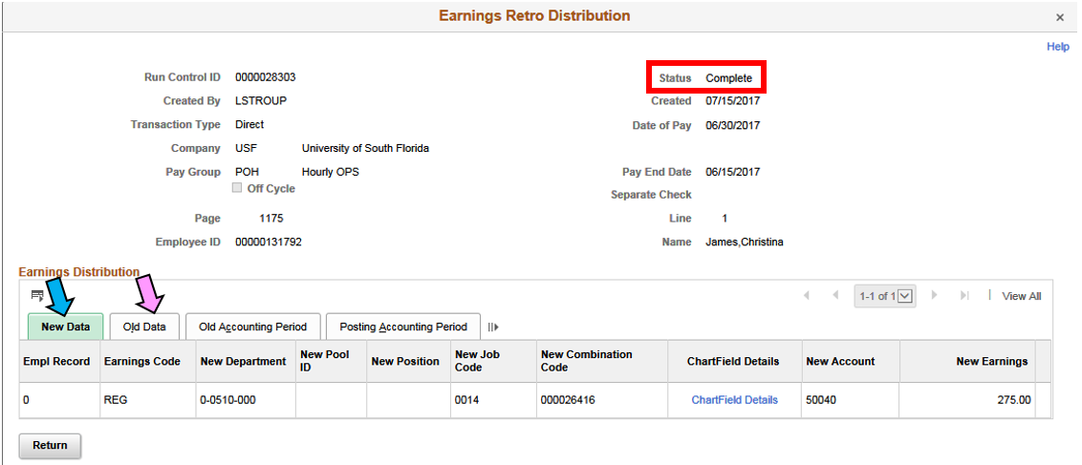

Here you will be able to review the transaction detail as well as the Status of the RET in GEMS

States include:
Initiated – Entered
Editing – Awaiting RET batch processing
Locked – In process
Passed Budget Checking – Ready for posting to FAST
Failed Budget Check (FailBdgChk) – Failed Budget checking – RET will be deleted from GEMS.
Complete – Posted in FAST and GEMS payroll actuals

Query to view final results in GEMS Actuals

After a RET has been processed (Complete) you can run the following query to verify the chartfields and amounts.

U_RET_REQ_DEL_CHRGS_FROM_ALL

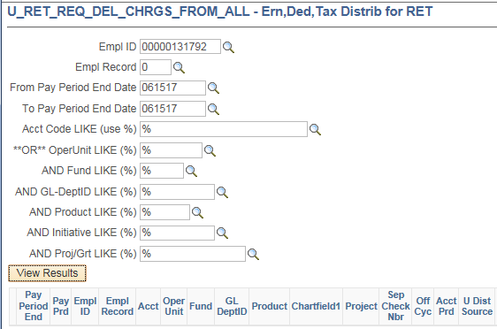

(Some of the columns have been hidden to be able to screenshot the details of the report.)

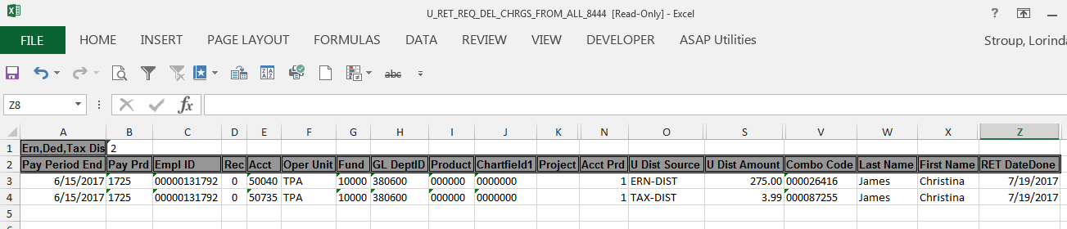

Cleaning data on U_RET_REQUEST queries with negative amounts.

It is common to have to complete multiple RETs for one employee when wages in the same pay period need to be allocated to multiple projects/chartfields. Cleaning the data helps clarify what is actually available to move.

When RETs have already been processed column O (RET DateDone) will have a date and column N (RETDist Seq#) will have numbers other than 0.

This is a U_RET_REQUEST query with negative amounts.

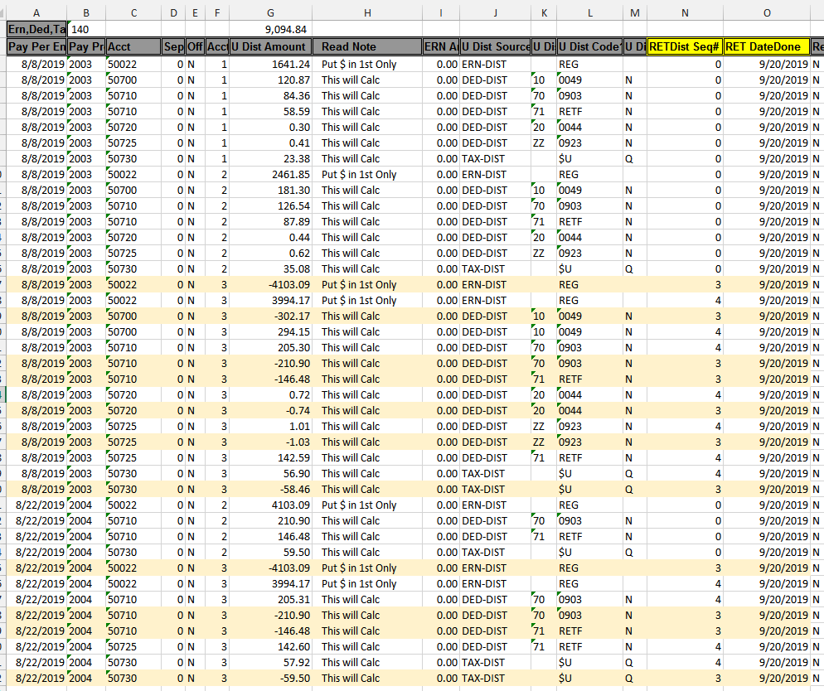

You should total the amount of Column G at the top to ensure you arrive at the same amount after cleaning the data.
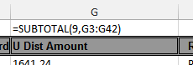
I use the subtotal formula.
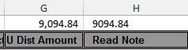

Copy and paste that value in Column H to provide a control total.

Using the RETDist Seq# is the easiest way to filter out the positives and negatives that cancel (0.00) each other out.

In this case Seq# 0 and Seq# 3 cancel each other out. If I filter to just show me 0 and 3 in column N. Notice the subtotal at the top of column G is zero. These are the rows that can be deleted.

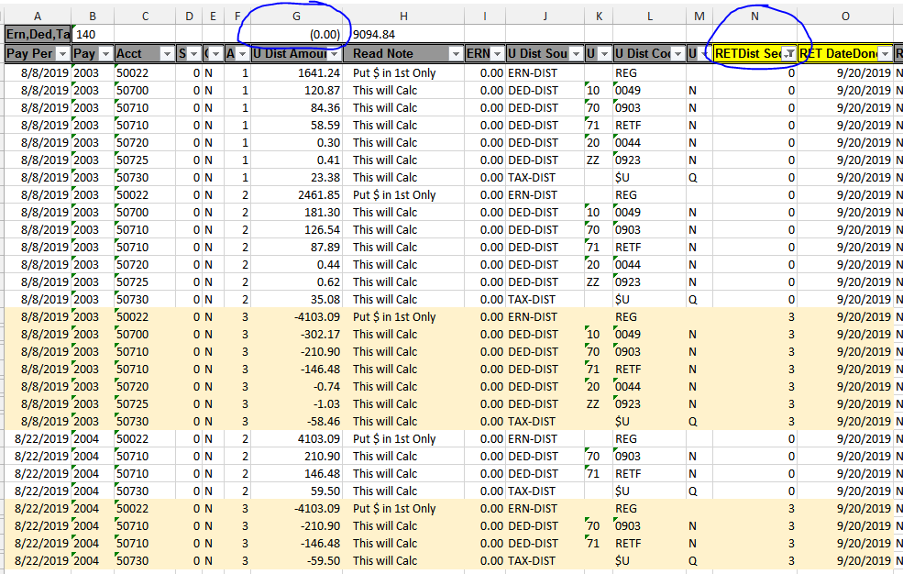

Also, if you filter column N to just show you Seq# 4 you get this result.
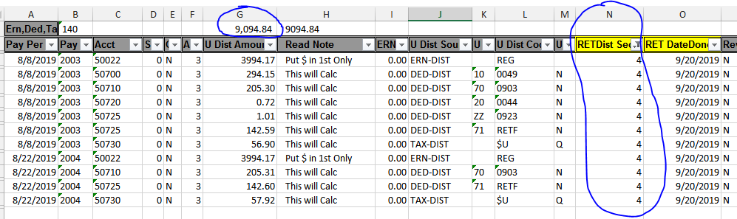

This is the data that needs to be copied onto the RET Form.

The goal is to remove the positives and negatives that zero each other out in each pay period/accounting period. This provides the actual amounts available to move.

The Sequence numbers will vary depending on the number of RETs processed on the employee/pay period/chartfields. If you need help defining the data that should go on the RET form, please contact Payroll Accounting so we can assist you. The email is UCO_Payroll_Accounting@usf.edu

