**USF343HUCO - PAYROLL BUSINESS PROCEDURES**

**ONLINE PAYROLL CERTIFICATIONS (CERTS)**

|  |  |  |  |
| --- | --- | --- | --- |
| **Process Owner:** | University Payroll | **Date Revised:** | 5/20/20 |
|  |  |  |  |

PURPOSE

The purpose of this procedure is to provide instructions on how to submit hours to be paid for a department’s employees each pay period using the University’s online Payroll Certification tool.

SCOPE

This process is initiated in UCO Payroll and resides in a web-based application accessible via MYUSF to those individuals who have been granted access to their specific departments.

USF Payroll is committed to ensuring all employees are paid accurately, timely and in accordance with all University, State and Federal policies, procedures and regulations. Additionally, USF Payroll is responsible for the reporting and compliance for employee benefits, tax and payroll deductions, as well as ensuring that payroll transactions are properly recorded in the University's accounting system.

UNIQUE TERMS/DEFINITIONS

CERTS – the online Payroll Certification application, also the individual certification records for each employee

MINI-CERTS – a process that brings in changes made on Job Data in GEMS between the time the original CERTS were created and when this process is run, done on day before online certifications are due.

PAY PERIOD – the pay period defined on the Bi-Weekly Processing Schedule

PAY PERIOD BEGIN DATE – the first day of the pay period, always a Friday

PAY PERIOD END DATE – the last/final day of the pay period, always a Thursday

ACCELERATED PAY PERIOD –In pay periods where there is a holiday, payroll may be processed on an accelerated schedule and the normal CERTS deadlines must be moved forward to compensate for the shorter processing time.

PCAF – Payroll Certification Adjustment Form, used to process payroll requests once CERTS has closed

PREPARER – the person who enters hours to be paid and submits them for approval

CERTIFIER – the person who reviews and approves hours submitted by the Preparer

EXCEPTION HOURLY EMPLOYEES – a designation in CERTS referring to non-exempt staff employees (PEU paygroup), who are overtime eligible and must submit timesheets

HOURLY EMPLOYEES – a designation in CERTS referring to temporary (a.k.a. OPS) hourly employees (POH paygroup) who are overtime eligible and must submit timesheets

SALARIED EMPLOYEES – a designation in CERTS referring to all employees who are exempt from overtime, including faculty, administration, and exempt staff employees (paygroups PSF, PS9, PS3, PSA, and PSU)

PROCESS DESCRIPTION

Payroll certification (CERTS) is the process by which departments submit to Payroll the hours to be paid for each employee within each department. This process utilizes the online certification system, called “CERTS”, and specific paper certification forms to be used only when necessary.

The creation of CERTSrecords is completed on Monday mornings during the second week of each pay period. The CERTS will be available by approximately 8:30 AM. In CERTS there are two levels of department access: “Preparers” and “Certifiers”. An individual can be included on both the "Preparer" and "Certifier" tables which will allow them to perform both functions. However, the same individual cannot perform both functions for the same employee within a single pay period.

The creation of Mini-CERTSis completed Thursday (the pay period end date) at 3:00 PM. During this time users will not be able to access CERTS during the Mini-CERTS processing time. This process is generally completed by 3:30 PM and users will again gain access to CERTS. The Mini-CERTS process is necessary to capture changes and corrections made to employee Job Data in GEMS after the original CERTS data was created. As the Mini-CERTS process captures any Job Data changes, no matter how small, it will delete any regular or overtime hours previously prepared or approved by the Preparer or Certifier. The affected employee records are identified in CERTS by a black color bar around the employee's name and will require attention by the Preparer to re-input the hours to certify.

The deadline for completing all online certifications is Friday at 10:00 AM. All employees must be certified by this time or paper certification forms will be required. The Payroll Certification process allows you to submit to Payroll the hours your employees are due to be paid using both CERTS and paper Payroll Certification Adjustment Forms (PCAF) as needed. All paper certification forms are due into Payroll by 5:00 PM on Friday of the same week.

The normal CERTS deadlines may require modification in Accelerated Pay Periods.

TIMESHEETS and UNIVERSITY PUBLISHED PAY CALENDAR

All non-exempt staff and hourly employees must complete and submit a timesheet each pay period. The University tracks hours worked for all non-exempt employees via a standard timesheet using the established and published University pay calendar. Staff and hourly standard University timesheet templates, as well as instructions for completing timesheet templates, are available on the HR page in the Forms Library The timesheet templates as well as the pay calendar are updated and published annually to the HR and Payroll and Tax Services webpages.

All University System department employees required to complete a timesheet each pay period, must use these standardized University timesheet templates. NOTE: any third-party vendor that is currently producing a non-standard timesheet, or any department using a non-standard timesheet, must have that timesheet approved by UCO Payroll for completeness and for use going forward.

**Employees must sign their timesheets and their supervisor must review the accuracy of the submitted timesheet and must also sign indicating their approval.** Completed timesheets signed by the employee and their supervisor must be present when entering the hours into CERTS.

Each department must maintain its own internal procedures for timesheet collection, submission to the CERTS preparers and certifiers, and validation of the hours reported.

ASSIGNMENT OF PAYROLL CERTS ROLES

PREPARER ACCESS – GEMS department certifiers designate the employees eligible to prepare CERTS for their department. Certifiers can add and remove preparer access within the CERTS application (see below) for any department for which they have certifier access. Anyone other than students and individuals hired from temporary employment services may serve as a preparer of CERTS. A listing of preparers will be maintained for each GEMS department number.

GRANTING PREPARER ACCESS

The Department Certifier identifies the Preparer and the access is granted in the Payroll Certs system in the Authorized Preparer Maintenance option. Enter the GEMS department number in the fields provided Example:



Click the GO button and the following Preparers by Department-Select Option screen will display:



To add a new preparer click the **ADD NEW PREPARER** button. A “Preparer ID” field will display. Enter the GEMS employee ID number for the preparer to be added and then click the Add New Preparer button below the Preparer ID field:

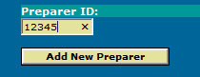

That employee will now be in the preparer table for that department.

As a reminder, students and individuals from temporary employment services who are hired for short periods of time cannot be designated to prepare CERTS due to the sensitive nature of payroll information.

To view a list of current preparers for a department, or to remove preparer access for an employee, click the **DELETE PREPARER** button in the Preparers by Department-Select Option screen. A list of employees will open displaying their name and GEMS employee ID numbers. To remove preparer access for an employee click the radio button to the left of their name and then click the **DELETE PREPARER** button below the list of employees. The preparer access will then be immediately removed for that employee.

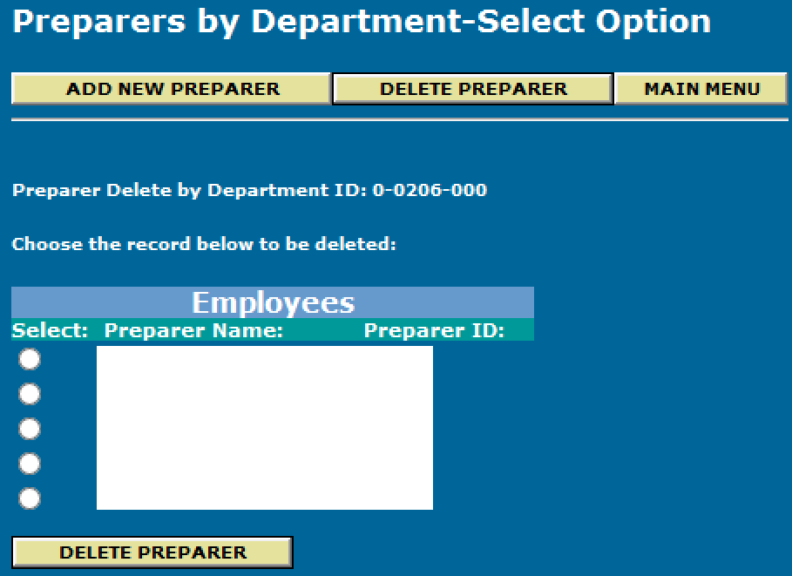

Click the **MAIN MENU** button to return to the CERTS main menu.

CERTIFIER ACCESS – Accountable officers and existing certifiers for a department can identify employees to serve as department certifiers. Those individuals can submit requests for certifier table maintenance to the University Payroll Department. Only individuals who occupy supervisory-level positions, including all administration and faculty positions as well as department manager staff positions, can serve in the certifier role. The University Payroll Department will confirm this condition before that person’s position number is added to the certifier table in GEMS.

A listing of approved certifiers will be maintained for each GEMS department number. The certifier table uses position numbers, not GEMS employee ID numbers, so if an individual changes position numbers their certifier access will end unless their new position number is already in the certifier table for that department. If a new person assumes a position number that is already in the certifier table they will have certifier access by default. Any active employee with a position number that is in the Certifier Table for a department will be allowed to approve CERTS for that department.

Note that an individual can have both preparer and certifier access for a department but they cannot both prepare and certify an employee in the same pay period.

**PAYROLL CERTS PREPARER STEPS**

Preparers should gather the approved timesheets for their department’s non-exempt employees and any adjustments needed for salaried employees per that department’s internal procedures. With this information they can begin preparing CERTS for that department.

The department’s CERTS are accessed via the Preparers Workscreen option from the CERTS main menu. Enter the GEMS department ID in the three fields next to Preparers Workscreen, then select which group of employees to prepare (Exception, Hourly, or Salaried) by clicking the appropriate radio button, and then click the **GO** button to the right of the department ID fields. Example selecting Exception employees:

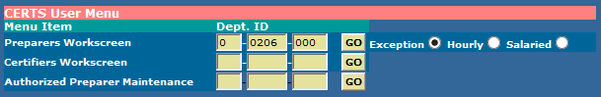

A list of employees will display, showing their name, GEMS ID number, the dates of each week of the pay period, the “Reg Hrs” which is a factor of their FTE (40 hours here indicates a 1.0 FTE), entry fields for regular and overtime hours, the employee’s biweekly pay rate, current CERTS status, and buttons for adding prior period hours or free-form messages for the Payroll department or for the certifier. Example:

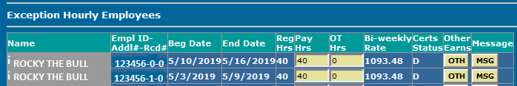

Standard hours for all positioned employees (faculty, administration, staff, and salaried temporary employees) will be defaulted into CERTS per each employee’s FTE and their active dates in each pay period. Hourly temporary employees will default with zero hours. Exception Hourly and Hourly employees will have each week of the pay period displayed separately because they are eligible for overtime in each individual week. Salaried employees will have only a single row showing the beginning and ending dates of the pay period.

**Any discrepancies noted in an employee’s salary, hourly rate, or FTE must be investigated and reported to Human Resources for proper corrective actions. Depending on timing the correction may not be able to be completed until after Certs are finalized. In this case prepare and submit the employee for zero hours/no pay through CERTS, and submit a PCAF later once the corrective action has been completed.**

In the example above the normal weekly hours are 40 (FTE is 1.0) for this employee, so 40 hours are defaulted in the Pay Hrs field and 0 overtime hours are defaulted in the OT Hrs field. If the employee reported 40 hours and no overtime for both weeks then no action is needed by the Preparer for that employee because the default hours are correct. If the employee worked less than 40 hours in either week the Preparer will change the 40 hours for the affected week to what was reported on the timesheet. If any overtime was reported and will be paid the Preparer will enter those hours in the OT Hrs field. Continue entering hours as needed for other employees.

The hours displayed in the Reg Hrs field indicates the maximum number of hours, based on that employee’s FTE, that can be entered in the Pay Hrs field for that week. If an employee’s FTE is less than 1.0 then the Reg Hrs displayed will be less than 40. Example, if an hourly employee’s FTE is .50 then the Reg Hrs will display as 20 and the maximum number of hours the Preparer can enter in the Pay Hrs field will be 20. If the employee worked more than 20 hours in the week then the Preparer will enter 20 hours in the Pay Hrs field and any hours worked above 20 must be entered in the OT Hrs field. Those overtime hours will come through to Payroll as regular hours and it is recommended that a message (see below) also be entered in cases where an employee with less than 1.0 FTE is being certified above their normal hours, explaining that the hours entered as overtime are in fact additional regular hours.

**Special note effective in 2020: Any employees who are approved for paid emergency sick leave (E-Sick) or emergency FMLA (E-FMLA) as defined in the Families First Coronavirus Response Act should be certified only for hours actually worked even if they are a salaried employee. E-Sick and E-FMLA hours approved by HR and entered in the employee’s Leave Management record will come through ALT during payroll processing as payable hours unlike all other leave activity that comes through ALT. Only certify hours actually worked for employees receiving E-Sick or E-FMLA hours in that pay period.**

The Preparers Workscreen displays a maximum of 25 lines per page. At the bottom of the page are the **Save Changes** button, The Page Down (**PgDn**) button, and the **Submit to Certifier** button.



**Save Changes** will save the changes entered on this page only. Before progressing to the next page the Preparer will need to save the changes they’ve entered on the current page.

Clicking the **PgDn** button will then display the next 25 lines of CERTS. Repeat as needed until all employees of the selected type have been prepared and saved.

Once each page of CERTS is completed and saved the Preparer can submit that page to the Certifier for review and approval. Once submitted the Preparer cannot make any changes or entries to that page of CERTS unless the Certifier “returns” for correction any of the employees on that page.

ADDITIONAL ACTIONS THE PREPARER CAN TAKE

ENTERING PRIOR PERIOD HOURS (PPH)

If necessary, Preparers can also enter prior period hours that were not previously paid. To do so click the **OTH** button and another window will open, displaying the following:

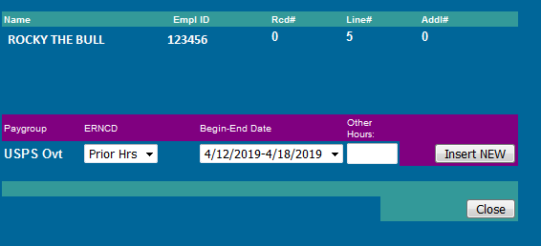

The Preparer can enter those PPH hours by clicking in the Begin-End Date field which will open a list of the dates for the last 10 weeks, or 5 pay periods. Select the appropriate week for the hours to be entered, enter the prior period hours to be paid in the Other Hours field, and click the **Insert NEW** button to save the entry. Repeat the process for any other weeks’ hours to be entered. When finished click the **Close** button to close this window and return to the previous screen.

Example of a completed entry showing prior period hours for two different weeks:

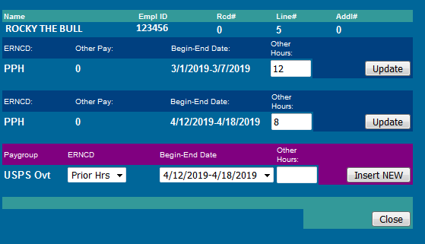

To change or correct any previously entered and saved PPH hours enter the new figure for that week and click the **Update** button to save the change.

If the prior period hours to be paid were worked in the previous 5 pay periods they can be entered in CERTS. Any hours older than the immediately preceding 5 pay periods can only be submitted for payment on a PCAF. If you have any prior period hours older than the immediately preceding 5 pay periods then certify ALL of them on a PCAF and none of them in CERTS.

ENTERING MESSAGES

The Preparer can also enter a message by clicking the **MSG** button, which opens a screen with a free-form entry box. Example:

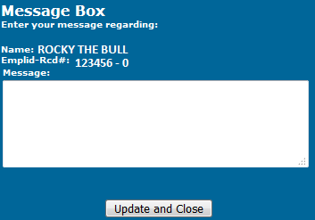

Enter the message and click the **Update and Close** button to save the message and return to the previous screen.

Messages are intended to provide Payroll with information explaining entries the department has submitted. These are messages that require Payroll action when the department cannot through CERTS, and to report special situations that require additional Payroll actions.

**Messages are standardized and must be one of the following**:

1. **PPH hours for PP####** *for reporting what pay period PPH hours submitted are for. Can also add* **at rate $____** *if the hourly rate to pay differs from the current hourly rate*
2. **Owe __OT hours--approved** *for confirming that the number of overtime hours submitted are in fact approved paid overtime*
3. **All hours regular pay** *for advising that additional hours above the FTE entered as overtime are in fact additional regular pay hours and not overtime hours*
4. **Charge OT to combo code #########** or **Charge PPH to combo code #########** *for requesting that submitted overtime or PPH hours be charged to the specific combo code you’ll provide in this message*
5. **Worker’s Comp full leave accrual** or **Military Leave full leave accrual** *for reporting employees with reduced hours due to being on Worker’s Comp or out on military service, this allows Payroll to ensure the employee accrues leave as though they worked 80 hours*

**NOTE: No other messages are to be entered into the CERTs message report.**

Any employees with PPH submitted will have a yellow space to the right of the OTH button on that line. Employees with messages will have a red space to the right of the MSG button. See below for example of a CERTS line with PPH and a message entered versus a line with neither entered:



**PAYROLL CERTS CERTIFIER STEPS**

From the CERTS main menu enter the GEMS department number in the fields next to the Certifiers Workscreen row and click the **GO** button

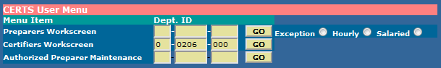

A single page with ALL employees for that department will display, with Exception employees first, Hourly employees second, and Salaried employees at the bottom.

Certifiers have view-only access to the hours each employee is to be paid. Certifiers can only approve or return hours. Certifiers have 4 buttons they can click:

* **A** = Approve that individual line
* **R =** Return that individual line to the Preparer for correction and re-submission
* **OTH** = To open and view any PPH entered by the Preparer
* **MSG** = To open and view any message entered by the Preparer

Example of submitted Salaried employees for the Certifier’s review, prior to approval:

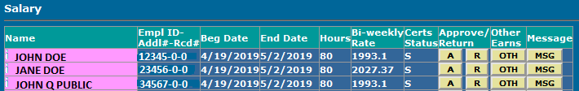

The Certifier must verify the accuracy of the entries made by the Preparer for each employee by confirming the employee ID, record number, and hours for each week against the timesheet or other documentation per that department’s internal procedures for entering Payroll CERTS. If any PPH or messages were entered those entries must also be verified for accuracy.

Discrepancies between the timesheet and what was entered in CERTS must be investigated. If any submitted CERTS require correction the Certifier can **Return** individual lines of employee CERTS to the Preparer for correction by clicking the “**R**” button for that line.

**As previously noted, any discrepancies noted in an employee’s salary, hourly rate, or FTE must be investigated and reported to Human Resources for proper corrective actions. Depending on timing the correction may not be able to be completed until after Certs are finalized. In this case the employee should have been prepared with zero hours/no pay in CERTS, and the department must submit a PCAF later once the corrective action has been completed.**

Once all the CERTS have been reviewed and verified for accuracy, the Certifier has the option to either approve by individual line by clicking the “**A**” button for that line, or they may approve all CERTS records by clicking the **Approve All** button at the bottom left of the screen.

**ADDITIONAL RECONCILIATION REQUIREMENTS**

CERTs to ALT Reconciliation:

Departments must validate that any leave used in that period for ALL employees, including salaried employees, is accurately recorded in ALT and on the timesheet if the employee is non-exempt. All paid leave for non-exempt staff must be itemized on the timesheet and must match approved leave activity in ALT.

CERTs to GEMS Reconciliation:

Departments must validate that hours approved to be paid, that exist on the standardized timesheet, job code changes, rates of pay, pay status are reconciled against the query U_DEPT_CHECK_REG on a bi-weekly basis. The results of this reconciliation, along with any discrepancies and resolutions, must be maintained by the department for five fiscal years along with the timesheets.

**CERTS STATUS**

As actions are taken on CERTS records the status of each line will change automatically depending on the previous status of that line and the action taken. The Name field displayed on the online certification screen is highlighted in different colors to bring attention to the various statuses.

Below is a chart detailing the Status Code, the corresponding color for that status, and whether a CERT record with that status can be updated by the Preparer:

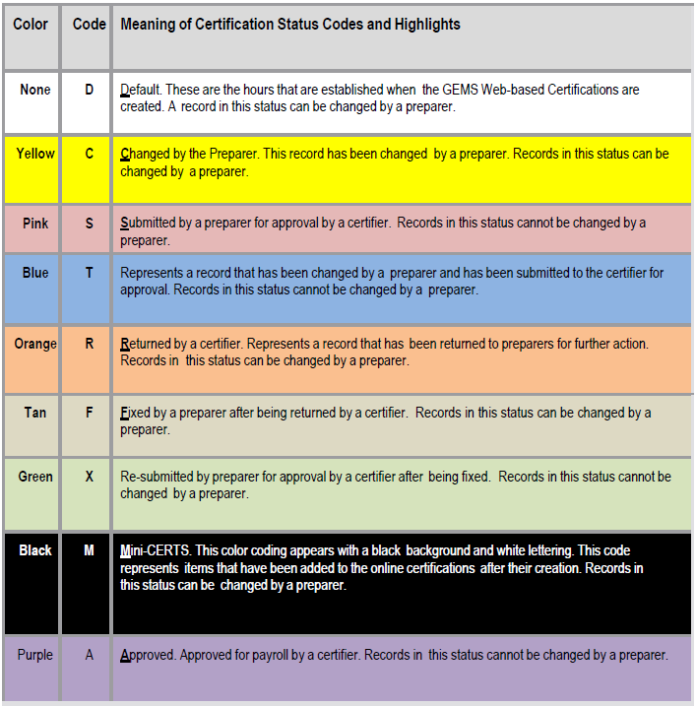

**CERTS REPORTS**

**Using Certification Reports**

There are fouravailable reports in CERTS that can be viewed on-line or printed if desired, accessed by entering the GEMS department number in the appropriate fields in the Unsecured or Secured reports section of the GERTS menu, and then clicking the corresponding **GO** button:

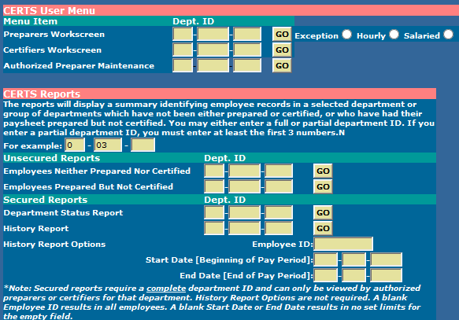

The available reports are:

* Employees Neither Prepared Nor Certified = self-explanatory
* Employees Prepared But Not Certified = this will show only employees who have been submitted to the Certifier but have not yet been approved
* Department Status Report = this shows all employees for that department and all activity completed to that point, including hours for each employee, PPH entries, messages, and who prepared and certified each employee
* History Report = same as the Department Status Report, it will show the same activity for prior pay periods. This report can be run for a single pay period or a range of periods, and it can be run for the entire department or for a single employee. Enter the start and end date of the pay period(s) needed and the GEMS employee ID number if running the report for a single employee.

The CERTS system will retain history information for approximately one year, therefore departments can run history reports and obtain the data that was entered in CERTS up to one year prior.

**RECORDS RETENTION REQUIREMENTS**

Employee timesheets must be retained by the department for 5 fiscal years. Also, copies of PCAF’s and any other Payroll adjustment forms (retroactive pay increase forms, bonus requests, etc), and any departmental-specific documentation used for verifying employee hours submitted via CERTS must also be retained for 5 fiscal years. Scanned copies are acceptable in all cases.