**Work Order Query**

U_GL_JRNL_DETAIL_PPLANT – query will give you detail, by line item, of charges on a work order

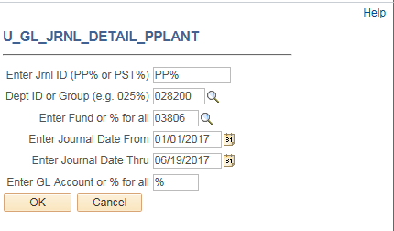

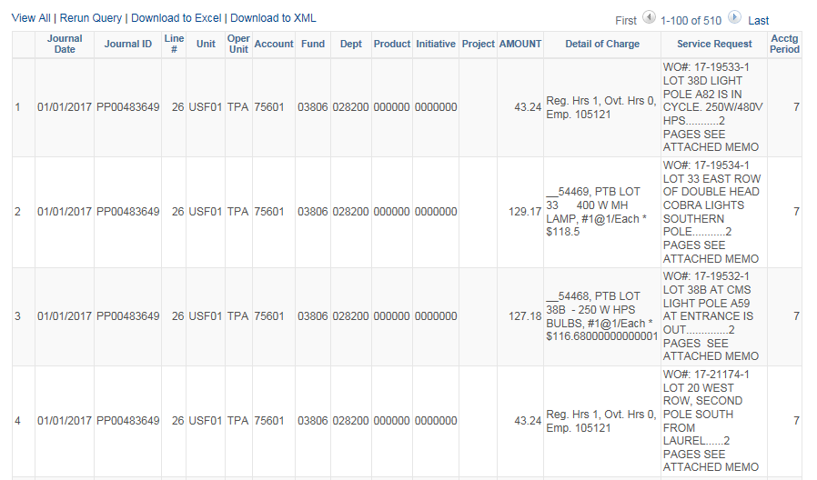

PP% = Physical Plant journal entry

PST% = Post Office journal entry

Billing Questions:

[Fm-servicecenter@usf.edu](mailto:Fm-servicecenter@usf.edu) or 813-974-2845

Questions will then be routed to the appropriate manager of billing area

