Log into GEMS Self-Service
On the Employee Self Service page, click on the Payroll tile.
On the Payroll page, click on the W-2/W-2c Consent tile
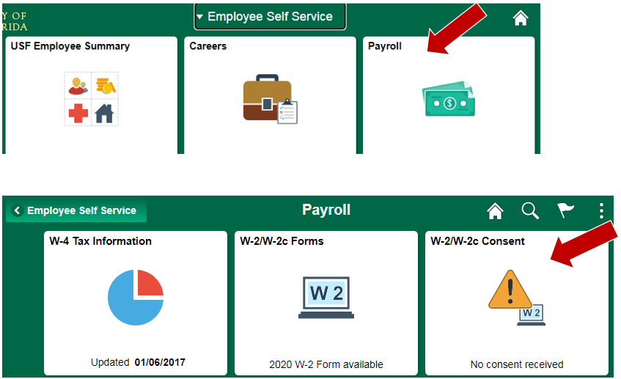

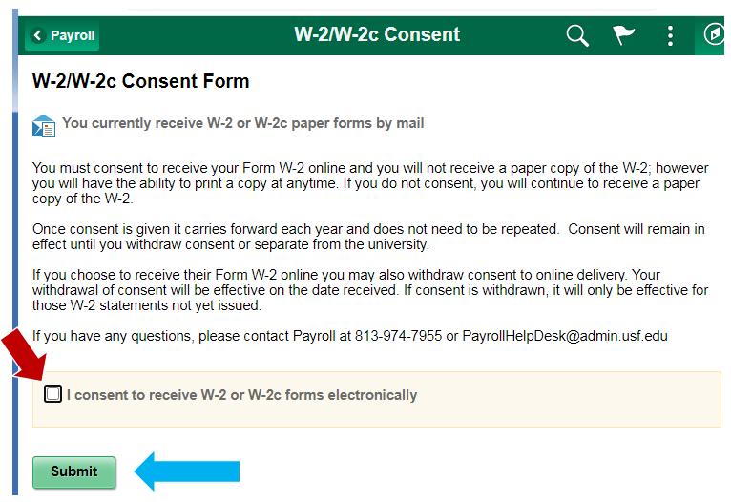
W-2/W-2c Consent Form
When you first navigate to the screen, you will be given the option to consent to receive your form electronically. Check the box, then click Submit.

NOTE: You need to receive at least one paycheck before you are able to consent to the electronic W-2. If you attempt this prior to that, you will receive a message that you are ineligible. This is because until you are paid, you have no tax balances, and thus no W-2 would be created for you.

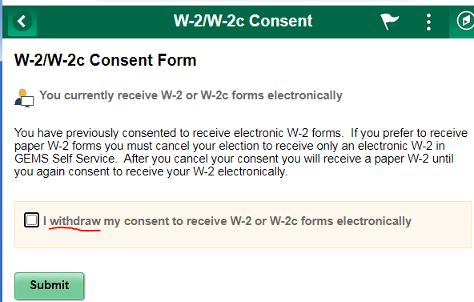
Once you have consented the consent tile will show Consent received.

Your electronic consent may be withdrawn at any time if you choose to do so by navigating to the same screen and checking the box to withdraw.

