The Employee Self-Service option is now available via the regular GEMS menu item under Business Systems when you log onto MyUSF using your NETID and Password.

Once you have successfully logged into GEMS/Employee Self Service click on the Payroll tile to access the Tax Withholding.

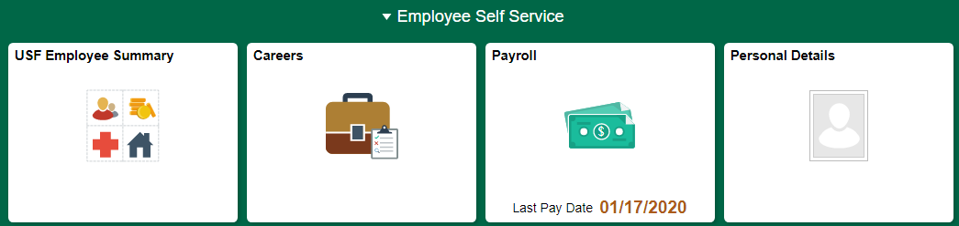

Click on Tax Withholding.

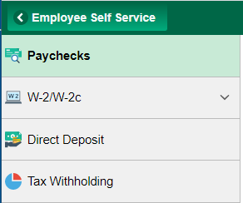

**The IRS has developed a list of [Frequently Asked Questions](https://nam04.safelinks.protection.outlook.com/?url=https%3A%2F%2Fwww.irs.gov%2Fnewsroom%2Ffaqs-on-the-2020-form-w-4&data=02%7C01%7Cnkwilliams%40USF.EDU%7C6c5b3cf1e2bc4fed627908d7a4c88e04%7C741bf7dee2e546df8d6782607df9deaa%7C0%7C0%7C637159053601088011&sdata=DFUkyJlbQOasMpHyUw%2FXPDpM9HUMNI9ue34QwM%2BBWwY%3D&reserved=0) regarding the new fields on the form. We encourage all employees to use the IRS Tax Estimator to ensure that the taxes calculated to your withholding preferences.  [https://www.irs.gov/individuals/tax-withholding-estimator](https://nam04.safelinks.protection.outlook.com/?url=https%3A%2F%2Fwww.irs.gov%2Findividuals%2Ftax-withholding-estimator&data=02%7C01%7Cnkwilliams%40USF.EDU%7C6c5b3cf1e2bc4fed627908d7a4c88e04%7C741bf7dee2e546df8d6782607df9deaa%7C0%7C0%7C637159053601088011&sdata=FMrOTOeDlKQm8EXVows0Z8DV1OT9cadX%2FcQ53qlScq0%3D&reserved=0)



*If you select exempt (no withholding), you will receive the below message. 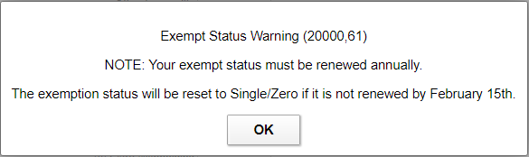

Click OK, and then click Submit to receive a confirmation message.

