You may enroll in direct deposit AFTER HR has entered your job into the employment system.

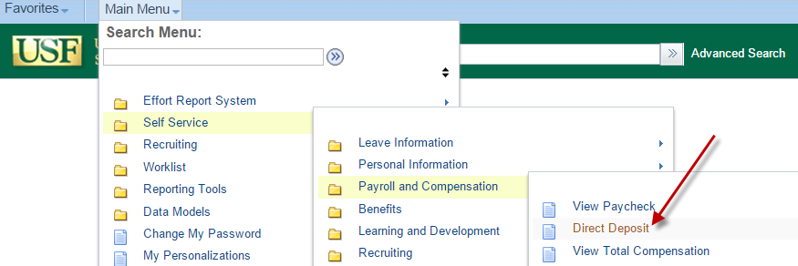
Go to www.usf.edu, and click on MyUSF

Sign in with your NETID

(the links to create one are to the left of the sign-in boxes)
Click on Business Systems > GEMS
If GEMS does not appear, please call IT Helpdesk at (813) 974-1222, or email Help@usf.edu.
Click Main Menu – then Self Service > Payroll and Compensation > Direct Deposit.

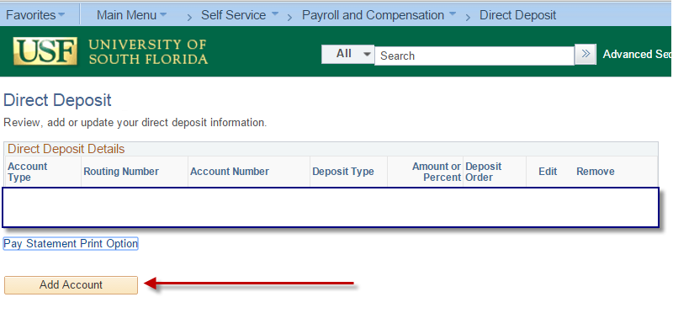
When you are first hired, and enter the Direct Deposit page for the first time, it is important to note that you may enter up to three distributions. These can be at multiple financial institutions, as well as checking and/or savings accounts.

Begin by clicking the Add Account button.

Direct Deposit Page
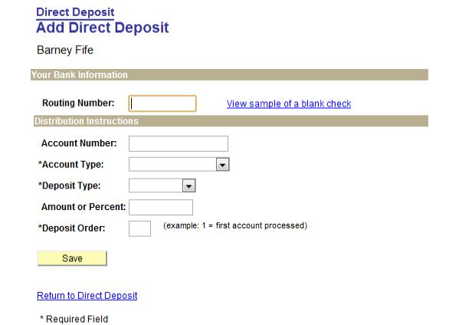
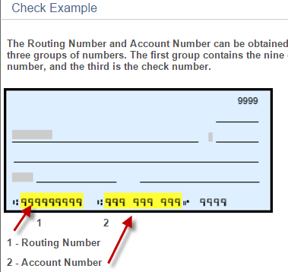
Routing Number: This number can be found at the bottom of a blank check (not a deposit slip) or by contacting your bank or financial institution.
Note: Routing Number is also called an ABA or Transit Number and is nine digits long. You MUST have this number to set-up your Direct Deposit.
Account Number: Available on the bottom of a blank check (see image at right) or from your financial institution.
Account Type: Choose Checking or Savings.
Deposit Type: Select Amount or Balance of Net Pay.
Amount: If you chose Balance of Net Pay, leave the amount field blank. If you are setting up another account with a specified Amount, enter the amount you wish to have deposited. Example: 5, 10, 50, 100, 200, 250, etc.
Deposit order: Your net pay will be deposited in the order listed in this field. If you choose Balance of Net Pay, the deposit order will default to 999. Additional flat amounts will have a default deposit order 1 or 2, but you may change that order number depending on your preference.

After adding your direct deposit information, click the
Button at the bottom of the page.

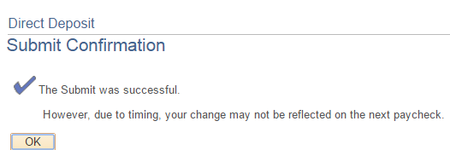
If your routing number is correct and there are no errors, you will then receive confirmation of your successful change.

Review, Edit or Delete Direct Deposit
If you have already set up direct deposit information online or through the payroll form, your account information will appear in the Direct Deposit Details.
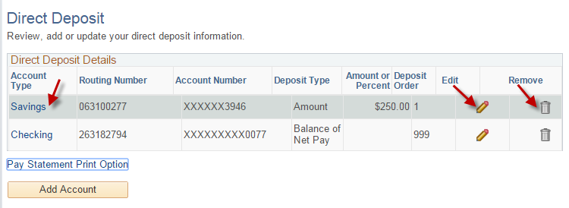
- To review account information, click the Savings or Checking link.
- To edit account information, click the pencil icon.
- To remove or delete account information, click the garbage icon.

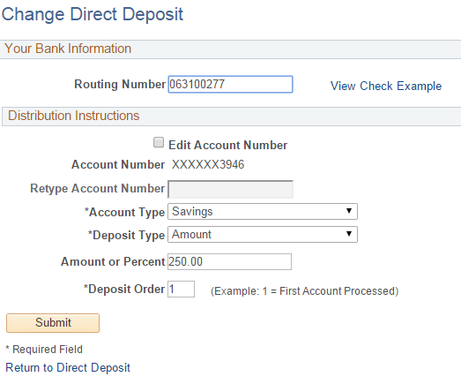
Edit or Change your account information

Update the Routing number, Account Number, Account type, Deposit type or Amount. Note: Click the Edit Account number box only if you wish to change your existing account number.
Your existing account number fields will be cleared out and ready for you to enter the new number.

When changes are completed, click the Submit button, or click the Return to Direct Deposit link to discard your changes.

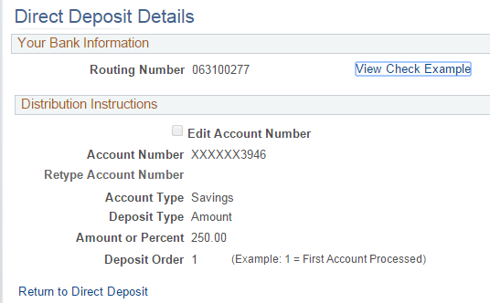

Review your account information for accuracy.

Click the Return to Direct Deposit link to go back to make changes.

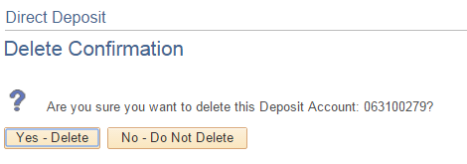
Remove or Delete your account information:
Click the Delete button (garbage) to remove an Account.
Note: A confirmation page will be displayed: click Yes – Delete or No-Do Not Delete.

