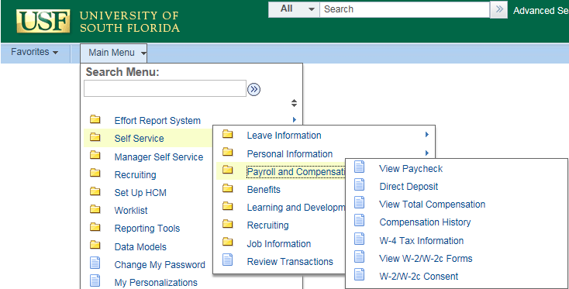
Log into GEMS Self-Service
Navigate to: Self Service > Payroll and
Compensation > W-2/W-2c Consent.

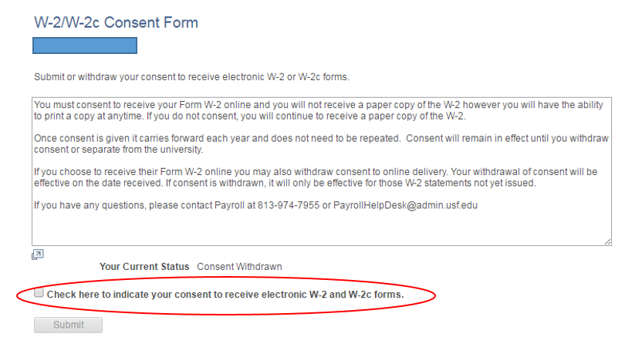
W-2/W-2c Consent Form

When you first navigate to the screen, you will be given the option to consent to receive your form electronically. Check the box, then click once that box turns yellow.

NOTE: You need to receive at least one paycheck before you are able to consent to the electronic W-2. If you attempt this prior to that, you will receive a message that you are ineligible. This is because until you are paid, you have no tax balances, and thus no W-2 would be created for you.

Once you have consented and you go back into the page, you will notice that your status has changed. Your status will read that you have consented.

Your electronic consent may be withdrawn at any time if you choose to do so by navigating to the same screen and checking the box to withdraw.

