**USF343HUCO - PAYROLL BUSINESS PROCEDURES**

**Staff Employee Shift Differential Hours Reporting**

|  |  |  |  |
| --- | --- | --- | --- |
| **Process Owner:** | University Payroll | **Date Revised:** | 10/26/2021 |
|  |  |  |  |

PURPOSE

The purpose of this procedure is to provide instructions on how to report worked hours that are eligible for a 2% shift differential hourly rate premium

SCOPE

This process applies only to **staff employees** who are covered by the AFSCME collective bargaining agreement ratified in October 2021. No other employees are eligible for this rate differential premium. Only hours worked between 7:00Pm and 7:00am are subject to a +2% rate differential premium. The existing Payroll CERTS application cannot be modified to accommodate the reporting of shift differential hours. Therefore, such hours worked must be reported to Payroll on an Excel form designed for this purpose.

UNIQUE TERMS/DEFINITIONS

In-Unit = Staff employees (paygroups PEU and PSU) who are covered by the AFSCME union collective bargaining agreement

Out-Of-Unit = Staff employees not covered by the AFSCME union collective bargaining agreement. Some staff members are out-of-unit based on the responsibilities of their job.

CERTS = Payroll Certifications application

Non-Exempt Staff = Staff employees in paygroup PEU who are eligible for overtime pay and who are required to submit timesheets. Also known as Exception Hourly employees in the Payroll CERTS application.

Exempt Staff = Staff employees in paygroup PSU who are salaried and therefore not eligible for overtime pay and who do not submit timesheets

PROCESS—high level

As part of the existing Payroll certification process, non-exempt staff employees (paygroup PEU) will submit signed timesheets to the designated contact in their business unit each pay period. The USF Staff Timesheet was revised in October 2021 to include a column for reporting hours eligible for the 2% rate differential. The employee will complete the timesheet as before recording the daily worked hours and any leave usage in the appropriate fields on the timesheet. What is new is that in-unit employees also will record any hours worked between 7:00pm and 7:00am in the “**Shift Differential, AFSCME only**” column on the timesheet.

See example timesheet below: the Shift Differential, AFSCME only column is identified by the red box in the example below

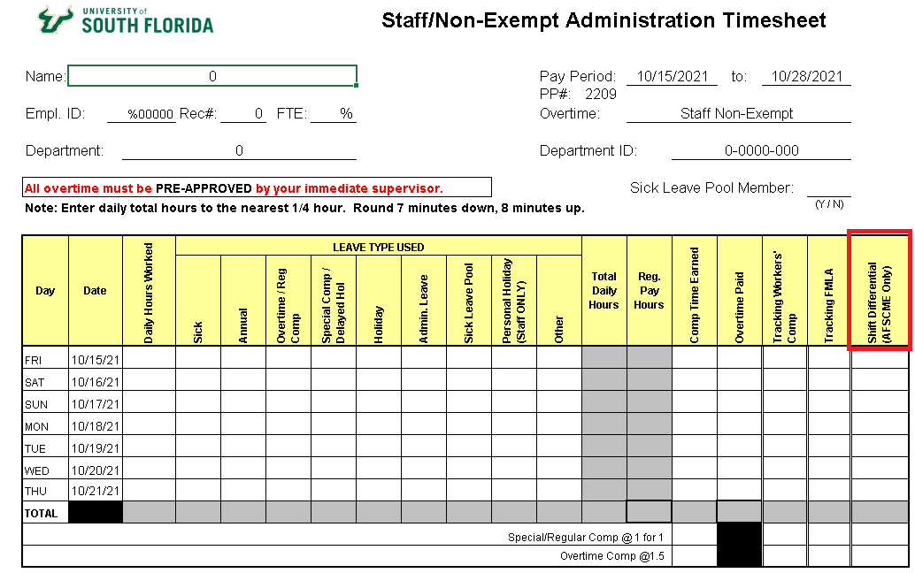

Department CERTS preparers and certifiers will process their Payroll certifications in the on-line application as before with no changes from the existing procedures. Because the CERTS application cannot accommodate the reporting of hours eligible for shift differential premiums it is necessary that those hours be reported to Payroll on an Excel form.

The **Shift Differential Hours Reporting Form** is used for this purpose. The form is an Excel form and must be submitted to Payroll two ways: as an Excel file and as a digitally signed, non-editable pdf format. Payroll will use the Excel files to copy and paste the provided information into a template used for systematic uploading into the Payroll system. This eliminates manual entry of the hours reported for shift differential pay by Payroll personnel. Payroll will retain the digitally signed pdf report as the source document.

PROCESS—detailed

* Employees will submit timesheets as normal. All regular hours, any leave usage, and any overtime hours worked are to be recorded as before with no changes in procedure.
* Additionally, if an in-unit employee worked any hours between 7:00pm and 7:00am those hours must be reported in the Shift Differential, AFSCME only column on the timesheet. The hours entered here indicate how many of the worked hours entered in the regular hours column for that day were worked between 7:00pm and 7:00am.
* Once the timesheet is approved by the supervisor it can then be processed per each department’s internal procedures.
* Enter your Payroll CERTS as per existing procedures for both regular and overtime hours.  Nothing different will be done in CERTS related to this new requirement.
* Any timesheets with hours reported in the “Shift Differential, AFSCME only” column on the timesheet require additional attention. Those hours reported in that column must be entered on the **Shift Differential Hours Reporting Form.**
* TheShift Differential Hours Reporting Form is used only for reporting those hours that must be paid with the +2% shift differential premium, not any hours to be paid at the normal rate
* Do not include any CERTS messages mentioning the shift differential hoursfor employees who are reporting such hours
* The **Shift Differential Hours Reporting Form** can be used to report multiple employees who have shift differential hours for the same department. The form appears as follows:

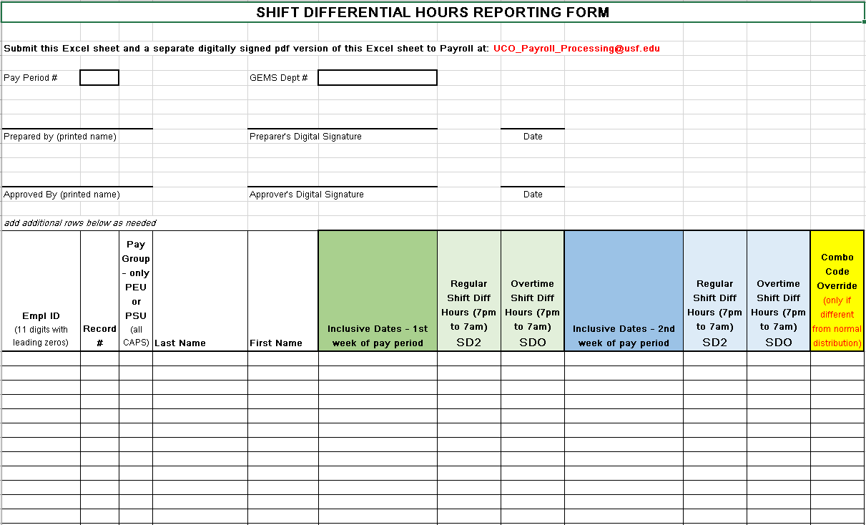

* Enter the pay period number and GEMS department number in those fields at the top
* Enter the names of the form’s preparer and approver
* In the fields below enter the following:
  + GEMS ID number with the leading zeros (the empl ID has a total of 11 digits)
  + The job record number
  + Paygroup, either PEU or PSU
  + Employee’s last name and first name
  + The date range of each week of the pay period, shown on the timesheet, where any shift differential hours were worked. The first week of the pay period should be entered in the column in green highlight; the second week of the pay period should be entered in the column in blue highlight. If the employee worked shift differential hours in both weeks then both weeks will need to be entered separately.
  + Enter the number of regular hours subject to the shift differential as reported on the timesheet in the Regular Shift Diff Hours (7pm to 7am) column for the appropriate pay period week(s). Round to the nearest quarter hour (ie: .25, .50, .75. **In this column enter only the hours subject to the shift differential, not all the hours for which the employee will be paid.**

*Example:*  a staff employee works 40 hours in a week and 18 of those hours were worked between 7pm and 7am that week. Example of such a timesheet:

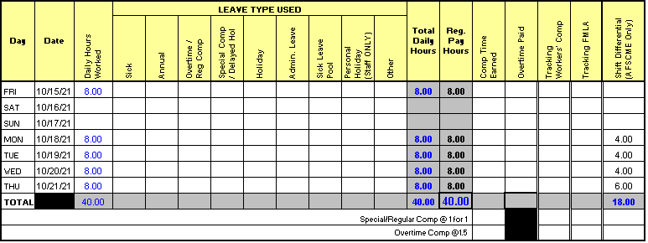

In this example certify 40 hours for that week in CERTS and on the **Shift Differential Hours Reporting Form** enter the date range of that week (10/15/21 to 10/21/21) and enter 18 hours in the regular column for that week.  The employee will receive a 2% rate differential additive to their pay for those 18 hours

* + If any of the hours subject to shift differential are overtime hours enter the number of hours to be paid at overtime in the Overtime Shift Diff Hours (7pm to 7am) column for the appropriate pay period week(s). Round to the nearest quarter hour (ie: .25, .50, .75.

*Example:*  an employee worked a total of 45 hours in a week, all of them between 7:00pm and 7:00am. In CERTS enter 40 regular and 5 overtime hours. On this form enter 40 hours in the Regular Shift Diff column and 5 hours in the Overtime Shift Diff column.

* + If the shift differential hours to be paid must be charged to a different funding source than the employee’s normal distribution enter the appropriate combo code in the Combo Code Override column. Leave this field blank if no special override is needed.
  + Repeat the steps above for additional employees who will receive shift differential pay
* If any hours from a prior pay period were due the shift differential and did not previously receive the shift differential for any reason report those hours on this form as well. Enter the appropriate prior pay period week date range(s) using either of the “Inclusive Dates” columns and then enter the regular and overtime hours, if any, that should receive the shift differential.
* When the form is complete save it as an Excel sheet. Also save a copy of the completed sheet that the preparer and approver will digitally sign. Digitally signing the form will convert it to a pdf document.
* The completed and digitally signed pdf document along with the Excel form should be emailed together to Payroll at the email address at the top of the form: [UCO_Payroll_Processing@usf.edu](mailto:UCO_Payroll_Processing@usf.edu)
* The deadline to submit these completed forms is the same as for all other adjustment forms:  by the end of the day that CERTS are due which is the Friday immediately following the pay period end date in non-accelerated pay periods.  Please consult the “Payroll closes 5pm” column in the biweekly processing schedule for the dates these and all other adjustment forms are due.
* Do not submit timesheet copies to Payroll, only send the completed Excel form and digitally signed pdf document to Payroll for paying the shift differential hours due.