Archivum Travel
Frequently Asked Questions
General

- What is Archivum Travel?
It is USF’s Travel application developed on the Appian BPM (Business Process Management) software using the Agile methodology. It is part of a set of business applications developed by USF IT.
- What are some of the benefits of Archivum Travel?
Some of the benefits are:
• Provide a simpler, user friendly and streamlined experience.
• Allow Mobile functionality and full visibility on the status and location of transactions in the workflow.
• Automated budget checking
• Improved data collection and reporting to USF World and Export Control to manage their responsibilities pertaining to safety and compliance on international travel.
• Better management information via dashboards, reports and metrics which are not available in PeopleSoft.

- Is training provided to use the system?
Yes, training video tutorials are posted on the travel website. Follow this link http://www.usf.edu/business-finance/controller/payment-services/archivum.aspx to access the video tutorials and other resources available.
- Who can I contact regarding Archivum Travel?
All questions and suggestions related to Archivum Travel can be directed to the Travel Helpdesk travelhelp@usf.edu
- Does Archivum Travel support all browsers and operating systems?
Yes, Archivum Travel supports all browsers and operating systems. If you encounter any issues with using a particular browser, please contact IT Tech Support help@usf.edu
- If an Alternate User Assignment is set up in FAST will the transaction route to the alternate user in Archivum?
Yes, the transaction will route to the Alternate user once the setup in FAST is completed.
- If an approver set up an alternate user in the system; why are some transactions still showing a task for the approver?
If the alternate user was set up after the transaction was routed as a task for the approver, the transaction will need to be approved by the approver or reassigned to the alternate user. You will need to contact travelhelp@usf.edu if a reassignment is needed.
- How do I delete my tasks that just say ‘Create Expense Report’ or ‘Create Travel Request’ and have no more information?
Archivum Travel saves the task as soon as you click on the action, however if you did not click on the button ‘Save as Draft’ on the bottom, right hand corner of the page no further information will be saved . To delete this task, you can simply click on it and click ‘cancel’.
9) I have recently been promoted to a Supervisor, do I need to request access to Archivum or FAST system to be able to approve travel transactions for the employees that report to me?
No, if you are listed as the supervisor for the employee in GEMS, you do not need any further set up to be able to approve transactions in Archivum.
- I am the Principal Investigator (PI) for my grant in FAST, do I need to request special access to
Archivum to be able to approve travel transactions for travel on my grant as Project Manager?
No, If you as listed as a Principal Investigator (PI) in the Grant Module in FAST, you do not need to request any further access to be able to approve transaction in Archivum.
- How can I set up an individual who is not an employee for travel reimbursement in Archivum?
In order for a non-employee to request reimbursement for travel related expenses they must first complete the updated “Non-Employee Profile Creation Request” form located on USF’s Travel Department website and forward to the Travel Helpdesk. It takes a minimum of 2 business days for the profile to be available in Archivum.
To access the form go to:
https://www.usf.edu/business-finance/controller/documents/travelnonempprofile.pdf
Note that the updated form includes the notice specific to new “Protections of Personal Data” which meets the “European Union General Data Protection Regulation” (EU GDPR). Old versions of the form will not be accepted.
12) What do I enter for Activity ID number when entering a Project chartfield?
The Activity ID number is related to the Project number being used. Contact your Grant Financial Administrator to get the appropriate Activity ID number.
Travel PCard Charge Reconciliation

- Should PCard charges be reflected in the Expense Report even if the PCard charges were not encumbered?
Yes, an Expense Report must be submitted even if all expenses were on PCard. When charges are associated with the correct Archivum Travel Request number on the Appian TR tab in PCard, they will automatically flow into the Expense Report when the correct Travel Request is pulled into the Expense Report.

- Once a PCard charge is reconciled in the PCard module, can the Travel Request number be changed?
Yes, the Travel Request number can be changed by accessing the ‘closed’ charge and updating the Travel request number. The chartfield the charge was reconciled to cannot be changed. For more details you can view the video on PCard reconciliation training for travel charges
- Can a PCard charge be split when reconciling in PCard module to assign to different Travel Request numbers?
Yes, the option to split the charge is available when reconciling the charge in the PCard module.

- Why can’t I assign a Travel Request number to my charge for PCard DSO Reimbursement?
Charges for PCard DSO Reimbursement are reimbursed directly through the balance sheet by the DSO’s, therefore are not included on the Archivum Expense Report or assigned an Appian Travel Request number.

Travel Requests

- When entering more than one chartfield in addition to ‘by percentage’, can it also be divided ‘by amount’?
When you are setting up the chartfield, it can only be divided by percentage however on each expense line, the amount can be adjusted ‘by amount’.
- Can the HR Supervisor see all expense details when approving?
Yes, if all expense estimates have been entered prior to submitting to supervisor, the supervisor can view the details before approving.
19) Will I need Vice President (VP) written approval to finalize my Travel Request if it had not completed prior to travel?
Yes, a Post Travel Authorization (PTA) Travel Request requires additional signed approval by the appropriate Vice President, which must be obtained and uploaded into Archivum Travel and also included in the Expense Report Receipt Package.
- If the VP requests the Post Travel Authorization reason and preventative action edited, can the Travel Request be sent back?
If changes need to be made to the reason and preventative action, then the Travel Request will need to be deleted and recreated.
- The Travel Request was sent back for revision; but the submitter has still not received the task. How should this be handled?
It sometimes takes up to one and a half minutes when a task is sent back to appear. Please allow this time to receive the task. If it has been longer, please send an e-mail to travelhelp@usf.edu.
- Do all Travel Requests submitted in Archivum, create an encumbrance in FAST?
No. An encumbrance in FAST is created only for Traveler Paid expenses on the Travel Request. The PCard charges are reconciled in the PCard module and posted directly to the ledger.
- What happens if the dates and location on my Travel Request changes?
If you become aware of the change on dates or location early enough, you can cancel the Travel Request and create a new one. If the change is required at the last minute, you will need to ensure that the changes are documented in the comments of the Expense Report for compliance and the approval of your supervisor. If it is a foreign trip, please notify USF World.
- I was told that a Travel Request needed my approval; however, I did not receive any notification.
Please check your ‘Clutter’ folder as the notifications may have routed to your ‘Clutter’ folder in Outlook. You can mark e-mail notifications coming from Archivum as ‘no Clutter’. Once you work the task by clicking on the link in your e-mail, the notifications will be routed to your inbox.
- Will the Travelers get an e-mail notification once the Travel Request is fully approved?
Yes, the Travelers will be notified.
- I have an approved Travel Request; however, the request is no longer required, as the conference has been cancelled. How do I cancel the Travel Request in Archivum?
Access the Travel Request from My Travel Dashboard. Under Travel Information, you can pull up the Travel Request by using the search features available. Once you see the Travel Request in the grid below, click on ‘More Info’ on the right side of the grid. After the Travel Details section opens below then you will see ‘Cancel Travel Request’.
- Is there an option to print a Travel Request?
No there is no option to print a Travel Request. It is not required to be included in the Expense Report receipt package.

Travel Expense Reports

28) How do I pull in PCard charges reconciled to the Travel Request into Archivum?
To create an Expense Report in Archivum Travel, you need to select a Travel Request or Post Travel Authorization. When you select the correct request, the PCard charges reconciled in PCard to this Travel Request number will be automatically pulled into ER.
- When will Expense reports in Archivum not have a corresponding FAST ER number?
If the ER has only expenses with payment type ‘PCard Payment’. There will no corresponding FAST ER since the PCard charges are reconciled in the PCard module and posted to the GL.
- Why does Expense Report require the last four digits of the credit card?

When credit card is selected for a traveler paid expense, the system prompts for the last four digits of the credit card number to validate that the expense was not paid using a USF PCard.

- If I am creating an Expense Report for a Non-employee, how can I verify their mailing address to confirm it is accurate?

If a non-employee record is selected to create an Expense Report, the mailing address of the Traveler will be displayed when selecting Traveler.

- The Expense Report coversheet was sent to the Traveler via DocuSign, however the traveler has not received it. What steps does the traveler need to take to sign the document?
It sometimes takes up to 36 minutes for DocuSign to deliver the document to the traveler. If the Traveler has not received the e-mail, they should check their ‘Clutter’ folder. If the Traveler did not receive the e-mail and 36 minutes have passed since it was sent to them, they can log in to DocuSign and sign and direct the document back to the submitter.
- Traveler is only seeking reimbursement for meals, what should I upload as receipt package?

If Traveler chooses to only be reimbursed for meals, please ensure that it is documented in the expense report. You will need to upload a document that clearly states the Traveler chose to be only reimbursed for meals

- How do I save my work when creating an Expense Report?
The ‘Save Draft’ button is located on the bottom right corner for all pages prior to the Travel Request or Expense Report number being generated.
For all subsequent pages, the ‘Save Draft’ button is located on the top left corner.

- I have a Traveler who paid for a personal item on their PCard, can we reduce the reimbursement on Expense Report by adding a negative line?
Negative lines cannot be added to make adjustments for expenses on PCard. The Traveler will need to write a check back to USF that should be deposited in the Cashier’s Office and a copy of the check and deposit slip should be included in the Expense Report Receipt Package and also with the PCard bank statement.
- When I enter the start time and end time of the trip on the Expense Report, does the system automatically calculate the meals for the first and last day of the trip?

No. The meal deduction should be selected individually on the first and last days of the trip.

- I am preparing an Expense Report that is paid from a project that requires a Supervisor signature on the Expense Report as per Office of Sponsored Research requirements. Can the supervisor sign using DocuSign?
Yes. Once the Expense Report is routed to the Supervisor for approval, if the supervisor signature is required the supervisor will automatically be prompted to sign via DocuSign. Submitters should not send the Expense Report Coversheets to the supervisors outside of the workflow.
- Do Travelers have the ability to change the amount and percentage on each expense line on the Expense Report?

Yes, the Traveler has the ability to modify expense amounts and percentages for each expense line on the Expense Report

- What should I do if I need to add an additional expense after my Expense Report has been approved for payment?
In order to add additional expenses to an approved Expense Report an Addendum Expense Report must submitted.
40) How do I submit an Addendum Expense Report?
To submit an addendum, create a PTA Travel Request. Include the reason for the addendum and a reference the original Expense Report. After the PTA Travel Request is fully approved, you will be able to create an Expense Report to process the expenses. Remember to mention this is an addendum in the comments section of the Expense Report.
Note that for Addendum PTA’s you do not require the VP signature and can upload the coversheet of the original Expense Report.

Signing In DocuSign

41) I was told the coversheet for Expense Report was sent to me via DocuSign, but I did not receive any e-mail notification.
DocuSign notifications are sent to the Travelers Official USF e-mail address. Please ensure you are checking the correct mailbox for the notifications. If you need to update your official USF e-mail address, please click on Manage My NetID and follow the steps required. Also, remember to check your ‘Clutter’ folder to check if it was misdirected there.
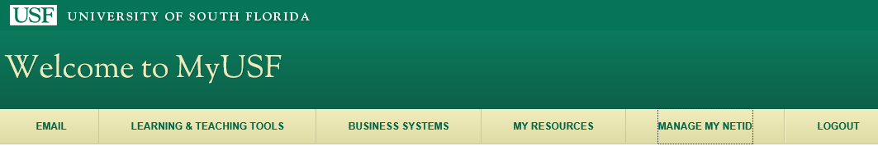
42) I have looked for the e-mail notification but could not locate it, is there any other way that I
can sign my Cash Advance coversheet?
Yes. You can visit http://docusign.com and click Log in in the upper right corner. Enter your USF primary e-mail address and click continue. You will be directed to your USF Single –SignOn page. 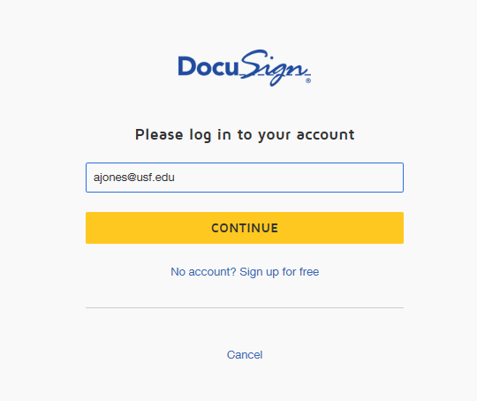
43) I did not receive the DocuSign e-mail and I cannot find the document by directly logging
into DocuSign. What do I have to do next?
If you continue to not see the document upon logging into DocuSign, then please use the Alternate Signing Method Security Code Access by clicking on the following link.
https://support.docusign.com/en/articles/Alternative-Signing-Method-Security-Code-Access

44) How do I decline to sign in DocuSign?
If you do not agree to what is in the coversheet you can decline to sign the document. To complete this action, click on Other Actions and select Decline to Sign. Do not use any other options available under ‘Other Actions’. You will need to provide a reason for declining the document. Then, click Decline to Sign.
Note: It can sometimes take up to 36 minutes for the submitter to receive the document in Archivum Travel.

