Bill Entry and Maintenance
FAST Billing Module

Finance and Account


Information compiled and prepared by:

Controller's Office, University of South Florida
www.usf.edu/business-finance/controller

Last update: March 31, 2019

Contents – Enter/Maintain New Bill-Header and Line Info  Navigation |  | 3
Enter and review Bill Header Information |  | 6
Enter Bill Line Information for New Bill/including sales tax and notes |  | 8
Update Bill Status for Processing |  | 14
Maintenance of Existing Un-processed bills |  | 16
Using Copy Bill to Create a New Bill |  | 17
Reprinting a Bill |  | 20
Frequently Asked Questions |  | 23
Resources/Contact Information |  | 24

Requirements

User must have an active FAST ID and possess the U_AR_BILLER security role. This security role is granted to the user only after the user has attended the Billing/AR training offered by UCO (University Controller’s Office). Find scheduled Billing/AR training on GEMS Self-service.

Overview

USF Auxiliaries may sell products or services to customers outside of USF who are paying with non-USF dollars. Before beginning operations, Auxiliaries must submit an EBA (Educational Business Activity) request and be granted authority to conduct a business. Find EBA information and forms on the UCO web site; www.usf.edu/business-finance/controller. Look under Accounting and Reporting/Forms.

Invoicing of commercial customers (but not USF departments) is performed in the Billing module of FAST. The Billing module is not used for interdepartmental activity (one department billing another department). Interdepartmental billing is performed by creating a journal entry using the Journal Entry Template for posting in the general ledger. Find the Journal Entry Template on the UCO web site under the Accounting and Reporting menu option.

The following are the steps involved in creating commercial customer billings.

If a new customer record is needed, request a new customer ID from UCO using the Customer Request Form found on the UCO web site.

If a customer record already exists, proceed with creating the billing

UCO staff will finalize the billing and mail it to the customer

Auxiliary staff may reprint a customer billing at any time

Once an invoice has been processed and mailed to the customer by UCO, it cannot be altered in any way. If an adjustment or correction is needed, the auxiliary staff must submit a Billing Correction Request found on the UCO web site. Only UCO staff may create adjustments or corrections.

Enter/Maintain Bills

Short Guide:

Step 1 Navigate to the Standard Billing Component; select “Add a New Value”
Step 2 Enter bill header information
Step 3 Enter bill line information including taxes and notes
Step 4 Change bill status for processing
Step 5 Bill maintenance

- Tile Navigation to the Standard Billing Component:

A new navigation option is present in the upgraded 9.2 version of PeopleSoft (FAST). 13 navigation tiles representing primary functions in FAST are presented on the USF home page. For billing and AR, notice the USF Billing and AR tile.

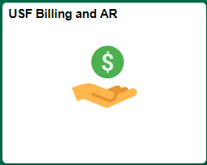

Click the tile to reveal a list of the common pages needed to create, review, and report on customer billings (illustrated below).

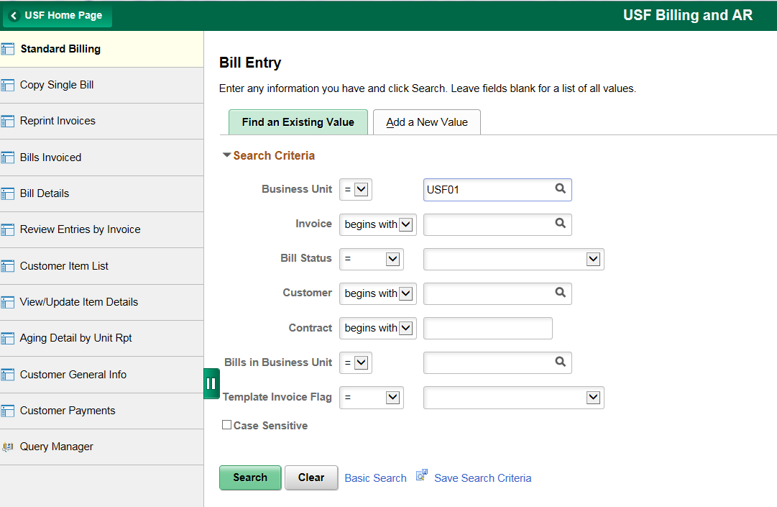

The page defaults to the Standard Billing page. To create a customer billing, follow the instructions in section 3 below.

At any time, to return to the USF Home Page, click the arrow symbol at the top left of the page.

The navigation at the left of the screen will remain visible as you create and save the new invoice. You may at any time click another option from the menu.

- Manual Navigation to the Standard Billing Component:

In the upgraded version of FAST, as an alternative, you can navigate the pages directly from the menu. However, the menu is no longer located horizontally at the top of the screen. It is now presented vertically, on the right side of the screen.

Click the Nav Bar symbol  located at the very top right corner of the screen. This reveals several choices.

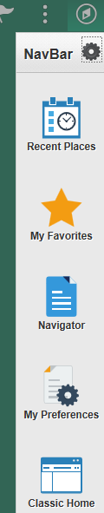

Click Navigator to reveal the menu options that you will remember from the previous version of FAST.

Then navigate: Billing/Maintain Bills/Standard Billing. This will present the “Find an Existing Value” page. To create a new bill, select the “Add a New Value” tab.

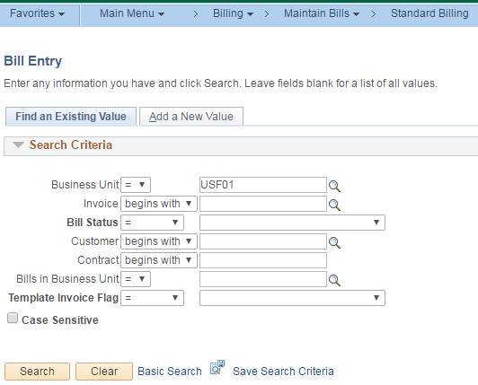

- Enter bill header information:

You will now first enter the required information for the header (see illustration below)

Enter the Business Unit “USF01” (it may appear as the default value)
Leave the Invoice field as it appears (the default is “NEXT”)
Enter the Bill Type Identifier as “COM” (commercial billing)
Enter the Bill Source; if you do not know your bill source search with the magnifying
glass symbol
Enter the Customer ID; if you do not know the customer ID, search with the magnifying
glass using your Bill Source

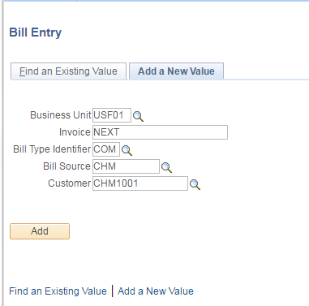

To complete the header entry and proceed to the bill line entry, click the ADD button .

Review bill header information:

Confirm that the Biller, Collector, Credit Analyst, and Bill Inquiry Phone are correct.

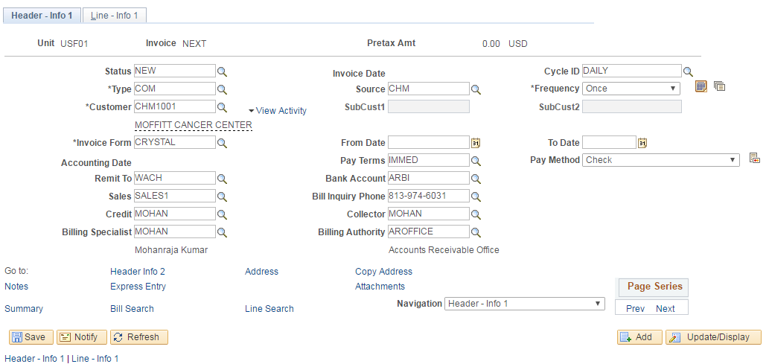

- Enter bill line information including taxes:

Click the “Line – Info 1” tab to begin creating billing lines. A customer billing may contain one or more billing lines. This same “Line – Info 1” tab is used for all billing lines.

Creating a billing line requires only four fields be completed. To create the first billing line:

Select the correct “Table” using the search icon . The correct table is the
PS/Billing Charge ID table identified as “ID”.

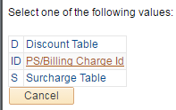

Select the appropriate Identifier, also called Charge Code, using the search icon.
Remember to use a charge code/identifier that is part of your bill source. The name of
the charge code ID should begin with your bill source (CHM in the illustration below).
Type your bill source, then click the search icon and select the appropriate charge code
from the list that appears.

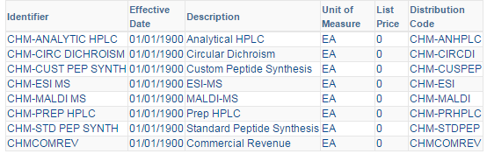

Next type the quantity to be billed. For example if a specific service was offered to the
customer, you might type a quantify of “1”. Or, as in this illustration, a total of 5 tests
were conducted and a quantity of “5” was entered.

Next, enter a unit price unless a default value other than zero appears. In this
illustration a unit price of $25.00 is used.

If this is to be a one line billing, you are nearly finished.

You must now determine if the charge on the billing is subject to sales tax. There are
two primary questions; 1) is the customer exempt from or subject to sales tax and 2)
is the service or product sold to the customer recognized as taxable by the State of
Florida. If you are uncertain of either of these questions, contact the UCO Tax Advisory
Services staff. Their contact information can be found on the UCO web site. Specifically
you may contact Michelle Verdisco at either mverdisc@usf.edu or 813.835.2264.

Assessment of sales tax is a determination made separately for each individual billing
line. It is also a two-step process.

First, the individual billing line must be tagged as taxable with the appropriate sales tax.

To tag a line as taxable, on the Line – Info 1 page, click the search icon in the Tax Code
field and select the appropriate tax code. In this illustration, the Hillsborough County
sales tax code is used.

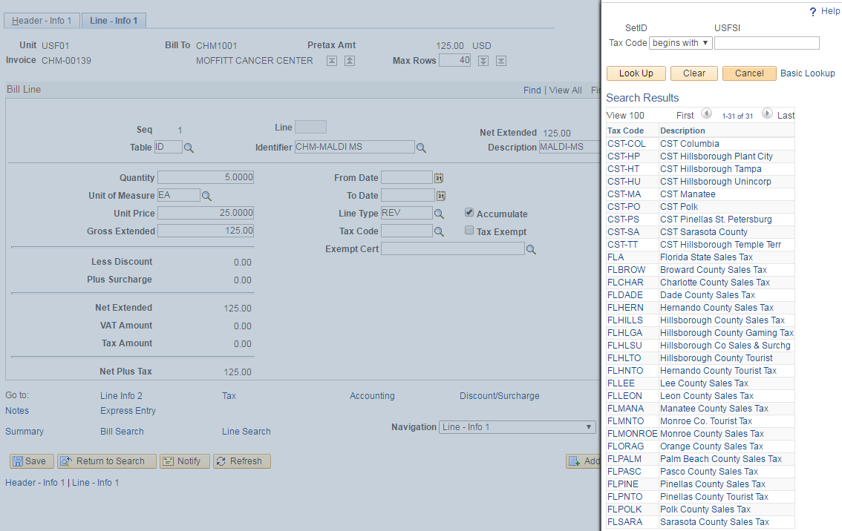

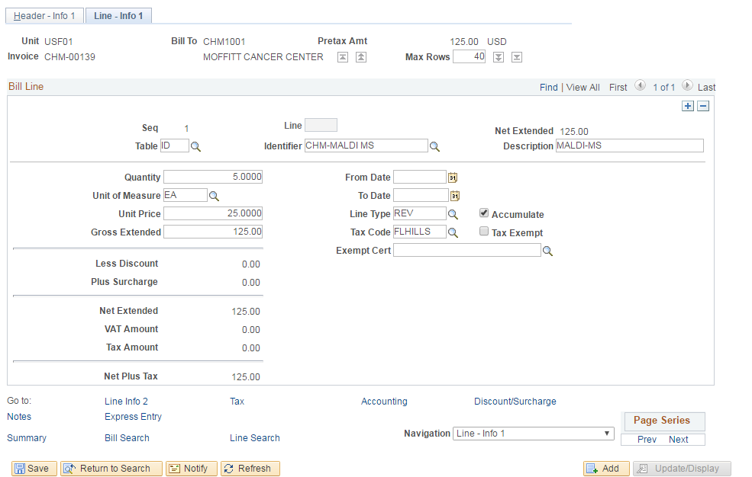

Next, you must calculate and assess the tax on the invoice. To do so, navigate to the
“Summary” page. On that page, click the button, then
Click the SAVE button. An invoice ID will appear in the upper left corner of
The invoice and the sales tax will be calculated and included in the balance due. In this
Illustration, notice the invoice ID is CHM-00139.

Entering notes to a billing:

It is sometimes desirable to enter a note to the customer on the invoice. The note should include helpful information for the customer related to the service provided which may help the customer expedite payment to USF. The note can be created as either a Header Note or as a specific Line Note. An individual note box has a 254 character limit. If your note will exceed that limit, you may create more than one note on one billing.

To enter a Header Note, first click the “Header-Info 1” tab. Then click the Notes button at
the lower left corner of the header.

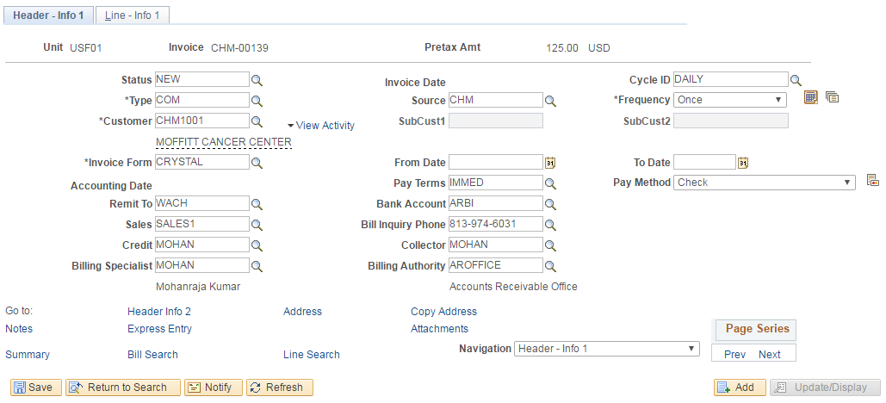

In the “Note Text” box, type the note. The “Standard Note Flag” box and the “Internal Only Flag” box should not be checked. Then click the SAVE button.

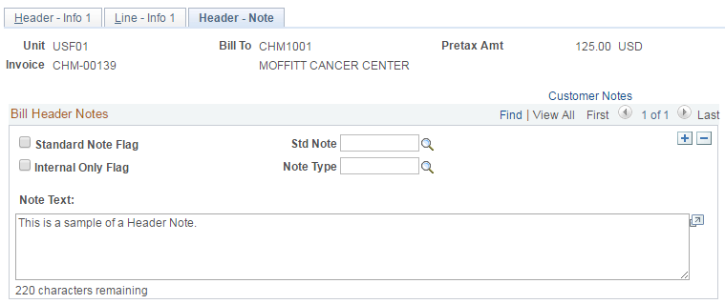

If more than one note needs to be added to the bill header, just click the button; a
new note page will appear.

The note will appear at the bottom of the invoice.

To enter a Line Note, first navigate to the “Line-Info 1” tab, then select the appropriate billing
line. Then click the Notes button at the lower left corner of the page.

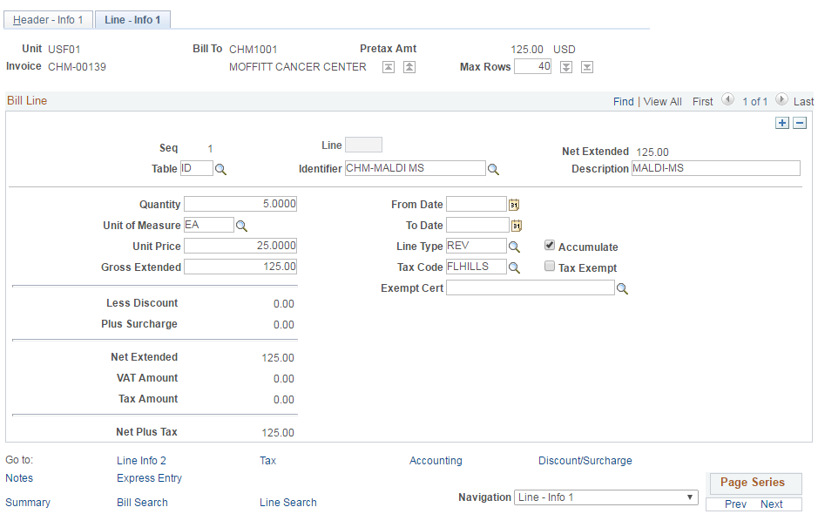

If more than one line note needs to be added, just navigate to another line, and create
an additional line line note.

Each line note will appear just below the specific line.

The line note should specifically relate to the billing line. It could describe the service in more detailed terms, it could include names or dates, or even the customers own purchase order (PO) number to help expedite payment.

In the “Note Text” box, type the note. The “Standard Note Flag” box and the “Internal Only Flag” box should not be checked. Then click the SAVE button.

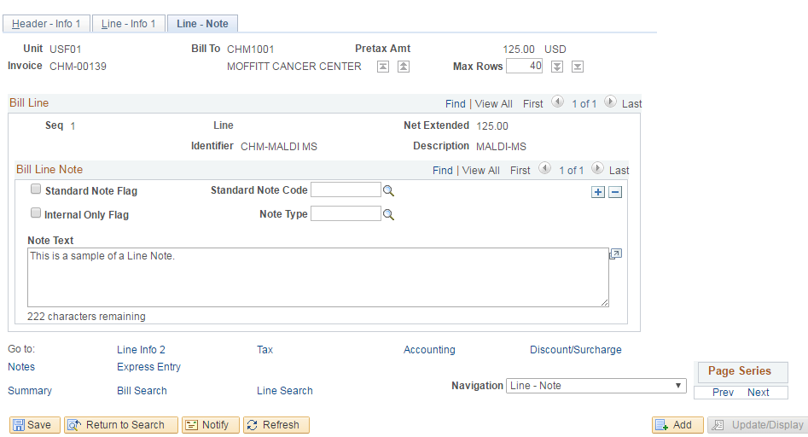

Entering more than one billing line:

It is sometimes necessary to enter more than one billing line on an invoice. The action of adding additional billing lines is taken on the “Line-Info 1” tab.

Remember that sales tax assessment is specific to individual lines. It is possible that one line charge may be subject to sales tax but other lines are not. Each individual appropriate billing line must be tagged for sales tax. Sales tax must then be calculated on the Summary page.

To ensure that the correct amount of sales tax is assessed, it is a good practice to re-calculate the sales tax after all billing lines have been created and just before setting the bill Status to RDY for processing.

Actions that will affect the sales tax calculation include adding a new billing line, changing a quantity, or changing a unit price.

To enter an additional billing line, first navigate to the “Line-Info 1” tab. Then click the
blue button. Notice the “SEQ” sequence number (line number) will change to reflect the
new line number.

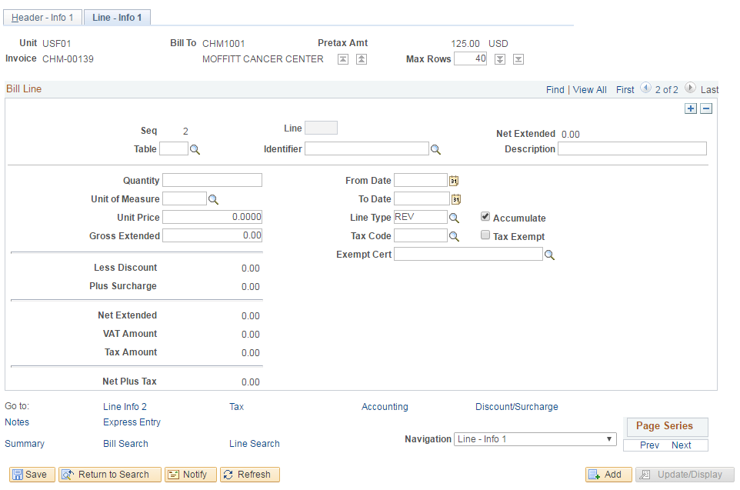

Continue by entering the new billing line information (Table ID, Identifier, quantity, and
Unit price) as described beginning on page 5.

- Updating the Status of a bill:

The status of a bill will determine if updates may still be made to the bill or if it is staged for processing, or if it is finalized.

The following are the available status options:

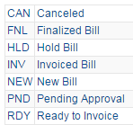
Two options are not available for your selection: FNL (Finalized Bill) and INV (Invoiced Bill).

When a billing is first created and saved, the Status will default to “NEW”. The billing will remain in the billing queue with that status until and only if manually changed. It is often the case that a billing is created and saved and then updated at a later time pending receipt of additional billing information.

When a billing is complete and ready for processing, the status may be changed to “RDY” (Ready to Invoice). Once in this status, changes may be made but in the evening of the day the bill is set to “RDY”, batch processing will select the bill for finalizing after which no further changes can be made. Once evening batch processing has completed, the bill will be automatically updated to “INV” (Invoiced Bill) status after which no changes may be made by either the billing department or the UCO.

An option available to billing departments is to add a layer of review. This is an option for billing departments and not a USF requirement. Billing departments employing this option may direct billers to set the Status to “HLD” (Hold Bill) or “PND” (Pending Approval). Bills in either of these two Status will not be selected for evening batch processing and they will not be automatically finalized. The “HLD” and “PND” status allow departmental/supervisory review within the billing department.

There may be occasion to cancel a billing. A billing may be created after which it is determined to be a duplicate or unneeded billing. In that situation, the Status may be set to “CAN” (cancelled). The bill will not be processed by evening batch processing but will remain in the billing history.

Please remember this quick check list prior to setting the status to RDY.

Is the correct customer ID selected?
Did you use your charge codes/identifiers; are they named with your bill source?
Does the invoice number appear with your bill source?
Have you re-calculated the sales tax?

To change the status, first navigate to the “Header-Info 1” tab, then select the appropriate status, and then save the update.

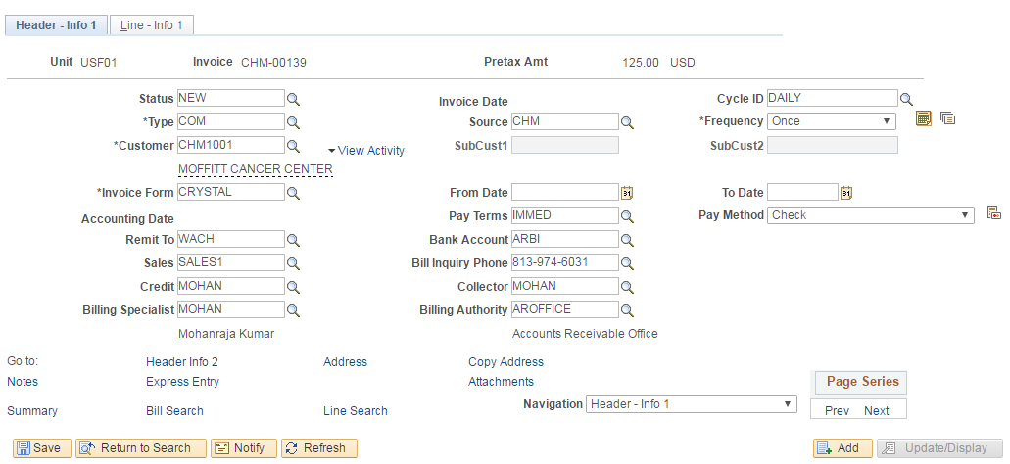

- Maintenance of Existing Un-processed Bills:

To locate an existing bill in the billing queue, navigate: Billing/Maintain Bills/Standard Billing. This will present the “Find an Existing Value” page. From this page, you may search for invoices based on your bill source, the status, the customer ID, or for a specific invoice ID.

This illustration is a search for invoices with a bill source of “URC” and a status of “NEW”.

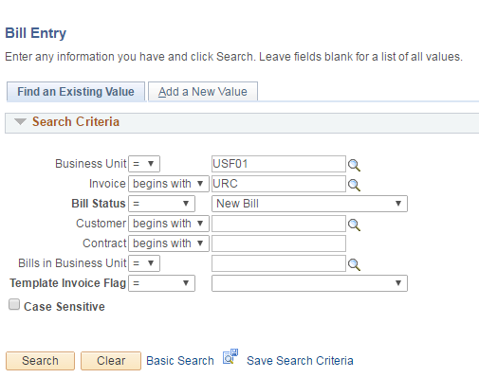

This search will produce a list of billings that need further attention and finalization. Click a specific invoice ID, then proceed with any updates.

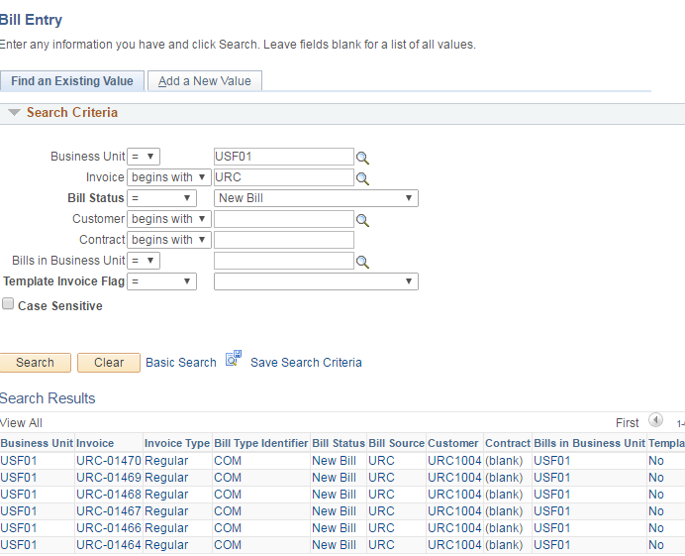

Copy Bill/creating an exact copy of an existing bill:

There may be occasion when multiple billings for the same service and same amount need to be created. You may also need to bill a customer on a frequency for the same service and same amount. An available option is to create a Copy Bill from a previously created bill. With just a few mouse clicks, an exact copy of a bill may be created which will bear a new unique invoice ID.

To copy an existing invoice, navigate: Billing/Maintain Bills/Copy Single Bill. This will present the “Find an Existing Value” page. From this page, you may search for invoices based on your bill source, the status, the customer ID, or for a specific invoice ID. But the best search is for a specific invoice ID. For illustration this search uses ITS-05000. Click for the invoice.

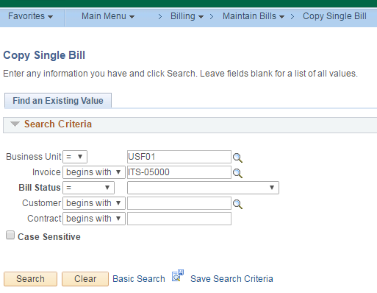

The search results will offer the option to copy the bill. Simply click the “Copy Bill” button, then click to complete the action.

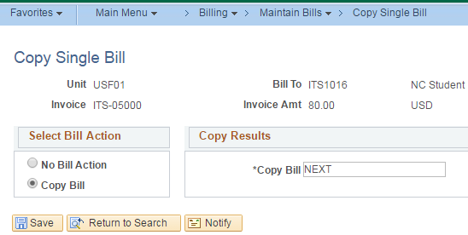

The page will confirm that the bill has been copied and will display the new copied invoice ID.

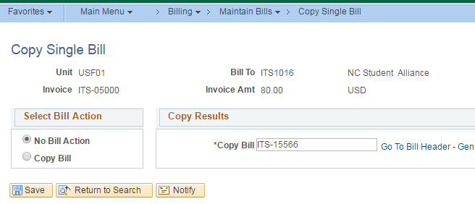

Next click the “Go To Bill Header – Gen Info” button to reveal the header of the newly copied bill. You may make updates if necessary or simply change the Status to “RDY”.

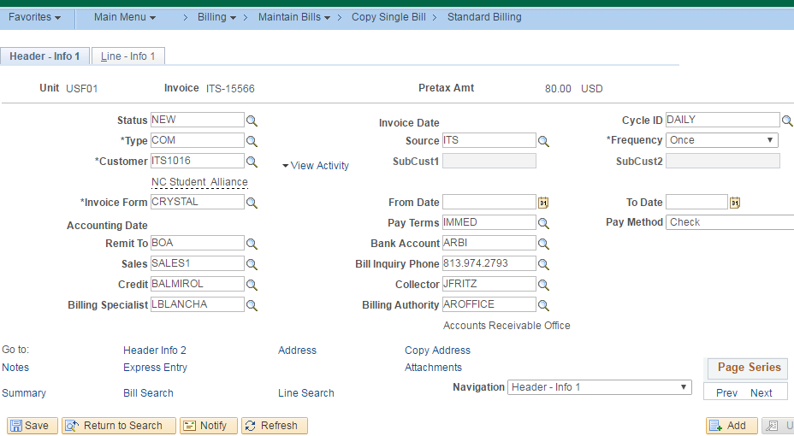

- Reprinting Bills:

Navigate to:
Enter a Run Control ID or use an existing Value.
Enter the Invoice, or Invoice Range you wish to reprint.
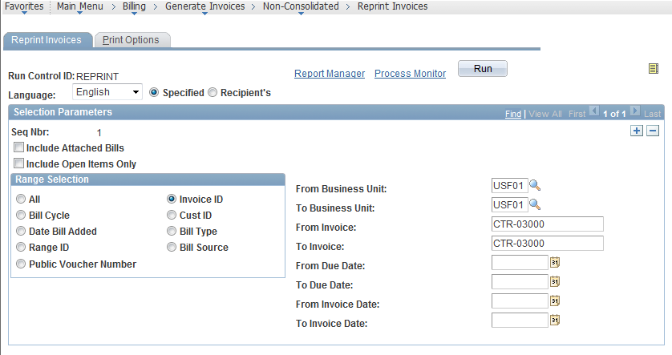
Click
Check the Box next to USF Billing Invoice
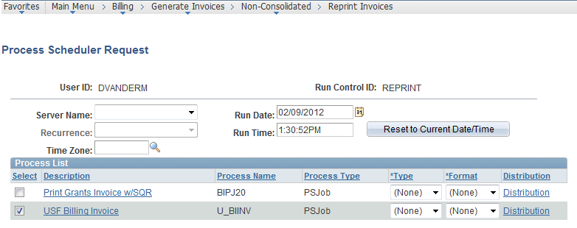
Click
Navigate to:
Select the Administration Tab
Click Refresh. When the BIXPRNT00 – BIXPRNT00.pdf states a Status of “Posted” the file is ready.
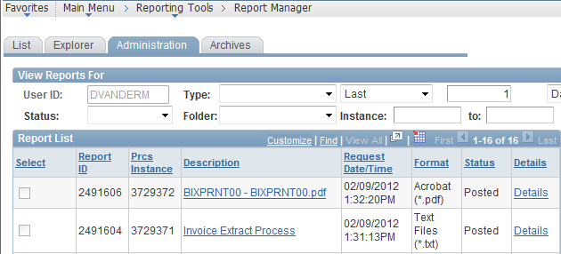
There are two ways to obtain your invoices. The first way is to click the Blue Hyperlink BIXPRNT00 – BIXPRNT00.pdf. This will open the invoices in a new window which you may use to print from.
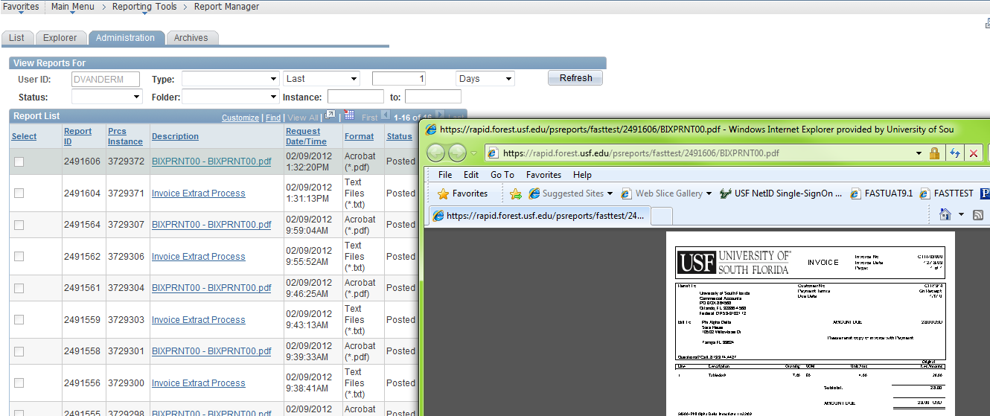

If you would prefer to save the file to a disk drive, click on the Details link to the right. Then Right Mouse click on the BIXPRNT00.pdf blue hyperlink and select “Save Target As”. You may then open the file and print as necessary.
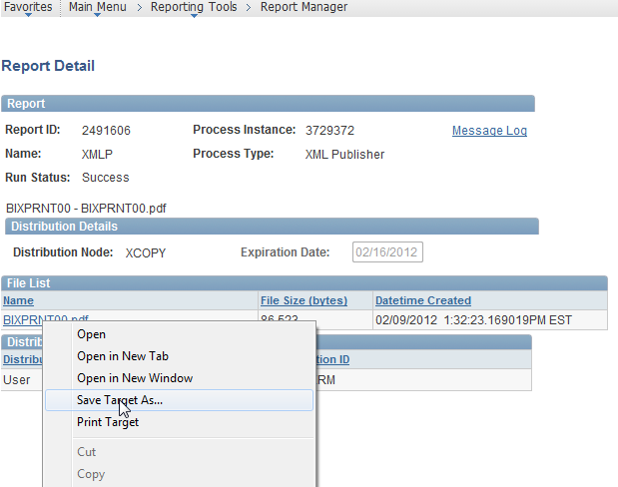

A customer billing may be reprinted only after it has been finalized through evening batch processing and the status has been changed to INV.

Remember that when signing out of FAST click the three dots in the upper right side of the screen. That will reveal options. Click Sign Out.

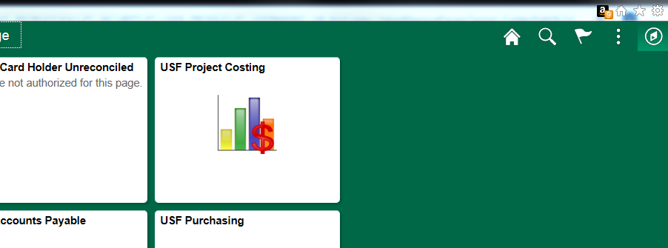

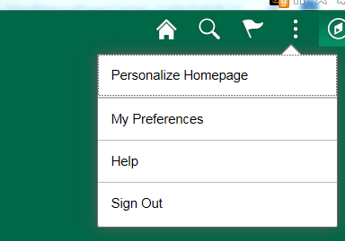

Frequently Asked Questions

• How do I get access to the billing and AR modules in FAST to create customer billings?

You must first attend the Billing and AR training offered by the UCO Controller’s Office. Register for this class on GEMS Self-service.

• How does a department get authorization to invoice customers for services?

You must first submit an EBA (Educational Business Activity) request. If the EBA is approved, you will be given a unique auxiliary fund ID in which you will conduct your business activity.

• Where is EBA information found?

Information about EBA and the EBA request form can be found on the UCO web site: www.usf.edu/business-finance/controller . Look under the Accounting and Reporting tab under Forms.

• How do I invoice other USF departments for services I sell them?

When one USF department provides a service for another USF department, the billing module is not used. You would bill for your services by creating an interdepartmental journal entry. Find the Journal Entry Spreadsheet on the UCO web site, www.usf.edu/business-finance/controller . Look under the Accounting and Reporting tab under Forms.

• How do I have a new customer ID created or update an existing customer ID?

The UCO maintains all customer records (an internal control). Just submit a Customer Request and Update Form; find this form at http://www.usf.edu/business-finance/controller/about/billing.aspx .

• What if my auxiliary needs new charge codes (identifiers) or needs an existing charge code updated?

The UCO maintains the charge code tables. Just submit a Charge Code/Distribution Code Request; find this form at http://www.usf.edu/business-finance/controller/about/billing.aspx .

• What if I need another person added as either a biller, collector, or credit analyst? What if my telephone number changes?

The UCO maintains the tables that include these fields. To add a new person as biller, collector, or credit analyst or to add or update a telephone number, just send the request by email to mdevore@usf.edu.

• How do I request a credit billing?

All adjustments and credits to customer billings must be created only by the UCO. Submit a Billing Correction Form to ARADJ@usf.edu. Find the form on the UCO web site at http://www.usf.edu/business-finance/controller/about/billing.aspx .

Resources/Contact Information

Office of the Controller
Phone: (813) 974-6061
Fax: (813) 974-4485
www.usf.edu/business-finance/controller

Billing and AR Forms
http://www.usf.edu/business-finance/controller/about/billing.aspx

Training and Resources
http://www.usf.edu/business-finance/controller/about/training.aspx

Tax Advisory Services
Phone: (813) 233-2398 (Anne Jetmundsen)
Phone: (813) 835-2264 (Michelle Verdisco)
Fax: (813) 974-4485
http://www.usf.edu/business-finance/controller/payroll/tax.aspx

Business Processes
www.usf.edu/businessprocesses

