Archivum Travel Reports
Guide: Using USF Travel Reports

USF Travel Reports
The USF Travel reports consist of three interactive dashboards and related tables that provide detailed information about travel requests and expense report submissions. The reports are designed for travel coordinators and administrators to easily and efficiently access details on the progress of travel requests and improve travel approval processing.
The three travel reports available for viewing are:
- Pending Status Travel Requests
- Pending Status Expense Reports
- TRs Approved with No ER
Using the interactive Travel report dashboards, you can view travel requests and expense reports submitted by your department. Specific tasks you can perform include the following:
- Review travel requests with a status of Fiscal Review
- Analyze travel requests that have not had a status change in over 30, 60, or 90 days
- View details on travel requests that have been sent back for more information
- Review expense report submissions and isolate those with a HOLD status
- Identify and review the last actions taken on travel requests and expense reports
The information below describes each of the Travel dashboards, provides tips on navigation, and identifies common tasks you can use to view the statuses and identify workflow issues.

Logging In to Power BI
Refer to the instructions in Confluence to access Power BI: https://confluence.usf.edu/display/UHID/Power+BI+Reports
After logging in to Power BI, access the travel reports as follows:
- Select the Apps option in the left panel.
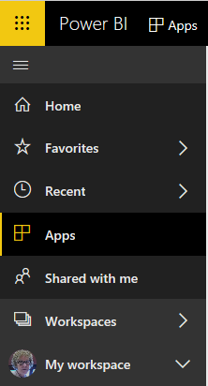
- Click Travel.

Notes:
- The data in these reports are not live but are refreshed once daily from Archivum. View the date on the bottom right of each report to confirm the refresh date.
- Security permissions are set to enable sharing of this data to appropriate users, e.g., travel coordinators have access to view travel requests submitted by travelers in their departments.
- Make selections on the far-left panel of the Power BI display to view the different components of each report.
- Use the Filters panel on the far right to further refine the data displayed.

Travel – Pending Status Travel Requests
The Travel – Pending Status Travel Requests report provides a dashboard for travel coordinators displaying diagrams, charts, and tables of travel requests. Note that view security is set to enable viewing of this data according to permissions.
There are four selections in the far-left panel in this report that provide views of the travel request data.

Selection 1: Pending Status Travel Requests Summary
This selection provides a summary dashboard of travel requests. This dashboard has three panels: the top panel allows you to filter by traveler (and college, depending on your security permissions); the left panel allows you to filter by various elements, such as dates and status; and the data panel displays the travel data with charts, graphs, and tables.
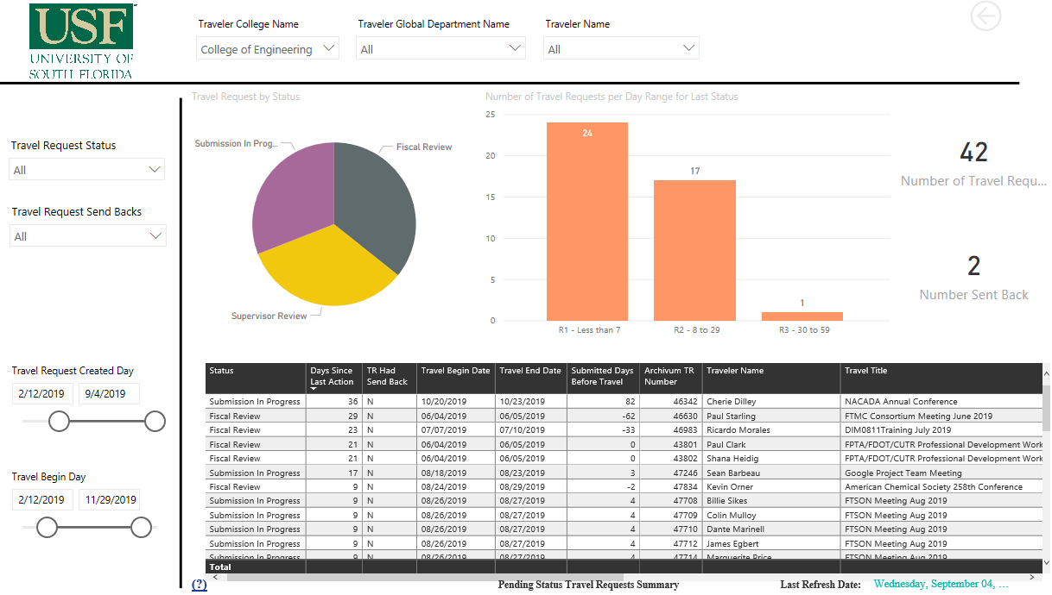
Data Panel (Workspace)
Filter Panel
Top Panel
Top Panel
The filters in the top panel display your college with drop-down fields to select one or more global departments and one or more travelers. Depending on your security permissions, you may have the option to select from the college filter.
Filter Panel
The left Filter Panel allows you to filter the display of information in the data panel.
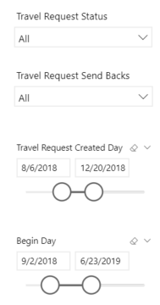
Select to filter by one or more the following options:
- Travel Request Status: Select one or more travel request statuses: Fiscal Review, Submission in Progress, Supervisor Review, Blank, All.
- Travel Request Send Backs: Select Y or N or All.
- Travel Request Created Day: Use the slider to select a date range for the date the travel request was initiated.
- Begin Day: Use the slider to select a date range for the beginning date of the travel.
Data Panel (Workspace)
The panel on the right is the main workspace and consists of 4 sections. These sections are described below:
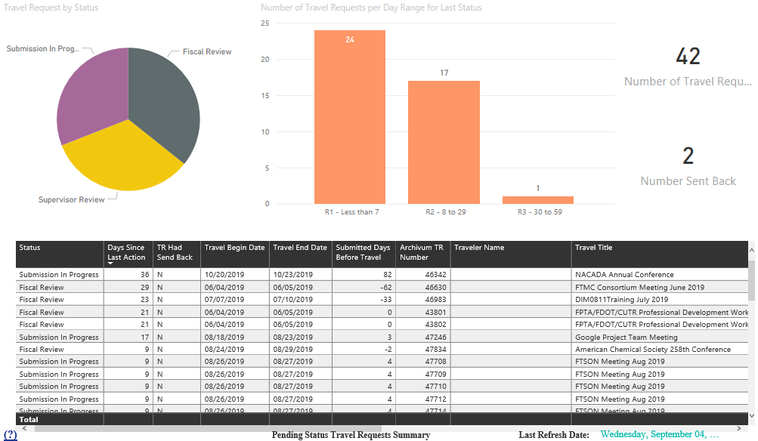
D
Counts
Notes:
- The displays for these sections are interactive; that is, if you select a component in one section, the numbers in the other sections adjust accordingly. For example, select the pie section for Submission In Progress, and the bar chart and table display the items specific to that status.
- To select an item in a display, click the segment of the bar graph or chart. To return to the full display, click that segment again.
- Hover over the pie chart or bar chart segments to view counts for that selection.

Section 1: Travel Requests by Status
This section displays a pie chart showing the number of travel requests by status. If filter options have been made, the pie chart displays counts for only the selected statuses:
- Blank
- Fiscal Review
- Submission in Progress
- Supervisor Review

Section 2: Number of Travel Requests per Day Range for Last Status
This section displays a bar chart showing the number of travel requests by the number of days since the last action was taken.
- R1 - Less than 7
- R2 - 8 to 29
- R3 - 30 to 59
- R4 - 60 to 89
- R5 - More than 90

Section 3: Counts (not labeled in report)
This section shows actual numbers based on the selections made in the filters for the number of requests and the number sent back.

Section 4: Status Table (not labeled in report)
This section displays a table detailing the status for the selections made in filtering the data. Select a column label to sort data by that value. For example, click the Traveler Name label to sort travelers alphabetically by first name.
Columns shown here:
Column Label | Description
Status | Current status of travel expense report:  - Canceled  - Deleted  - Deletion in Progress  - Fiscal Review  - Paid  - Prepay Auditor  - Request Approved  - Submission in Progress  - Supervisor Review
Days Since Last Action | Number of days that an expense report or travel request has been in a particular status.
TR Had Send Back | A travel request that has had a send back at any point will display with a “Y” in this column. A send back indicates more information was needed or the request had a problem, such as an incorrect Product Code.
Travel Begin Date | The date on which a travel trip begins.
Travel End Date | The date on which a travel trip ends.
Submitted Days Before Travel | The difference between the begin date of travel and the creation date of the travel request.
Archivum TR Number | The travel request number created by the Archivum database.
Traveler Name | First and last name of traveler.
Travel Title | Travel title entered by traveler for travel request and expense report.
Traveler Global Department Name | Global Department name associated with person listed as the traveler.
Traveler College Name | Name of College associated with person traveling.
Expense Amount | The total amount of the travel expense that is submitted with this travel request.
Travel Request Type | Indicates the type of travel request submission: Post-Travel Authorization, Travel Request, or Unknown.
FAST TAR | The Travel Authorization Request (TAR) Number with which the employee or traveler is associated.

Sample Tasks
The following are a few examples of ways you can view the data as well as explore the interactivity among the elements in the display.

View Travel Request Send Backs
You can view a list of travel requests that have been sent back for review. For example:
- Select Y in the Travel Request Send Backs filter in the Filter Panel.
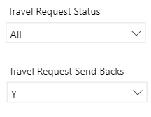
- Review the data in the Workspace, and select additional options, such as send backs that are in Fiscal Review.
- View the selections in the Status Table as shown here:

View Travel Requests with No Status Change in over 60 Days
You can quickly view the travel requests that have not had a recent status change. For example:
- Make any desired selections in the Filter Panel.
- In the Workspace, click on the bar in the bar chart for R4 – 60 to 89. Note that the pie chart values adjust.
- Hover over the slices in the pie chart to view the counts of each status.
- View the filtered data as shown here. Move the table slider to view additional columns in the table:
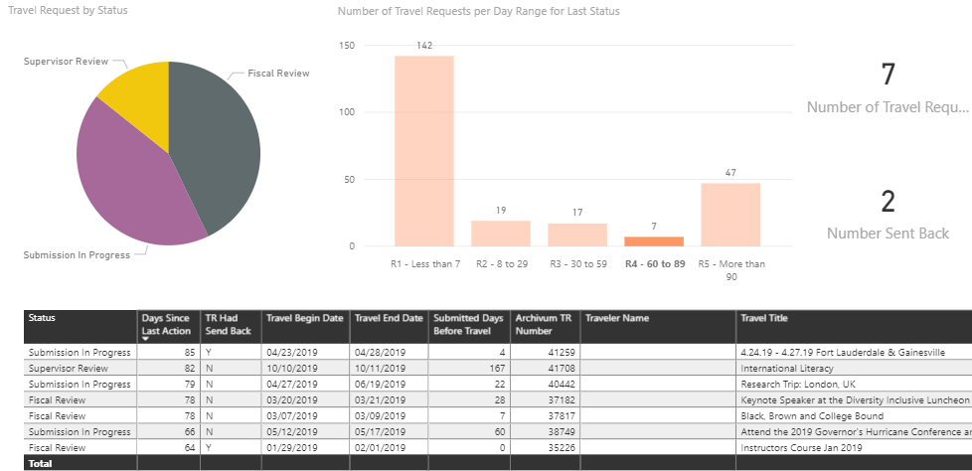

View Travel Request Status for Specific Employees
You can view the status of travel requests for specific employees to provide their statuses. For example:
- Select the employee’s name in the Top Panel.
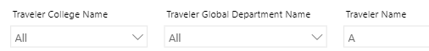
- In the Workspace, view the status and details in the table.
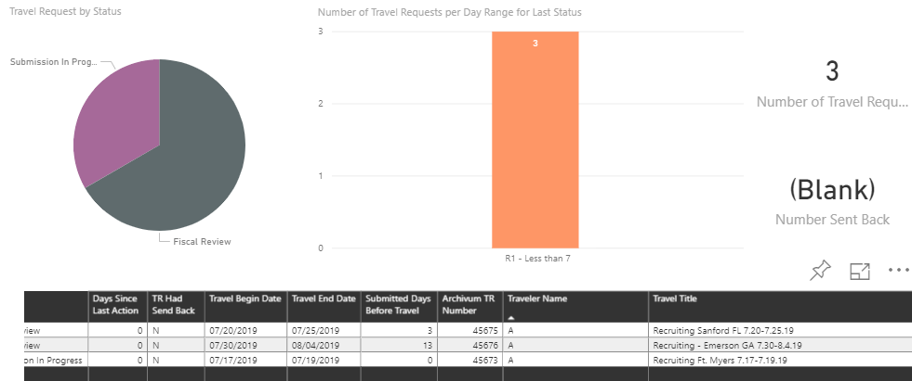

Table selections: Table Views
Selecting the Details options in the far-left panel displays various tables with details on travel requests and subsequent actions. Here are ways you can view and filter data on all tables:
- Sort the data by clicking the column label.
- Export data to Excel by selecting the ellipsis (…) then Export Data. Note: to view the ellipsis in the top right of the table, hover your cursor over the table contents.
The columns shown for each table are:

Selection 2: Details table:
Column Label | Description
Archivum TR Number | The travel request number created by the Archivum database.
FAST TAR | The Travel Authorization Request (TAR) Number with which the employee or traveler is associated.
Status | Current status of travel expense report:  - Canceled  - Deleted  - Deletion in Progress  - Fiscal Review  - Paid  - Prepay Auditor  - Request Approved  - Submission in Progress  - Supervisor Review
Employee ID | The Employee ID is the unique element that GEMS assigns to every employee over the course of their employment.
Rec # | Record number for appointment in GEMS.
Traveler Name | First and last name of traveler.
Travel Title | Travel title entered by traveler for travel request and expense report.
Traveler College Name | Name of college associated with person traveling.
Traveler Global Department Name | Global department name associated with person listed as the traveler.
Expense Description | The description the requester used to describe the travel expense, such as airfare, lodging, or meals.
Expense Amount | The total amount of the travel expense that is submitted with this travel request.
Payment Type | Indicates how the expense was paid: PCard Payment or Traveler Paid – Reimburse.
OU | Indicates the university location where the traveler in the traveler request is affiliated, such as USF Tampa or USF St Pete.
Fund Code | A five-digit value that identifies a source of funds.
FAST Dept Code | A six-digit code that determines FAST department.
Product | The unique code that represents a particular USF product.
Initiative Code | The code for the Travel Request Line Item Details with which the employee or traveler is associated.
Project ID | The identification number of the associated project.
TR Created Date | The date the travel request was created.
Travel Begin Date | The date on which the travel trip begins.
Travel End Date | The date on which a travel trip ends.
Travel Request Type | Indicates the type of travel request submission: Post-Travel Authorization, Travel Request, or Unknown.
Last Action Description | The description of the last action taken on this travel request.
Last Action Note | The note made on the last action taken on this travel request. The note is overwritten in the database when a new action is taken.
Last Action Type | Indicates the type of last action taken on the travel request, such as send back, approval, or fiscal review.
TR Had a Send Back | A travel request that has had a send back at any point will display with a “Y” in this column. A send back indicates more information was needed or the request had a problem, such as an incorrect Product Code.
Last Send Back Date | Indicates the date the travel request was last sent back for more information or additional action. If the travel request was not sent back, this field is blank.
Last Send Back Description | The description given when a travel request is sent back for more information or additional action. If the travel request was not sent back, this field displays “None.”
Last Send Back Note | The note attached to the travel request when it is sent back for more information or additional action. If the travel request was not sent back, this field displays “None.”
Last Send Back Type | The reason the travel request was sent back, such as Fiscal Review or Supervisor Review.
Hire Date | The employee's GEMS appointment hire date.
Termination Date | The GEMS date in which the traveler's job position is terminated, if applicable.
Send Back Person Name | This field records the name of the person who last sends back the travel request for additional information.

Selection 3: Last Action Details:
Column Label | Description
Archivum TR Number | The travel request number created by the Archivum database.
FAST TAR | The Travel Authorization Request (TAR) Number with which the employee or traveler is associated.
Status | Current status of travel expense report:  - Canceled  - Deleted  - Deletion in Progress  - Fiscal Review  - Paid  - Prepay Auditor  - Request Approved  - Submission in Progress  - Supervisor Review
Last Action Description | The description of the last action taken on this travel request.
Last Action Note | The note made on the last action taken on this travel request. The note is overwritten in the database when a new action is taken.
Last Action Type | Indicates the type of last action taken on the travel request, such as send back, approval, or fiscal review.
Last Action Person Name | This field records the name of the person who last updated the travel request.
Traveler Name | First and last name of traveler.
Travel Title | Travel title entered by traveler for travel request and expense report.
Traveler College Name | Name of college associated with person traveling.
Traveler Global Department Name | Global department name associated with person listed as the traveler.
TR Created Date | The date the travel request was created.
Travel Begin Date | The date on which the travel trip begins.
Travel End Date | The date on which a travel trip ends.
Bucket Range Days After Travel | The calculated number of days after travel occurs that the travel request was last given a status. The ranges are:  - R1 - Less than 7  - R2 - 8 to 29  - R3 - 30 to 59  - R4 - 60 to 89  - R5 - More than 90

Selection 4: Last Send Back Details:
Column Label | Description
Archivum TR Number | The travel request number created by the Archivum database.
FAST TAR | The Travel Authorization Request (TAR) Number with which the employee or traveler is associated.
Status | Current status of travel expense report:  - Canceled  - Deleted  - Deletion in Progress  - Fiscal Review  - Paid  - Prepay Auditor  - Request Approved  - Submission in Progress  - Supervisor Review
Last Send Back Date | Indicates the date the travel request was last sent back for more information or additional action. If the travel request was not sent back, this field is blank.
Last Send Back Description | The description given when a travel request is sent back for more information or additional action. If the travel request was not sent back, this field displays “None.”
Last Send Back Note | The note attached to the travel request when it is sent back for more information or additional action. If the travel request was not sent back, this field displays “None.”
Last Send Back Type | The reason the travel request was sent back, such as Fiscal Review or Supervisor Review.
Send Back Person Name | The first and last name of the person who last sent back the travel request for more information or additional action.
Traveler Name | First and last name of traveler.
Travel Title | Travel title entered by traveler for travel request and expense report.
Traveler College Name | Name of college associated with person traveling.
Traveler Global Department Name | Global department name associated with person listed as the traveler.
TR Created Date | The date the travel request was created.
Travel Begin Date | The date on which the travel trip begins.
Travel End Date | The date on which a travel trip ends.
Bucket Range Days After Travel | The calculated number of days after travel occurs that the travel request was last given a status. The ranges are:  - R1 - Less than 7  - R2 - 8 to 29  - R3 - 30 to 59  - R4 - 60 to 89  - R5 - More than 90

Travel – Pending Status Expense Reports
The Travel – Pending Status Expense Reports provides a dashboard for travel coordinators and supervisors displaying diagrams, charts, and tables of travel expense reports. Note that view security is set to enable viewing of this data according to permissions.
There are four selections in the far-left panel in this report that provide views of the travel expense report data.

Selection 1: Pending Status Expense Report Summary
This selection provides a summary dashboard of travel expense reports. The dashboard consists of three panels: the top panel allows you to select a traveler (or other options, depending on your security permissions); the left panel allows you to filter by various elements, such as holds, travel days, and send back status; and the data panel displays the expense report data in different formats with charts, graphs, and tables.
Top Panel
The filters in the top panel display your college with drop-down fields available to select one or more global departments, travelers, fund codes, or FAST department codes.
Filter Panel
The Filter Panel enables filtering of the data in the workspace.
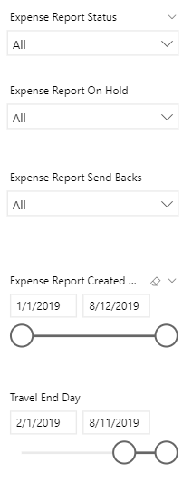
Select to filter by one or more the following options:
- Expense Report Status: Select one or more expense report statuses.
- Expense Report On Hold: Select Y or N or All.
- Expense Report Send Backs: Select Y or N or All.
- Expense Report Created Day: Use the slider to select a date range for the date the expense report was initiated.
- Travel End Day: Use the slider to select a date range for the ending date of the travel.

Data Panel (Workspace)
The panel on the right is the main workspace and consists of four sections. The sections are described in detail below.
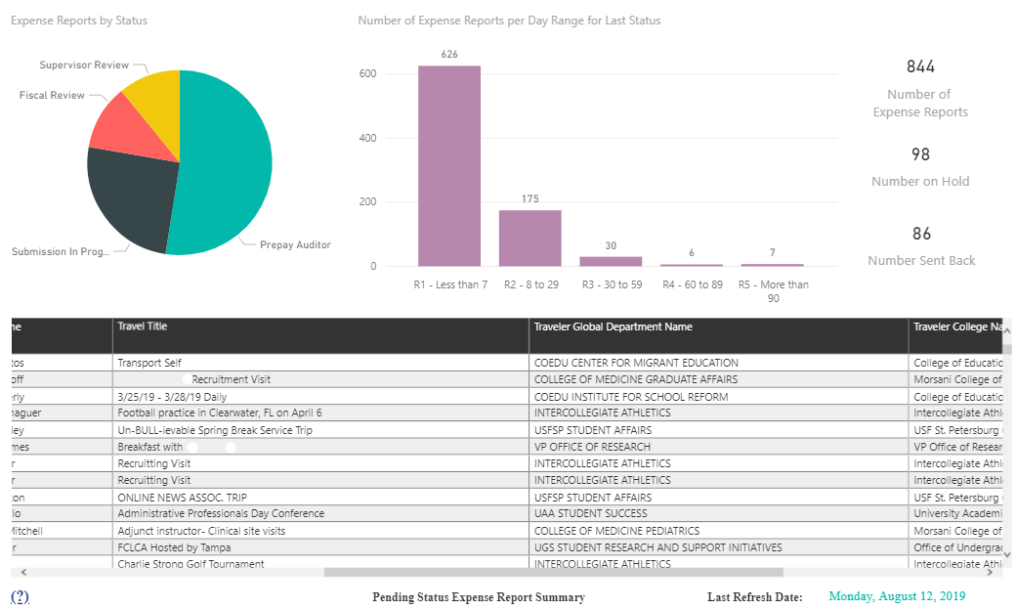
Counts
Notes:
- The displays for these sections are interactive; that is, if you select a component in one section, the numbers in the other sections adjust accordingly. For example, selecting the R3 – 30 to 59 bar adjusts the table entries, the counts, and the status pie chart to show only those expense reports with a last status of 30 to 59 days prior.
- To select an item in a display, click the segment of the bar graph or chart. To return to the full display, click that segment again.
- Hover over the pie chart or bar chart segments to view counts for that selection.

Section 1: Expense Reports by Status
This section displays a pie chart showing the number of expense reports by status. If filter options have been made, the pie chart displays counts for only the selected statuses:
- Fiscal Review
- Prepay Auditor
- Submission in Progress
- Supervisor Review

Section 2: Number of Expense Reports per Day Range for Last Status
This section displays a bar chart showing the number of travel requests by the number of days since the last action was taken.
- R1 - Less than 7
- R2 - 8 to 29
- R3 - 30 to 59
- R4 - 60 to 89
- R5 - More than 90

Section 3: Counts (not labeled in report)
This section shows actual numbers based on the selections made in filtering the data for the number of expense reports, the number of reports on hold, and the number of reports sent back.

Section 4: Status Table (not labeled in report)
This section displays a table detailing the status for the selections made in filtering the data. Select a column label to sort data by that value. For example, click the Traveler Name label to sort travelers alphabetically by first name.
Columns shown here:
Column Label | Description
Status | Current status of travel expense report:  - Canceled  - Deleted  - Deletion in Progress  - Fiscal Review  - Paid  - Prepay Auditor  - Request Approved  - Submission in Progress  - Supervisor Review
Days Since Last Action | The number of days that an expense report has been in a particular status.
ER On Hold | Indicates whether the expense report currently has a Hold.
ER Had Send Back | An expense report that has had a send back at any point will display with a “Y” in this column. A send back indicates more information was needed or the request had a problem, such as a needed adjustment to a meal allowance.
Travel Begin Day | The date on which the travel trip begins.
Travel End Day | The date on which a travel trip ends.
ER Creation Lag | This field is calculated as the difference between the last day of travel and the creation of the travel expense report.
Archivum ER Number | The travel expense report number created by the Archivum database.
Traveler Name | First and last name of traveler.
Travel Title | Travel title entered by traveler for travel request and expense report.
Traveler Global Department Name | Global department name associated with person listed as the traveler.
Traveler College Name | Name of college associated with person traveling.
Expense Amount | The total amount of the travel expense that is submitted with the travel request.
FAST TER | The Travel Expense Report (TER) number assigned to this travel request.
FAST Department Code | A six-digit code that determines the FAST department.

Sample Tasks
The following are a few examples of ways you can view the data as well as explore the interactivity among the elements in the display.

View Expense Reports On Hold
You can view a list of expense reports that are currently on hold. For example:
- Select Y in the Expense Report On Hold filter in the Filter Panel.
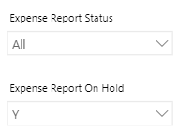
- Review the data in the Workspace, and select additional options, such as holds that have not had recent status changes.
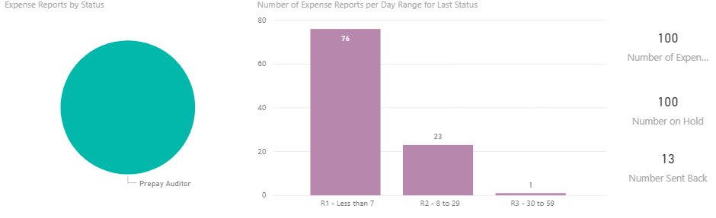
- Optionally filter the results for Expense Report Send Backs in the Filter Panel.
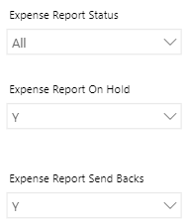
- View the selections in the Status Table as shown here:
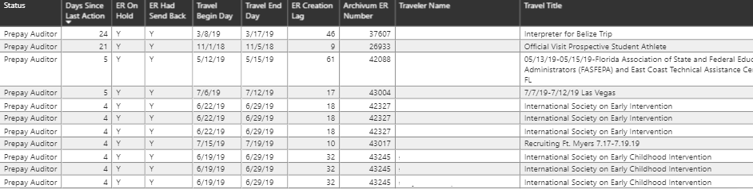

View the Status of Reports Aged More than X Days
- Set desired filters in the Filter Panel.
- Click a bar in the Number of Expense Reports per Day Range section of the Workspace.
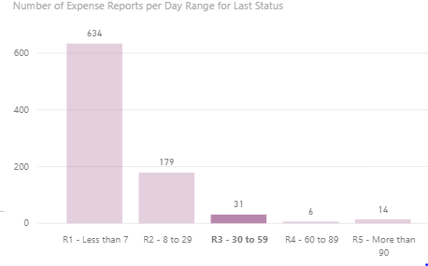
- Note that the other sections adjust to reflect the selection. When you hover over a segment of the pie chart, the percentages are of the filtered total.
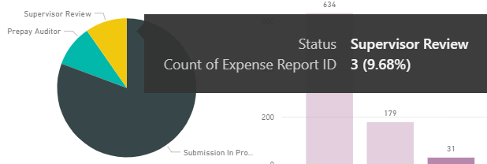
- View the results in the Counts section as well as the Status Table.
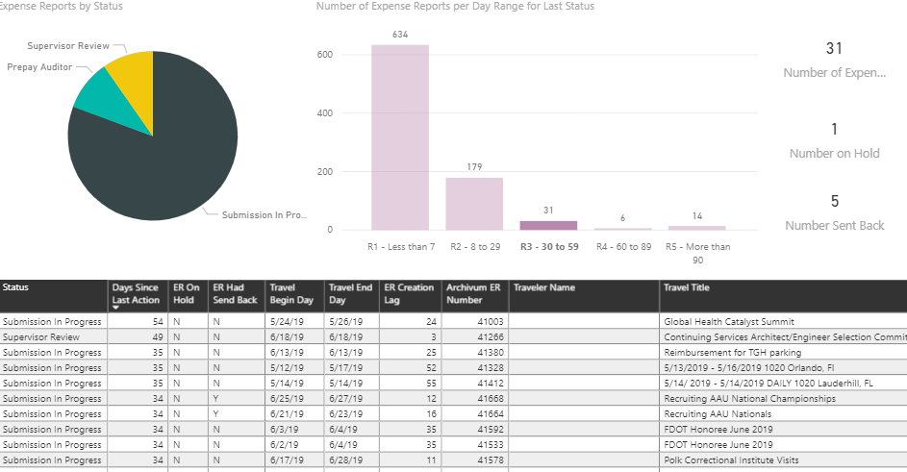

Table selections: Table Views
Selecting the Details options in the far-left panel displays various tables with details on the expense reports and subsequent actions. Here are ways you can view and filter data on all tables:
- Sort the data by clicking the column label.
- Export data to Excel by selecting the ellipsis (…) then Export Data. Note: to view the ellipsis in the top right of the table, hover your cursor over the table contents.
The columns shown for each table are shown by tab below.

Selection 2: Details table:
Column Label | Description
Archivum TR Number | Travel request number created by the Archivum database.
FAST TER | The Travel Expense Report (TER) number assigned to this travel request.
Status | Current status of travel expense report:  - Canceled  - Deleted  - Deletion in Progress  - Fiscal Review  - Paid  - Prepay Auditor  - Request Approved  - Submission in Progress  - Supervisor Review
Employee ID | The Employee ID is the unique element that GEMS assigns to every employee over the course of their employment.
Rec # | Record number for appointment in GEMS.
Traveler Name | The first and last name of the traveler.
Travel Title | Travel title entered by traveler for travel request and expense report.
Traveler College Name | Name of College associated with the person traveling.
Traveler Global Department Name | Global Department name associated with person listed as the traveler.
Expense Description | The description the requester used to describe the travel expense, such as airfare, lodging, or meals.
Expense Amount | The total amount of the travel expense that is submitted with the travel request.
Payment Type | Indicates how the expense was paid: PCard Payment or Traveler Paid – Reimburse.
Fund Code | A five-digit value that identifies a source of funds.
FAST Dept Code | A six-digit code that determines FAST department.
Product | The unique code that represents a particular USF product.
Initiative Code | The code for the Travel Request Line Item Details with which the employee or traveler is associated.
Project ID | The identification number of the associated project.
ER Created Date | The day the travel expense report was created.
Travel Begin Day | The date on which the travel trip begins.
Travel End Day | The date on which a travel trip ends.
ER Hold | Indicates whether the expense report currently has a Hold.
Last Action Date | Indicates the date of the last action take on this travel expense report.
Last Action Description | The description of the last action taken on this travel expense report.
Last Action Note | The note made on the last action taken on this travel expense report. The note is overwritten in the database when a new action is taken.
Last Action Type | Indicates the type of last action taken on the travel expense report, such as budget check or submission.
ER Had a Send Back | An expense report that has had a send back at any point will display with a “Y” in this column. A send back indicates more information was needed or the request had a problem, such as an incorrect Product Code.
Send Back Date | Indicates the date the expense report was last sent back for more information or additional action. If the travel request was not sent back, this field is blank.
Send Back Description | The description given when the expense report is sent back for more information or additional action. If the expense report was not sent back, this field displays “None.”
Send Back Type | The reason the expense report was sent back, such as Prepay Auditor or Fiscal Review.
Send Back Note | The note attached to the expense report when it is sent back for more information or additional action. If the expense report was not sent back, this field displays “None.”
Bucket Range | The calculated number of days after an expense report is submitted that it was last given a status. The ranges are:  - R1 - Less than 7  - R2 - 8 to 29  - R3 - 30 to 59  - R4 - 60 to 89  - R5 - More than 90
Hire Date | The employee's GEMS appointment hire date.
Termination Date | The GEMS date in which the traveler's job position is terminated, if applicable.

Selection 3: Last Action Details table:
Column Label | Description
Archivum TR Number | The travel request number created by the Archivum database.
FAST TER | The Travel Expense Report (TER) number assigned to this travel request.
Status | Current status of travel expense report:  - Canceled  - Deleted  - Deletion in Progress  - Fiscal Review  - Paid  - Prepay Auditor  - Request Approved  - Submission in Progress  - Supervisor Review
ER has Hold | Indicates whether the expense report currently has a Hold.
Last Action Date | Indicates the date of the last action take on this travel expense report.
Last Action Description | The description of the last action taken on this travel expense report.
Last Action Note | The note made on the last action taken on this travel expense report. The note is overwritten in the database when a new action is taken.
Last Action Type | Indicates the type of last action taken on the travel expense report, such as budget check or submission.
Last Action Person Name | This field records the name of the person who last updated the travel expense report.
Traveler Name | First and last name of traveler.
Travel Title | Travel title entered by traveler for travel request and expense report.
Traveler College Name | Name of college associated with person traveling.
Traveler Global Department Name | Global department name associated with person listed as the traveler.
Expense Amount | The total amount of the travel expense that is submitted with the travel request.
ER Created Day | The day the travel expense report was created.
Travel End Day | The date on which a travel trip ends.
Bucket Range | The calculated number of days after an expense report is submitted that it was last given a status. The ranges are:  - R1 - Less than 7  - R2 - 8 to 29  - R3 - 30 to 59  - R4 - 60 to 89  R5 - More than 90

Selection 4: Last Send Back Details table:
Column Label | Description
Archivum TR Number | The travel request number created by the Archivum database.
FAST TAR | The Travel Authorization Request (TAR) Number with which the employee or traveler is associated.
Status | Current status of travel expense report:  - Canceled  - Deleted  - Deletion in Progress  - Fiscal Review  - Paid  - Prepay Auditor  - Request Approved  - Submission in Progress  - Supervisor Review
ER Had Send Back | An expense report that has had a send back at any point will display with a “Y” in this column. A send back indicates more information was needed or the request had a problem, such as a needed adjustment to a meal allowance.
Last Send Back Date | Indicates the date the expense report was last sent back for more information or additional action. If the travel request was not sent back, this field is blank.
Last Send Back Description | The description given when the expense report is sent back for more information or additional action. If the expense report was not sent back, this field displays “None.”
Last Send Back Note | The note attached to the expense report when it is sent back for more information or additional action. If the expense report was not sent back, this field displays “None.”
Last Send Back Action Type | The reason the expense report was sent back, such as Prepay Auditor or Fiscal Review.
Last Send Back Person | This field records the name of the person who last sent back the expense report for additional information or review.
Traveler Name | First and last name of traveler.
Travel Title | Travel title entered by traveler for travel request and expense report.
Traveler College Name | Name of college associated with person traveling.
Traveler Global Department Name | Global department name associated with person listed as the traveler.
Expense Amount | The total amount of the travel expense that is submitted with the travel request.
ER Created Day | The day the travel expense report was created.
Travel End Day | The date on which a travel trip ends.
Bucket Range | The calculated number of days after an expense report is submitted that it was last given a status. The ranges are:  - R1 - Less than 7  - R2 - 8 to 29  - R3 - 30 to 59  - R4 - 60 to 89  - R5 - More than 90

Travel – TRs Approved with No ER
The Travel – TRs Approved with No ER report provides a dashboard showing the travel requests that have been approved without an expense report. Note that view security is set to enable viewing of this data according to permissions.
Note: This report only pulls data for travel requests with travel end dates prior to today.
There are two selections in this report that provide views of the expense report data: Travel Requests Approved with No ER and Details.

Selection 1: Travel Requests Approved with No ER
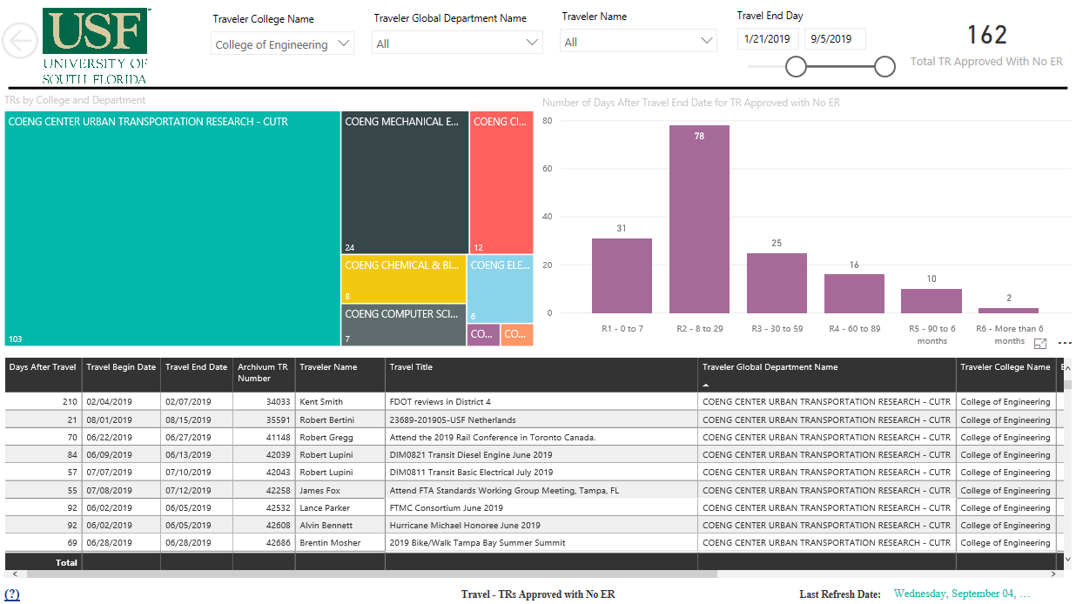
Data Panel (Workspace)
Top Panel
This dashboard has two panels: The Top Panel and the Data Panel (Workspace). Filter the display by selecting one or more travelers, departments, or dates to view the travel requests that have been approved without an accompanying expense report.
As with the other reports, the displays for these sections are interactive; that is, if you select a component in one section, the numbers in the other sections adjust accordingly. For example, selecting an individual bar in the Number of Days bar chart adjusts the entries in the table to display only the data for the indicated number of days after travel.
The data panel consists of three sections. The sections are described in detail below.

Section 1: TRs by College and Department
This section displays the college for which you have security, and when opening the report, the treemap displays the college or colleges for which you have permissions. To view individual departments within your college:
- Hover over the rectangular display for your college.
- Click the down arrow (Drill Down).
- Click anywhere in the colored rectangle for the desired college.
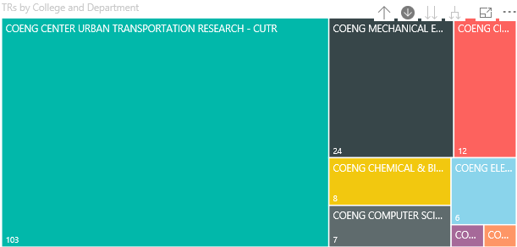
The display breaks down the numbers by department.
- Drill up to return to the previous display (Up Arrow).
Note that if you have permissions for more than one college, the process is the same; however, you will see all of your colleges in the initial treemap display.

Section 2: Number of Days After Travel End Date for TR Approved with No ER
This section displays a bar chart showing the elapsed time after the end date of travel that the request was approved.
- R1 – 0 to 7
- R2 - 8 to 29
- R3 - 30 to 59
- R4 - 60 to 89
- R5 – 90 to 6 months
- R6 – More than 6 months

Section 3: Status Table (not labeled in report)
This section displays a table detailing the status for the selections made in filtering the data. Select a column label to sort data by that value. For example, click the Traveler Name label to sort travelers alphabetically by first name.
Columns shown here:
Column Label | Description
Days After Travel | The calculated number of days after the travel end date that the travel request was approved.
Travel Begin Date | The date on which the travel trip begins.
Travel End Date | The date on which a travel trip ends.
Archivum TR Number | An expense report that has had a send back at any point will display with a “Y” in this column. A send back indicates more information was needed or the request had a problem, such as a needed adjustment to a meal allowance.
Traveler Name | First and last name of traveler.
Travel Title | Travel title entered by traveler for travel request and expense report.
Traveler Global Department Name | Global department name associated with person listed as the traveler.
Traveler College Name | Name of college associated with person traveling.
Expense Amount | The total amount of the travel expense that is submitted with this travel request.
Travel Request Type | Indicates the type of travel request submission: Post-Travel Authorization, Travel Request, or Unknown.
GEMS Dept Code | The unique GEMS code that represents the department profile associated to the traveler.
Submitter Name | The name of the person submitting the travel request, which may be different than the traveler.
Furthest Location | The travelers furthest point of travel.
FAST TAR | The Travel Authorization Request (TAR) Number with which the employee or traveler is associated.

Selection 2: Details
This table provides details on the travel requests that have been approved without an expense report and lists several data points as shown in the column listing below. Here are ways you can view and filter data on all tables:
- Sort the data by clicking the column label.
- Export data to Excel by selecting the ellipsis (…) then Export Data. Note: to view the ellipsis in the top right of the table, hover your cursor over the table contents.
Details table columns:
Column Label | Description
Archivum TR Number | Travel request number created by the Archivum database.
FAST TAR | The Travel Authorization Request (TAR) Number with which the employee or traveler is associated.
Status | Current status of travel expense report:  - Canceled  - Deleted  - Deletion in Progress  - Fiscal Review  - Paid  - Prepay Auditor  - Request Approved  - Submission in Progress  - Supervisor Review
Traveler Name | First and last name of traveler.
Travel Title | Travel title entered by traveler for travel request and expense report.
Traveler College Name | Name of college associated with person traveling.
Traveler Global Department Name | Global department name associated with person listed as the traveler.
Expense Description | The description the requester used to describe the travel expense, such as airfare, lodging, or meals.
Expense Amount | The total amount of the travel expense that is submitted with the travel request.
Payment Type | Indicates how the expense was paid: PCard Payment or Traveler Paid – Reimburse.
OU | Indicates the university location where the traveler in the traveler request is affiliated, such as USF Tampa or USF St Pete.
Fund Code | A five-digit value that identifies a source of funds.
FAST Dept Code | A six-digit code to determine FAST Department.
Product | The unique code that represents a particular USF product.
Initiative Code | The code for the Travel Request Line Item Details with which the employee or traveler is associated.
Project ID | The identification number of the associated project.
TR Created Date | The date the travel request was created.
Travel Begin Date | The date on which the travel trip begins.
Travel End Date | The date on which a travel trip ends.
Travel Request Type | Indicates the type of travel request submission: Post-Travel Authorization, Travel Request, or Unknown.
Last Action Description | The description of the last action taken on this travel request.
Last Action Note | The note made on the last action taken on this travel request. The note is overwritten in the database when a new action is taken.
Last Action Type | Indicates the type of last action taken on the travel request, such as send back, approval, or fiscal review.
TR Had a Send Back | A travel request that has had a send back at any point will display with a “Y” in this column. A send back indicates more information was needed or the request had a problem, such as an incorrect Product Code.
Last Send Back Date | Indicates the date the travel request was last sent back for more information or additional action. If the travel request was not sent back, this field is blank.
Last Send Back Description | The description given when the travel request is sent back for more information or additional action. If the expense report was not sent back, this field displays “None.”
Last Send Back Note | The note attached to the travel request when it is sent back for more information or additional action. If the expense report was not sent back, this field displays “None.”
Last Send Back Type | The reason the travel request was sent back, such as Prepay Auditor or Fiscal Review.
Send Back Person Name | This field records the name of the person who last sent back the travel request for additional information or review.

