How to read your paycheck:
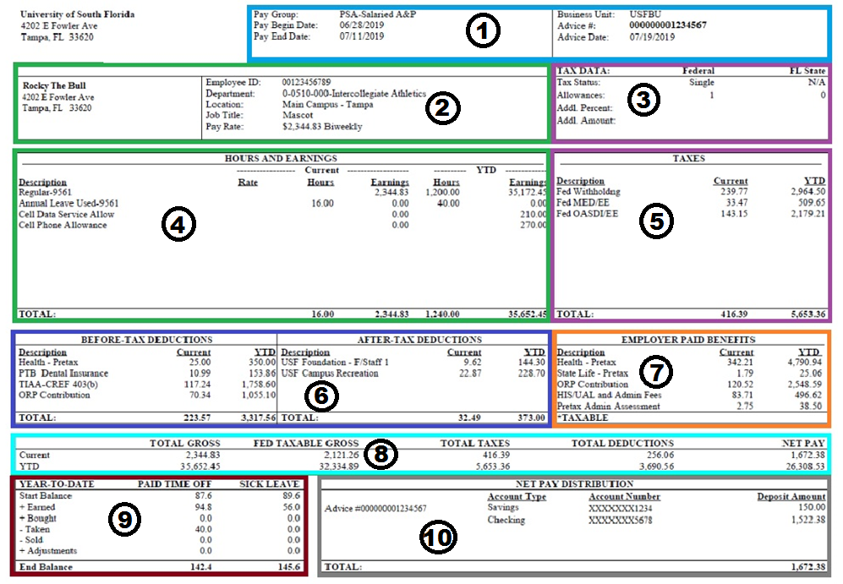
Section | Description | Fields
1 | Payroll Information | § Pay Group (The employee's classification) § Pay Period Begin and End Dates  § Business Unit: USF § Advice Number: Check Number for a Direct Deposit Stub  § Advice Date: Check Date
2 | Employee Information | § Employee Name, Employee Address, Employee ID  § Department: The employee’s primary department § Location: The employee’s primary location § Job Title: The employee’s primary job title  § Pay Rate: The employee’s pay rate, expressed either as a biweekly salary amount for faculty, administration, staff, and exempt temporary employees, or as an hourly rate for hourly temporary employees
3 | Tax Data | § W-4 election exemption claimed for Federal Withholding Tax calculation
4 | Hours and Earnings | § Displays the employee’s wages by earnings type and job code for the current period § Displays the employee’s year-to-date wages by earnings type
5 | Taxes | The employee's current period and year-to-date tax withholdings by type:  § Fed Withholding: Federal income tax withheld  § Fed MED/EE: Employee portion of Medicare tax  § Fed OASDI/EE: Employee portion of Social Security tax
6 | Deductions--Before and After Tax | § Before Tax Deductions: are deducted before taxes, which reduces the Federal taxable wages.  § After Tax Deductions: are deducted after the before tax, and tax deductions.
7 | Employer-Paid Benefits | § These are the employer paid portions of elected benefits.  § If any amounts are included as taxable income, they will be indicated with a *
8 | Paycheck Summary | § Displays a breakdown of current period and year-to-date earnings, taxes, deductions, and net pay.
9 | Leave Balances | Paid Time Off (annual leave) and Sick Leave balances  § Start Balance: the beginning leave balance as of the first pay period of the year  § + Earned: hours accrued year-to-date  § - Taken: hours used year-to-date  § + Adjustments: leave balance adjustments year-to-date
10 | Net Pay Distribution | § Advice Number: The number assigned to the employee’s pay advice, similar to a check number  § Account Type: The type of bank account, either Checking or Savings  § Account Number: The bank account last 4 digits  § Deposit Amount: The amount sent to that bank account via direct deposit  § If multiple bank accounts are used the each will display in a separate line  § Total: The total net pay sent via direct deposit

