University of South Florida
Amazon Business Ship-To Set Up Instructions
- Sign in to your USF Amazon Business Prime account.
- Go to Your Account
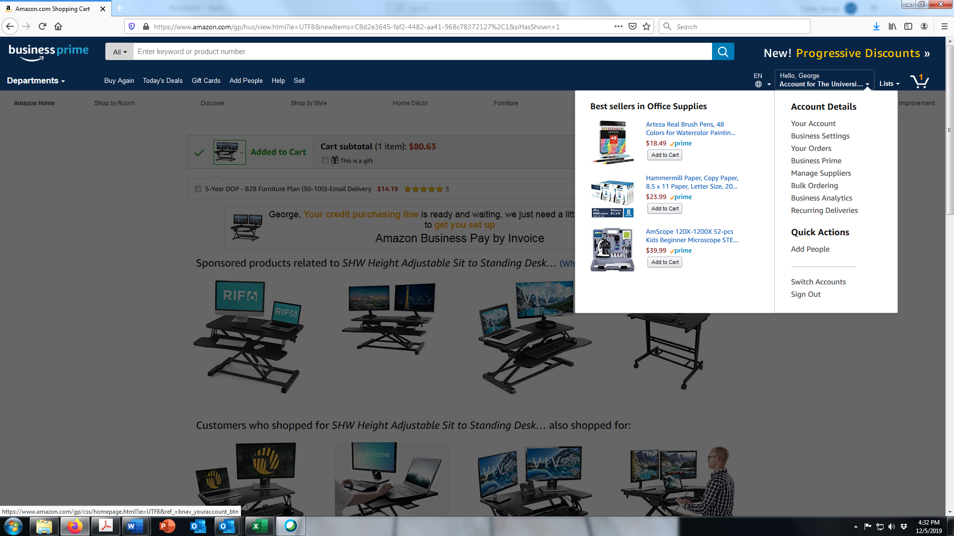
- Go to Your Addresses
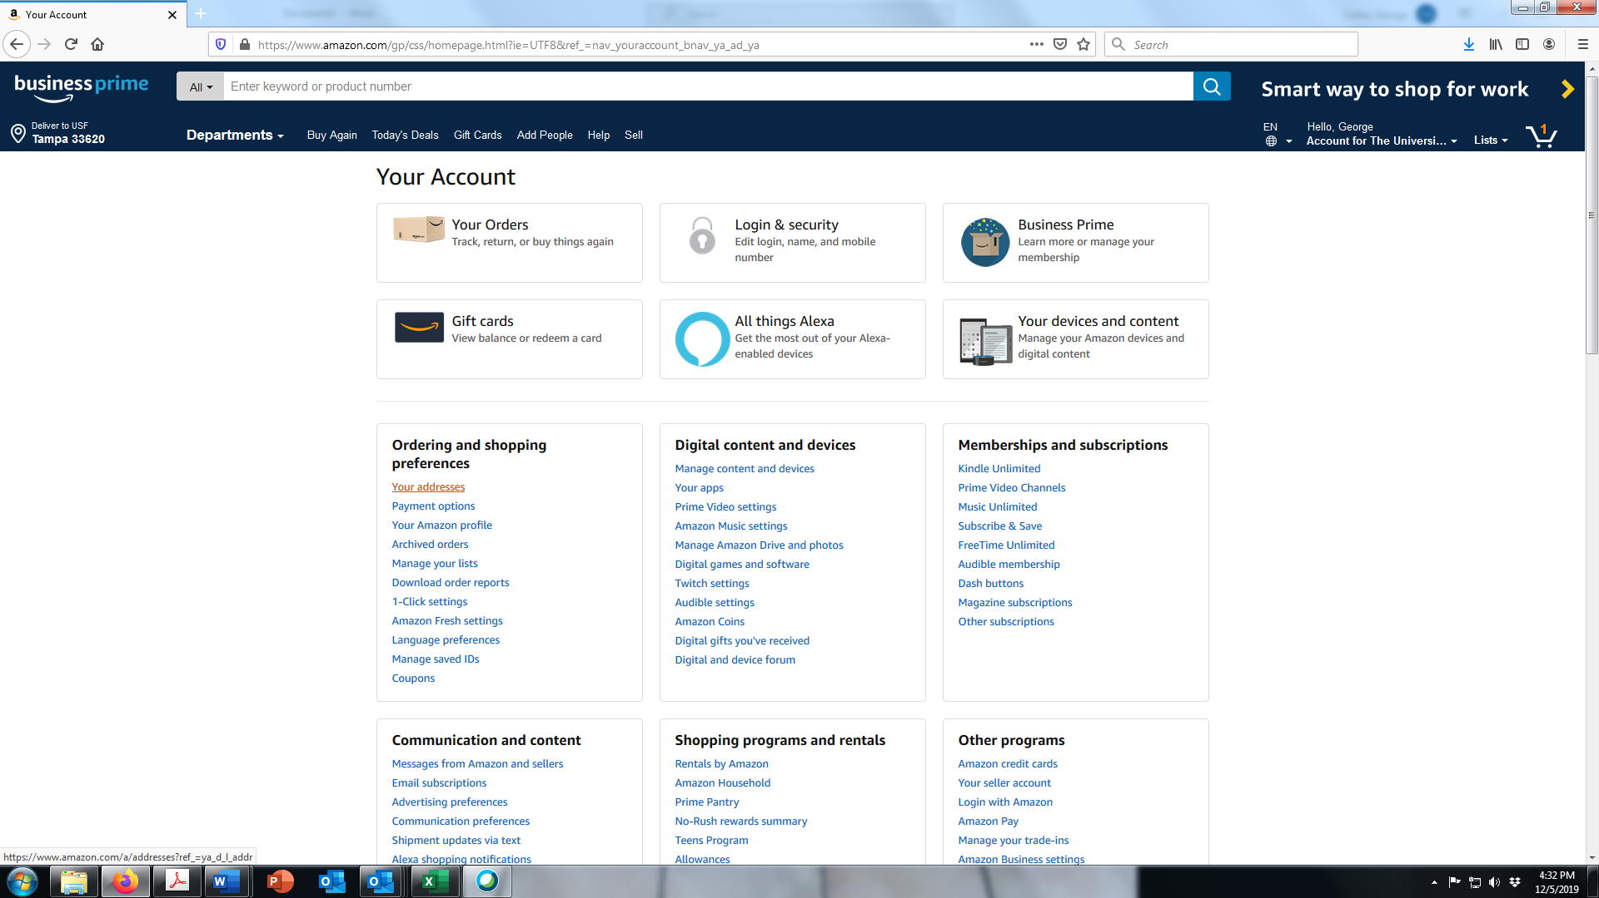

- Click on Add Address. You can add as many addresses as you like & set a default.
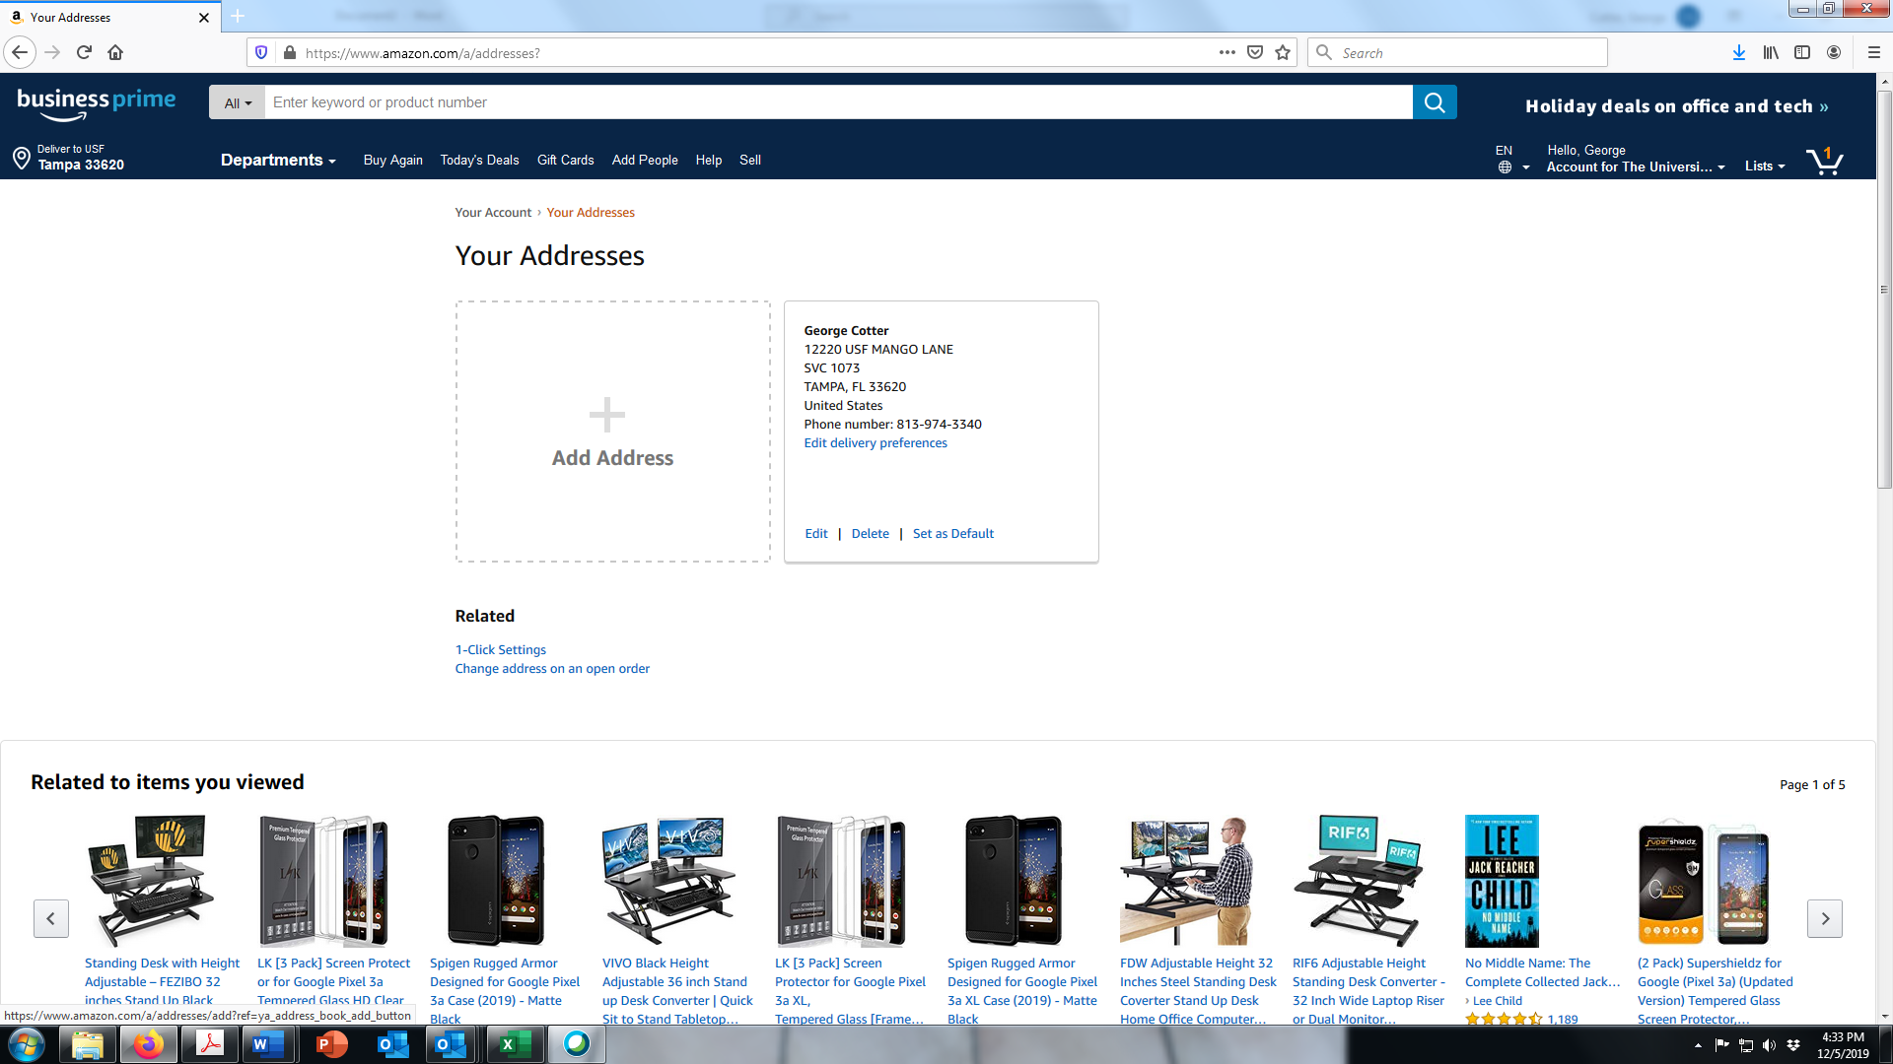
- Fill in the Add a new Address to support Amazon delivery
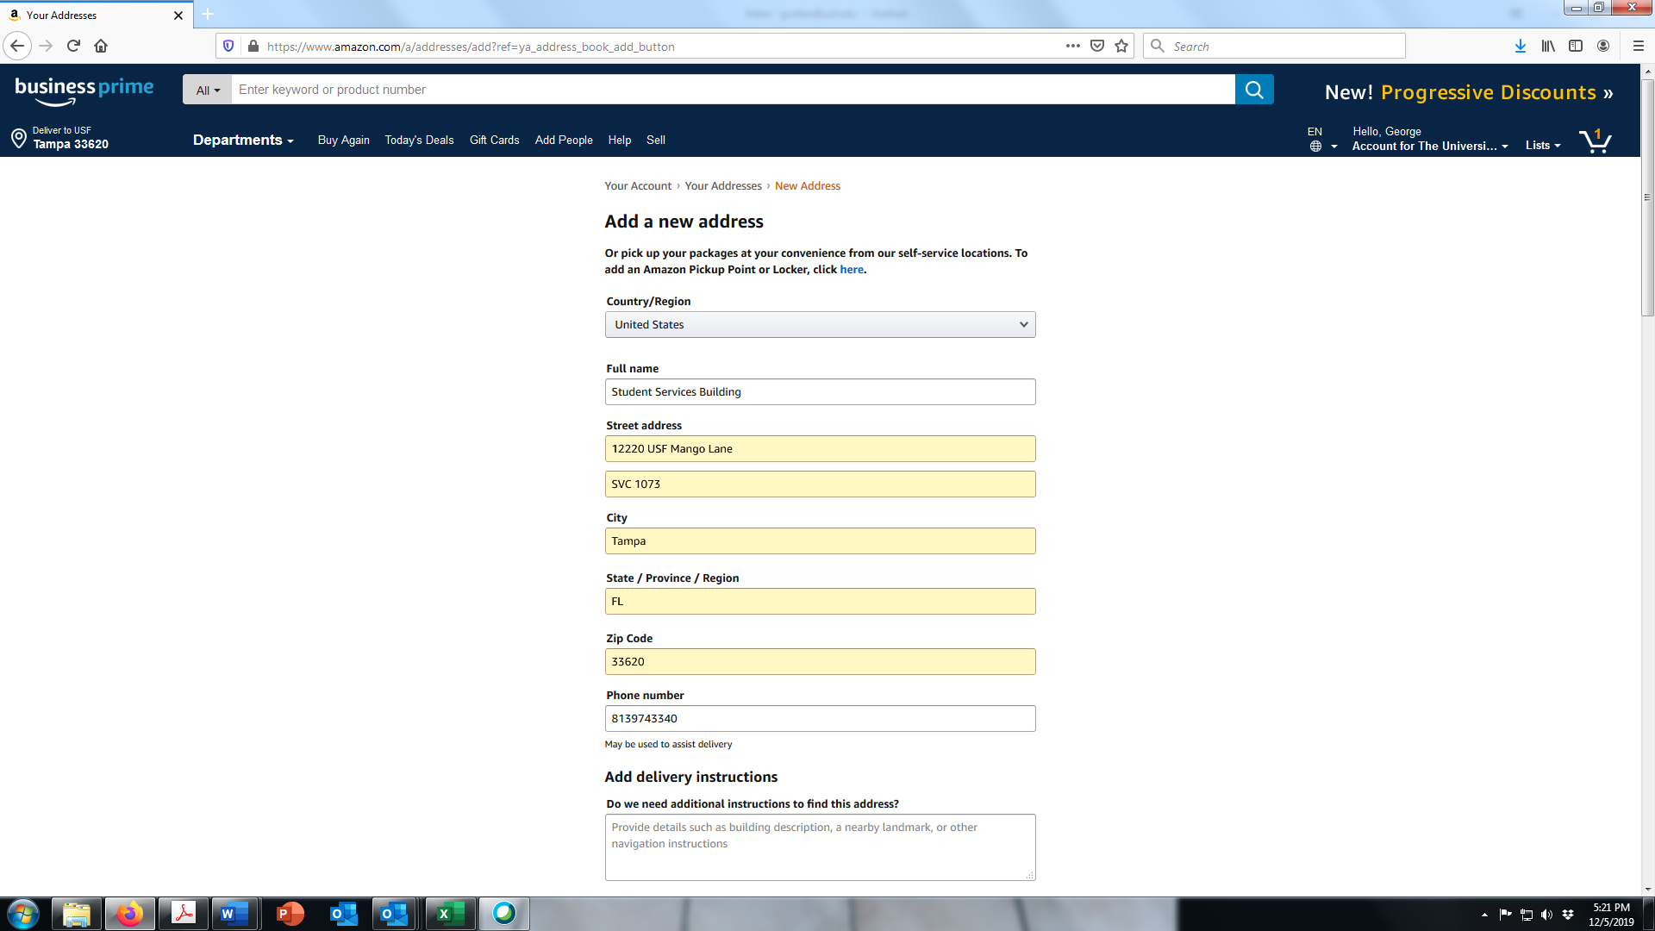
Physical Address
Mail Stop
Additional Delivery instructions
Location Name
- When you check out, you will be able to add an attention to name, or department name, so that it is clearly labeled on the shipping label.

