Archivum Travel
Tutorial: Signing/Declining Documents in DocuSign

Purpose: | To assist users to sign/decline travel documents sent via DocuSign for Expense Reports and Cash advances in Archivum Travel
Notes: | Expense Reports and Cash Advances submitted in Archivum Travel can be signed via DocuSign for all USF employee and student travelers. DocuSign’s electronic signature technology will allow you to choose, draw, or upload the signature you will use to sign documents. You can visit the following link support.docusign.com/en/guides/ndse-user-guide-change-your-signature for a guide on how to create your signature. You will be prompted to create your own signature the first time you use DocuSign.

Steps to Signing Documents in DocuSign for Archivum Travel:
Steps | Description
1 | When DocuSign is selected as an option to send the coversheet for the traveler’s signature, the traveler will receive an e-mail like the one below notifying them that they need to review and sign. Click on Review Document. If you are expecting a document to sign and have not received an e-mail notification, please check your ‘Clutter’ folder in case it was directed there.  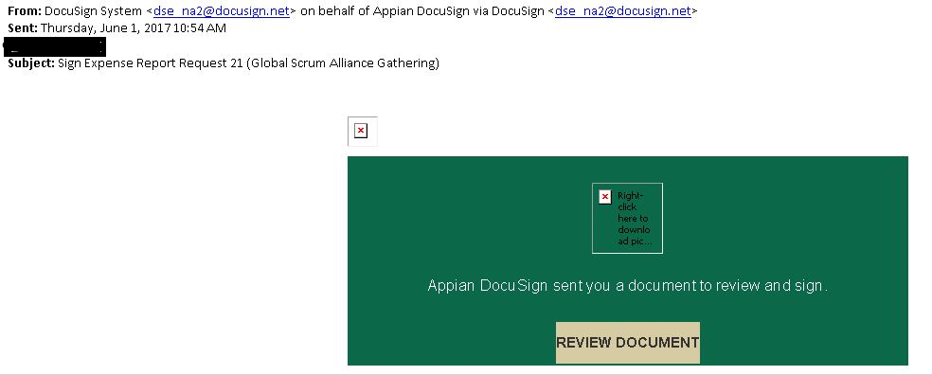
2. | You will be directed to the DocuSign sign in page. Click continue. If you did not receive an e-mail, you can also access the document directly in DocuSign. Visit http://docusign.com and click Log in in the upper right corner. Enter your USF primary e-mail address and click continue.  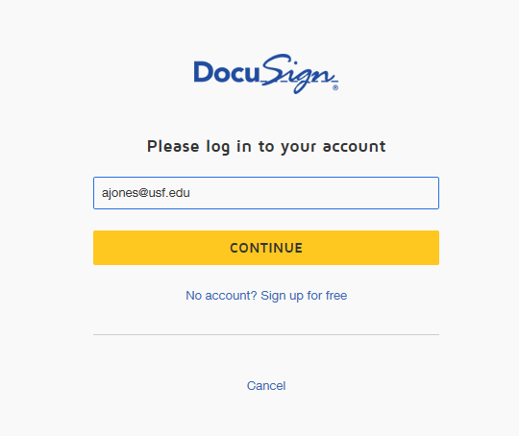
3. | You will be directed to USF’s Single-SignOn page as seen below for authentication. Enter your NetID and NetID password. Click Sign in.  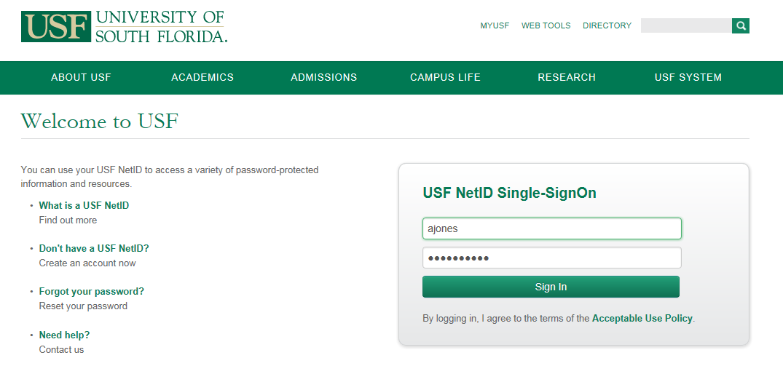
4. | You will be directed to the DocuSign web page as seen below. Select the checkbox I agree to use electronic records and signatures. And click continue.  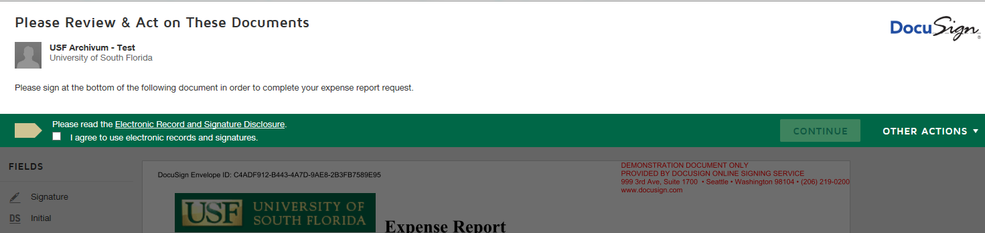
5. | Scroll to the end of the document where the signature is required. Click on Signature on the left and drag and drop in the space for the signature.  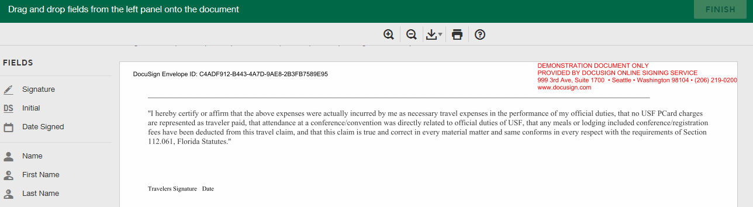
6. | The first time you receive the request in DocuSign a new window opens. You can directly click on Adopt and Sign to accept the default signature or you can click on Select Style and select a different option or you can click on Draw and draw your signature/initials using a mouse, your finger or stylus on a touchscreen. Click Adopt and Sign to adopt and save the signature and return to the document.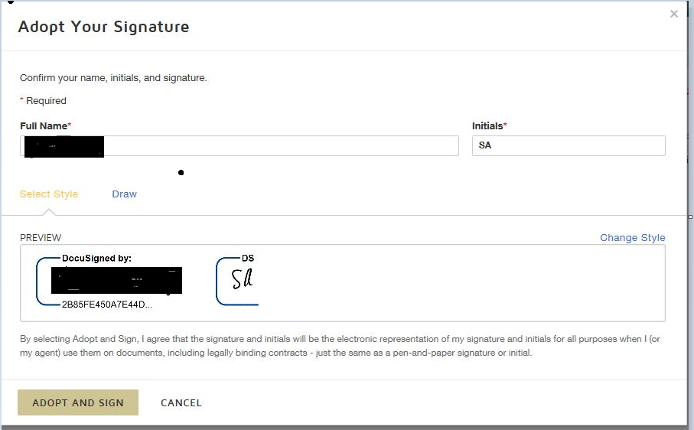
7. | After signature is saved, click on Date Signed on the left and drag and drop in the space for the date right after the signature.
8. | Once you are satisfied with the signature, click the Finish button at the bottom or top right hand corner of the document.
9. | A message appears stating that you have completed signing your document. You have the options to download or print a copy of the document.  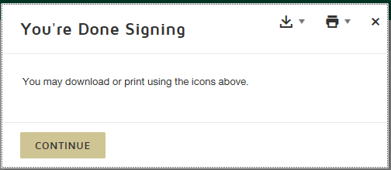
10. | Click Continue and you will receive confirmation as below. Note: It can sometimes take up to 32 minutes for the submitter to receive the document in Archivum Travel  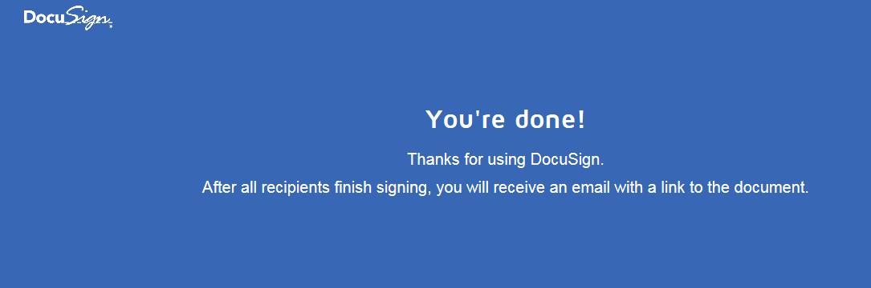
11. | You will also receive an e-mail confirmation that your document signing is completed.  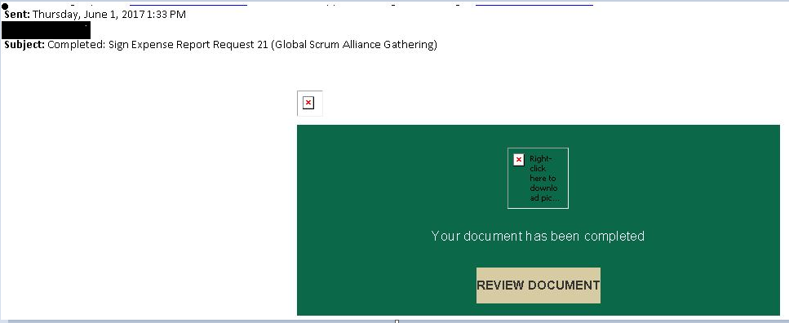
12. | If you do not agree to what is in the coversheet you can decline to sign the document. To complete this action, click on Other Actions and select Decline to Sign. Do not use any other options available under ‘Other Actions’. Note: It can sometimes take up to 32 minutes for the submitter to receive the document in Archivum Travel  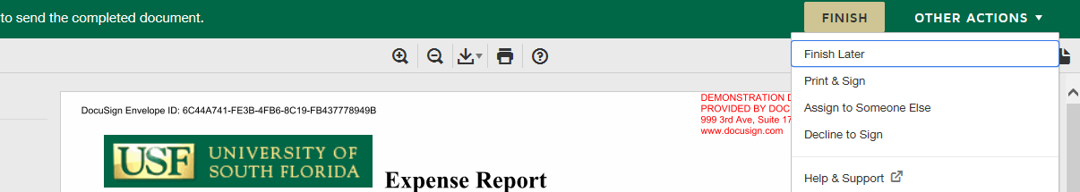
13. | Click Continue.  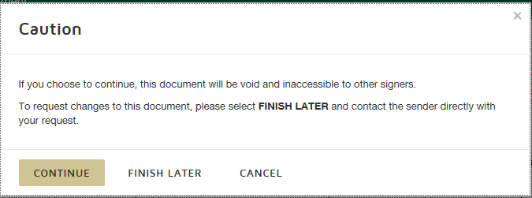
14. | You will need to provide a reason for declining the document. Then click Decline to Sign.  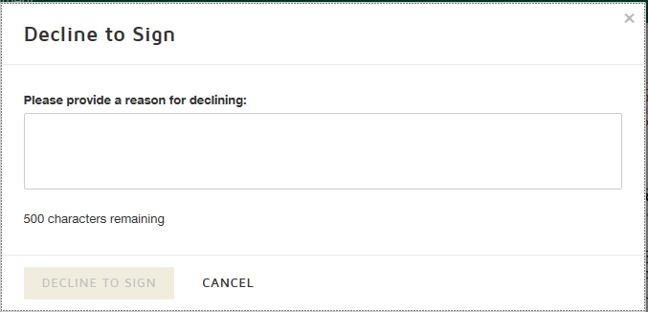
15. | You will receive the confirmation below and the Expense Report/ Cash Advance will be routed to the submitter to update and resubmit.  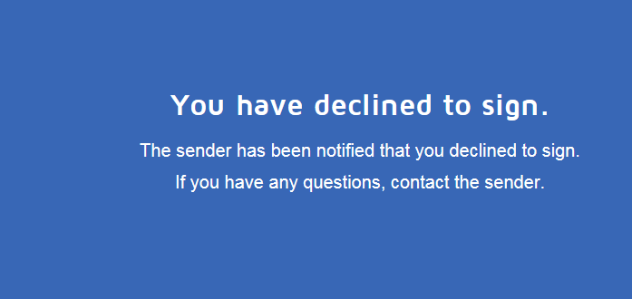
16 | You will also receive an e-mail confirmation that your document signing is completed.  