**Event**: **“Addressing Mental Health for Haitian Populations: Solutions”**

**Date**: February 21, 2019

**Time**: 6:00 pm – 9:00 p.m.

**Room**: Patel College of Global Sustainability Auditorium, University of South Florida (USF), Tampa, Florida

**6:00 – 6:30 Meet and Greet**

**Music by: Elijah Jean Leon  
 Sebastien Jean-Leon**

**Chrisley Jean-Leon**

**Kimberly Clark**

**Emcee**:  **Simeon-Jones, Kersuze Ph.D., Associate Professor, School of Interdisciplinary Global Studies, Africana Studies, University of South Florida (USF)**

**6:30-6:45 Welcoming Remarks**

Guitele J. Rahill, Ph.D., LCSW

Riaan van Zyl, Ph.D., Director, USF School of Social Work

Bernd Reiter, Ph.D., Director, Institute for the Study of Latin America and the Caribbean (ISLAC), USF

Steven Surrency, Ph.D., M.A., Ph.D., CI & CT; SC:L., Communication Sciences and Disorders, CBCS, USF; Chair of USF CBCS Diversity Committee

**6:45 -7:30 Documentary Screening: “Healing A Nation: *Twoub Mantal*”**

“Healing A Nation: *Twoub Mantal*” documents the legacy of mental health inequity in Haiti. The film tells the story of Richard, a social worker from the Cité Soleil region of Port-au-Prince, who suffered what appeared to be a psychotic episode stemming from cumulative traumatic experiences. Richard’s preventable death while presumably in treatment at a psychiatric hospital in Port-au-Prince exposed the failure of the Haitian mental health system concerning disadvantaged populations in Haiti -and is the impetus for this film.

Because pregnant Haitian teens are a key target population for mental health intervention, the evening will also include a discussion of the Krik Krak project funded by the Grand Challenges Explorations Round 20 grant from the Bill and Melinda Gates Foundation: [https://Krikkrakmentalhealth.com](https://krikkrakmentalhealth.com/)

**7:40-8:30 Panel Discussion and Q & A Session- moderated by Dr. Kersuze Simeon-Jones**

**Panelists:** Dr. Guitele J. Rahill, Dr. Sabine Lamour (Haiti-based), Dr. Manisha Joshi,

Prof. Jean Wilner Louis (Haiti-based)

**Closing Remarks: Dr. Steven Surrency**

 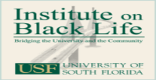 

**ADELPHI**

HOME HEALTH CARE

Thomas A. Rahill, and Family ISLAC

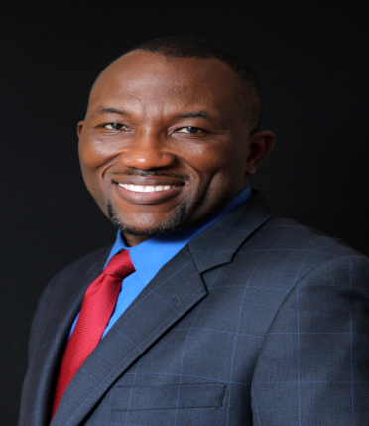

**Mr. Jean-René Rinvil** is an award-winning video producer, director and editor who received his Bachelor’s Degree in Mass Communications from USF and his Master’s degree in Television, Film and News Media from The Art Institute of Chicago (SAIC). His commitment (for over 18 years) has been to create films that interest a worldwide audience is evident in “Healing a nation: *TwoubMantal*”. His film *Culture Clash* received positive reviewsin the Video Librarian Magazine and won the “Best Documentary” award at the Haiti Movie Award (MPAH) in 2014, at the 2015 Greater Washington Immigration Film Festival, and at the Urban Media Makers Film Festival in 2006. He is currently involved in co-producing several video interventions for “Krik Krak: Mental Health for Pregnant Haitian Teens”, funded by the Bill and Melinda gates Foundation: [**https://krikkrakmentalhealth.com/**](https://krikkrakmentalhealth.com/ )

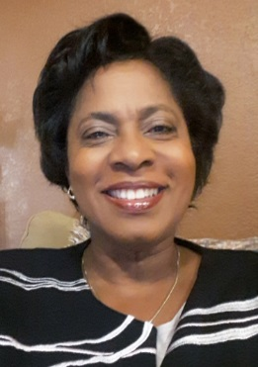

**Dr. Guitele Jeudy Rahill** is an Associate Professor of Social Work at CBCS USF and member of Executive Faculty Committee of the USF Institute for the Study of Latin American and the Caribbean (ISLAC). She received her Ph.D. in Social Welfare from Florida International University, where she was a Presidential Fellow. She is interested in interactions among traditional norms, health beliefs and practices, biopsychosocial conditions, disasters, and structural violence, as they impact domestic and sexual violence, psychological trauma, and family system disruption among underserved populations. She is currently focused on developing and adapting Evidence-Based health and mental health interventions for Haitian populations in Haiti and in the Diaspora, in order to increase the uptake of Evidence-based interventions to Haitian populations via contextual adaptation, implementation and dissemination.

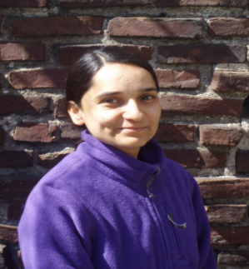

**Dr. Manisha Joshi** is an Associate Professor of Social Work at CBCS, USF. She received her Ph.D. in Social Welfare from the University of Pennsylvania and her MS in Public Health (Maternal and Child Health) from Harvard University. She focuses on advancing knowledge about the health of women and children in the U.S. and in resource-constrained settings (India, Haiti, Kyrgyzstan), with a focus on violence against women (Intimate partner violence and sexual violence, particularly rapes perpetrated by non-partners. She currentlyserves as an appointed member of the Council on Global Learning and Practice, a unit of the Council for Social Work Education, which is responsible for developing the national agenda for understanding and stimulating the international parameters of social work education.



**Dr. Kersuze Simeon-Jones**,author of *Literary and Sociopolitical Writings of the Black Diaspora in the Nineteenth and Twentieth Centuries*, isAssociate Professor in the School of Interdisciplinary Global Studies, Affiliate Faculty in the Department of World Languages and the Department of Women’s and Gender Studie**s.** Her Doctoral degree is in History and Literature of the Black Diaspora. She has a Master's in French and Francophone Literature from Rutgers University. Her primary research and teaching interests include Intellectual History and Sociopolitical Movements of the African Diaspora, Haiti’s National History, and Women's History within the African/Black Diaspora.

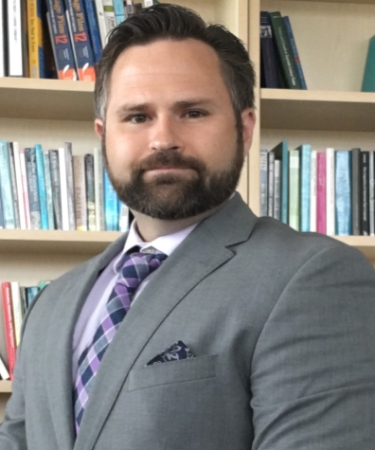

**Dr. Steven Surrency** is a linguist whose research interests focus on hermeneutics, linguistic stigmatization, cultural problems in interpretation, and ethical dilemmas for both spoken and sign-language interpretation. He is particularly interested in international issues in interpretation. In addition to his work at the University of South Florida, he works actively in the World Federation of the Deaf and the World Association of Sign Language Interpreters. He often consults at the United Nations and in other high-level international venues. He is the Chair of the USF CBSC Diversity Committee.

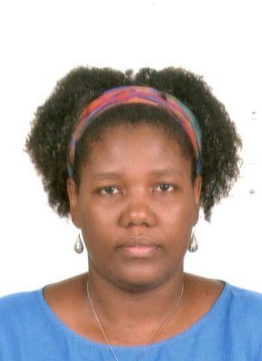

**Dr. Sabine Lamour** received her Ph.D. in sociology. She is the national coordinator of SOFA (Solidarité des Femmes Haïtiennes/ Solidarity of Haitian Women). Since 2005, she has been actively working as an independent consultant with women's organizations in rural and urban Haiti. Dr. Lamour is a self-described feminist activist.  She teaches courses at l’Université d’État d’Haïti. She is interested in topics such as family relationships, gender, piracy, slavery, colorism, family dynamics in the Caribbean, and Haiti’s political system. She recently co-authored a book entitled, *Dejouer le silence: Contre-discours sur les femmes Haïtiennes*.

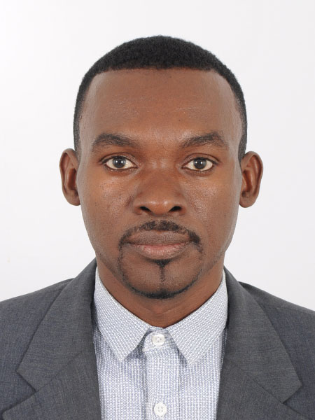

**Professor Jean Wilner Louis** received his Master’s degree in Clinical Psychology from the *Université de Toulouse-II le Mirail*. He was a Scholar in the USF S.H.A.R.E. Haiti project, which was funded by the National Institute of Child and Human Development of the National Institutes of Health (NIH). He is a gifted lecturer who has successfully planned and delivered in the development of training modules and animation of seminars for NGO employees, educators, health professional and parents of adolescents. His research interests focus on psychological trauma in Childhood and community mental health.