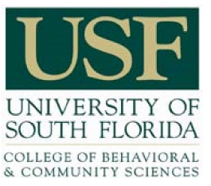

College of Behavioral & Community Sciences Professional and Staff Recognition Award Program Nomination Form

Name of Nominee: ______________________________________________________
Job Title: _______________________________________________________________ Department/School: _____________________________________________________
Length of Employment with the Department/School/College: ____________________

Nominator’s Name: ______________________________________________________
Job Title: _______________________________________________________________ Department/School: _____________________________________________________
Phone: _________________________________________________________________
Email: _________________________________________________________________

Nominator’s Signature____________________________________________________

I certify that within the 12 months prior to this nomination, the nominee has had no formal disciplinary actions. I also support this nomination.

Nominee’s Supervisor’s Signature_________________________________________

Please submit this form along with the letter of nomination, and any additional letters of support to: Wendy Stoneman-Shelby, Unit HR Administrator - wendys1@usf.edu.

