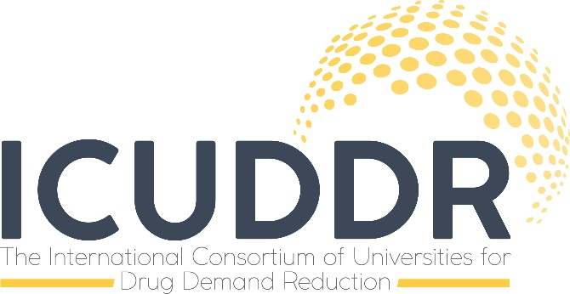
University Request Form to Use the UTC or UPC Curricula
Universal Treatment Curriculum (UTC)
The Universal Treatment Curriculum (UTC) was developed by the Colombo Plan International Centre for Credentialing and Education of Addiction Professionals (CPICCE), through support of the U.S. Department of State’s Bureau of International Narcotics and Law Enforcement Affairs (INL). The UTC was designed to enhance the quality of training for addiction treatment professionals through promotion of evidence-based substance abuse treatment practices. The curriculum has undergone peer review, and has been refined and tailored for use in different regions of the world. The UTC curriculum includes three types of courses: (1) the UTC Basic Level Series, including eight courses that cover a broad spectrum of treatment services for substance use disorders, (2) the UTC Advanced Level Series, including 10 courses that provide a more comprehensive and theoretical foundation in addiction treatment practices, and (3) specialised curricula to address populations with special needs, such as women and children, rural populations, persons with co-occurring health disorders, and criminal justice populations. Separate “Trainer” and “Participant” manuals are available for each UTC curriculum course, and Power Point slides are also available for each course. The UTC curriculum is periodically revised and updated, and new UTC courses are added on a regular basis.
Universal Prevention Curriculum (UPC)
The Universal Prevention Curriculum (UPC) was developed to reflect the International Standards on Drug Use Prevention, published by the United Nations Office on Drugs and Crime (UNODC; 2013), and was designed by international prevention experts from around the world. The UPC is based on principles from scientific research, and sound ethical and quality standards. The UPC was designed to meet the current demand for a comprehensive and evidence-based training package in the field of drug use prevention. The Universal Prevention Curriculum is comprised of two training series, each addressing the needs of different target groups:
- The UPC “Coordinators Series” is intended for coordinators, managers, and practitioners who oversee major prevention programs or systems.
- The UPC “Implementers Series” is intended for implementers or practitioners who work with families, in schools, in the workplace, and in the community.
The following steps are required for North American universities/colleges and other organizations to use the UTC and/or UPC curriculum:
- Complete the attached University/College Request Form, and submit a scanned copy via email to Cary Hopkins Eyles, Assistant Director of the UTC/UPC Coordinating Center at USF (chopkin3@usf.edu; 813/974-2922);

- A University/College Authorisation Form will then be forwarded to the contact person at the academic institution, upon review and approval of the request form.

- Instruct all participants in UTC/UPC-related programs to complete on-line information to help evaluate the dissemination and use of the UTC/UPC curriculum.
Conditions of Use
The Universal Treatment Curriculum (UTC) and the Universal Prevention Curriculum (UPC) each contain trainer and participant manuals and supplementary materials. These curricula are considered in the “public domain” when implemented by universities/colleges or other organizations in North America, and can be used without charge. Universities/colleges or other organizations using the UTC/UPC curricula agree to the following conditions of use:
- The UTC/UPC curricula can’t be offered for sale by the authorized academic institution or organization;
- The UTC/UPC curricula can’t be disseminated outside of the authorized academic institution or organization without prior consent from the UTC/UPC Coordinating Center at USF and CPICCE;
- Any online or written description of the UTC/UPC curricula and related materials will provide attribution and acknowledgement to CPICCE;
- Instructors/trainers from authorized universities/colleges or organizations that administer the UTC/UPC curricula shall be certified, as per requirements of their institution. For example, instructors at universities/colleges who administer the UTC/UPC curricula as part of an academic course sequence should be certified to teach undergraduate or graduate coursework at that institution;
- Academic institutions using the UTC/UPC curricula will agree to share information with the UTC/UPC Coordinating Center for North American Universities and with CPICCE regarding courses/training offered and students/participants involved in those courses or trainings, for purposes of monitoring and evaluation. Information that may be periodically requested includes the following:
- Specific UTC/UPC courses that have been used in academic programs or for other training purposes;
- The number of annual course offerings/trainings that involve use of the UTC/UPC curriculum;
- Revisions or modifications made to the UTC/UPC curricula in implementing academic courses or trainings.

Information from Requesting Institution
Contact Information
Lead person at the requesting institution, position title, and credentials: __________________________________________________________________________________________
Institution/organization: ______________________________________________________________________
Name of institutional unit (e.g., college/department/program): _______________________________________
_________________________________________________________________________________________
E-mail address for lead person: ________________________________________________________________
Phone number for lead person: ________________________________________________________________
Intended Use of the UTC/UPC Curricula
Academic coursework ______ Continuing education ______ Certification ____________
Other professional training _____ Other use (describe): __________________________________________
Describe the institutional and programmatic setting (briefly describe the university/college and department or program sponsoring the UTC/UPC courses/training): _________________________________________________________________________________________
__________________________________________________________________________________________
Describe how the UTC/UPC curricula will be provided (check all that apply):
Single class ______ Multiple classes _______ Single training session _____ Multiple training sessions ______ Online class or training ______ Other (please describe):_____________________________________________
Target Audience/Participants (check all that apply)
Undergraduate students ______ Graduate students _____ Addiction professionals ____________
Other (describe): ___________________________________________________________________________
Anticipated number of participants trained per year: _______________________________________________
Indicate the UTC Curriculum to be Used (check all that apply):
UTC Basic Level ______ UTC Advanced Level ______ UTC Specialty Curricula ______ Unsure _______
Indicate the UPC Curriculum to be Used (check all that apply):
UPC Coordinator’s Series _____ UPC Implementer’s Series _______ Both _______ Unsure _______
Intended Format of Use (check all that apply)
Use entire UTC or UPC course(s) _____ Use components of UTC or UPC courses _____ Other (please specify): __________________________________________________________________________________
Will the UTC/UPC curricula be used in combination with other materials? Yes _______ No_______
Please describe how the UTC/UPC curricula will be integrated with other materials or N/A:______________________________________________________________________________________
Purpose in Using the UTC/UPC Curricula
Provide academic course credit _________ Certification __________ Licensure _____________
Continuing education credits____________ Other______________ (please describe): ________________________________________________________________________________________

Printed Name of Person Requesting the UTC/UPC Curricula ___________________________________

Signature of Person Requesting the UTC/UPC Curricula ______________________________________

Signature of the Coordinating Center Leadership ________________________________________________________________________________________
Date ______________________________

Signature implies agreement to abide by the “Conditions of Use” as described in this document. Authorization to use the UTC and UPC curricula may be revoked with notice by CPICCE or the UTC/UPC Coordinating Center.

