Center for Student Involvement

Graduate Advisor
(Campus Traditions Board)

The University of South Florida Center for Student Involvement (CSI) cultivates an environment in which students are engaged in transformational experiences that lead to lifelong learning, personal growth, and connection to the University. CSI contributes to student success through quality involvement opportunities, education, and advising which foster USF pride, global leaders and holistic student development. CSI consists of the following areas: overall Student Involvement initiatives and promotion, Campus Traditions Board (Homecoming and USF Week), Campus Activities Board, Fraternity/ Sorority Life, University Lecture Series, and the Centre Gallery. In just one semester, CSI Programs can average over 25,000 attendees at over 100 events. CSI is staffed by approximately 30 student leaders across three programming boards, the Centre Gallery, and front desk staff assistant team as well as over 30 student volunteers. Additionally, there are 6 graduate assistants, 1 administrative specialist, 4 coordinators, 1 assistant director, 1 associate director, and 1 director that rounds out the full, award-winning team.

The Graduate Advisor (GA) for Campus Traditions Board will be responsible for the enhancement, advising, mentoring and leadership development of the Campus Traditions Board students as they work to ensure maximum involvement and engagement from the student body leading to student academic and personal success, while fostering a lifelong affinity to the university. Campus Traditions Board is a student-run programming board that is committed to maintaining USF traditions and instilling university pride in events such as Homecoming, USF Week, and Mr. and Miss USF. The Graduate Advisor also works to ensure maximum involvement and engagement from the student body. In addition to providing direction and oversight of these programs, GAs teach students how to execute contracts, work with vendors, and how to lead other students.
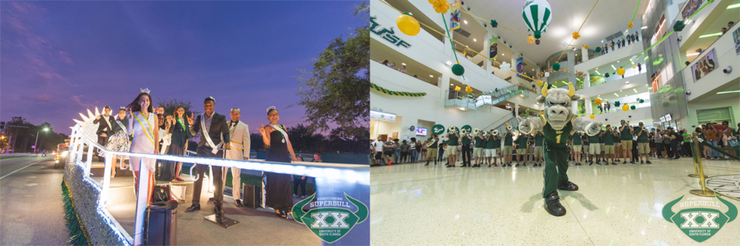

Center for student involvement
getinvolved@usf.edu | 813-974-1001 | involvement.usf.edu

Duties/Responsibilities

- Support and model the vision and goals of the Center for Student Involvement.
- Co-advise, mentor, and provide leadership development to the student leaders of the Campus Traditions Board
- Assist with the creation, development, and implementation of university-wide programs and events, specifically Homecoming, USF Week, and Mr. and Miss USF
- Advise students on event planning and management, contract negotiation, assessment of activities, and leading peer student groups
- Negotiate contracts, work with university, local, and state-wide vendors, and maintain the Campus Traditions Board budget
- Create, enhance, and sustain collaborative partnership with key campus organizations and departments to create successful co-curricular involvement and programming opportunities for students
- Sustain and enhance current Campus Tradition Board programs through marketing strategies and programming opportunities
- Participate in CSI development and staff trainings and event staffing rotation
- Support Student Affairs initiatives by serving on committees, attending events and working with other departments to achieve mission, values, and goals of Student Affairs and Student Success (SASS)
- Other duties as assigned

Expected Learning Outcomes

- Be able to identify and implement strategies for enhancing a campus community through student engagement and involvement.
- Learn and develop advising strategies and skills in order to effectively build strong advising relationships with student leaders.
- Become experienced in training, developing, and assessing student leaders.
- Increase proficiency in planning, implementing, and assessing campus-wide events focused on meeting the needs of a diverse student population.
- Obtain an understanding of skills and educate student leaders on the skills needed to work with and engage a diverse student population.
- Expand knowledge and educate student leaders on how to budget, market and negotiate contracts for campus wide events.
- Obtain experience working in a fast paced environment as a team with professional staff, fellow Graduate Assistants and student workers.

