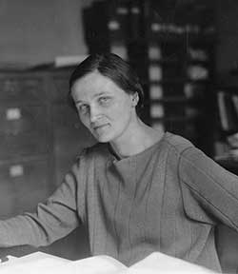
The physicist that I chose to research is Cecilia Payne-Gaposchkin. She was born on May 10th, 1900 in Wendover, England and died on December 7th, 1979 in Cambridge, Massachusetts. At the age of 19, Payne-Gaposchkin entered the University of Cambridge in England. She was inspired to be an astronomer through her classes there and her passion led her to move to the United States due to more opportunities being present for female astronomers in America than in England. Payne-Gaposchkin wrote her Ph.D. thesis on how stars are composed of hydrogen and helium and that the spectral sequence corresponded to the stellar temperature. She was awarded her Ph.D. in Astronomy through Radcliffe College because Harvard College did not grant doctoral degrees to women at the time. Her thesis has been called the most brilliant Ph.D. thesis ever written in astronomy.
Payne-Gaposchkin travelled the world to work with different astronomers on stellar temperature. Her travels brought her to Europe where she met a fellow Russian astronomer, Sergey Gaposchkin. They married in 1934 and they collaborated on studies of stars, stellar temperature and stellar composition. Payne-Gaposchkin was hired as a lecturer at Harvard College in 1938 but she was not listed in the course catalog as an instructor until after WWII because she was a woman. In 1956, she was appointed to a full professor at Harvard College and became the chairman of the astronomy department. Over the course of her career, Payne-Gaposchkin wrote five academic books, and an autobiography called The Dyer’s Hand.

