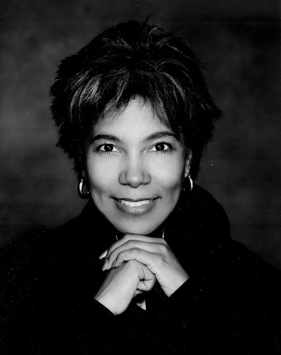
Claudia Joan Alexander

Research area
Geophysicist and planetary research scientist

Date of birth and death
May 30, 1959-July 11,2015

Degrees conferred
Bachelor’s degree in geophysics from University of California, Berkeley (1983)
Master’s degree in geophysics and space physics from University of California, Berkeley (1985)
Ph.D. in the physics of space plasma from University of Michigan (1993)

Biography
In the year 1959 Harold and Gaynelle Alexander welcomed into the world a baby girl, Claudia Alexander. She was born in Canada, but was raised in Santa Clara, California alongside her two siblings Suzanne and David. Growing up, Alexander had a passion and desire to study journalism. Her parents however urged her to pursue an education in engineering. Although Alexander was hired for her engineering skillset, she developed a new passion while working at the Ames Research Center for planetary science. Throughout her career as a planetary scientist Alexander wrote children’s books, as well as science fiction novels.

Research
Alexander’s master’s thesis stated information pertaining to “solar cycle variations in extreme ultraviolet radiation of the Venus ionosphere and its interaction with solar wind” (Wikipedia.org). Alexander’s career began at the United States Geological Survey as well as an internship opportunity at the Ames Research Center. At both of these research facilities Alexander studied plate tectonics, as well as Jovian moons. It was her internship however, that sparked her interest in planetary science. Alexander worked for the United States Geological Survey and NASA’s Jet Propulsion Laboratory in 1986. She played a vital role in the Galileo mission, which included a spacecraft that traveled to Jupiter. Alexander was the project manager, and oversaw the spacecraft’s entrance into Jupiter’s atmosphere. Alexander conducted extensive research while at NASA on multiple topics pertaining to planetary science. These topics include Jupiter, plate tectonics, Venus, space plasma, solar wind, comets, and magnetospheres. Her final project before her passing, Alexander was the project manager of a mission that was to conduct research on the comet 67P/Churyumov Gerasimenko.

Awards, Honors, and Special Recognition
Emerald Honor for Women of Color in Research & Engineering (Career Communications Group)

Resources: https://www.wikiwand.com/en/Claudia_Alexander, https://successstory.com/people/claudia-joan-alexander, and https://en.wikipedia.org/wiki/Claudia_Alexander

