Daniel C. Tsui
Born February 28, 1939
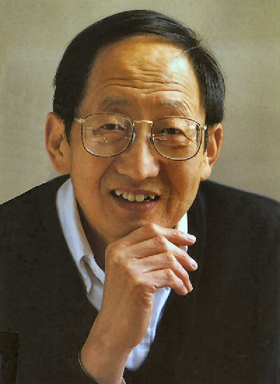
Daniel C Tsui is a Chinese-American scientist and physicist who focuses his research on electrical properties of thin films and semiconductors. This means according to Wikipedia, “display a range of useful properties such as passing current more easily in one direction than the other, showing variable resistance, and sensitivity to light or heat.” He also researches solid-state physics, the study of rigid matter through methods such as quantum mechanics and electromagnetism. .
Tsui was born in 1939 in Fan village, China to his parents who were both farmers. Daniel describes his life as “filled with the years of drought, flood and war which were constantly on the consciousness of the inhabitants of my over-populated village, but also with my parents' self-sacrificing love and the happy moments they created for me.” (Daniel C.). When he was 12 years old, he moved to Hong Kong and attended National Taiwan University after graduation. Tsui was then given a full scholarship to Augustana College in Illinois. He accepted the offer and moved to the United States in 1958 and became the only Chinese-American in his college. He then continued his education in physics at the University of Chicago, where he got his PhD. He met his wife here.
After graduating, he joined the Bell Laboratories and pioneered the study in two-dimensional electrons. This is an electron gas that is free to move in two dimensions, but tightly confined in the third. Daniel describes this time, “I found myself a niche in semiconductor research, though I never got into the main stream either in semiconductor physics, which was mostly optics and high energy band-structures, or its use in device applications. I wandered into a new frontier, which was dubbed the physics of two-dimensional electrons.” (Daniel C.).
In 1982 he became a professor at Princeton University for Electrical Engineering. In 1998, Daniel Tsui was awarded the Nobel Prize for his discovery of the fractional quantum Hall effect. This effect is described as “the quantum changes in electrical potential to occur in fractional increments of the steps observed by Klitzing, a result that could not be explained by existing theoretical models.” (Britannica).
In conclusion, Daniel C. Tsui was an astounding physicist who discovered a landmark effect in physics. He also pushed the boundaries as a Chinese-American, who fought against the hardships and worked against the odds to become a successful scientist who helped benefit society.

