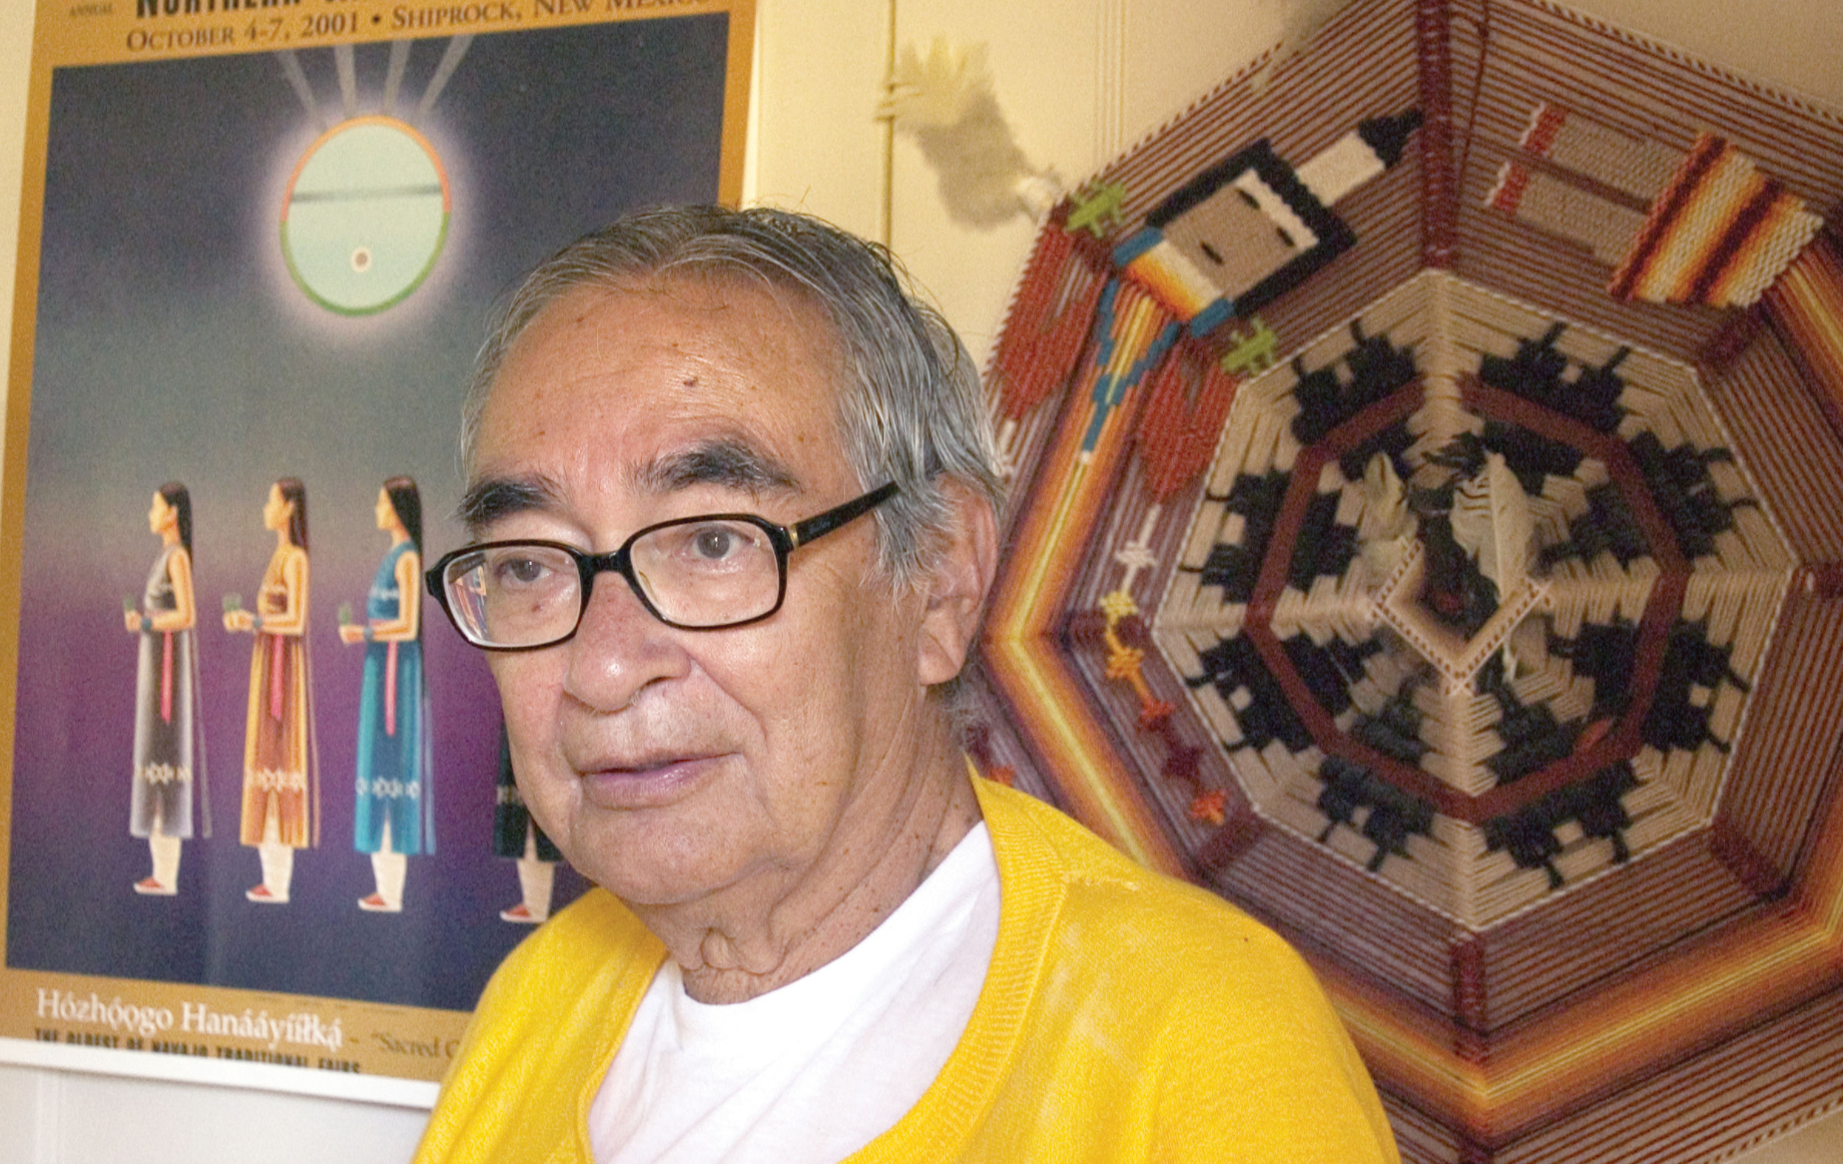
Fred Begay (also Clever Fox) (July 2, 1932 – April 30, 2013)

B.S. Mathematics and Science, University of New Mexico, 1961
M.S. Physics, University of New Mexico in 1963
Ph.D., Nuclear physics in 1971
Former Chairman to the Navajo Nation's Environmental Protection Commission
Board of Science and Technology for International Development, US National Academy of Sciences Member National Research Council
Biography
Begay was born in 1932 on the Ute Mountain Indian Reservation in Colorado. His parents, who were Navajo and Ute healers and spiritual leaders (Hataaliis) from the Tachii'ni and Kin lichii nii clans, taught him traditional Navajo ceremonies. “It turns out many of the prayers and songs have built in lots of science,” says Begay. “I was immersed in all that knowledge before I even got to the first grade.”
At age ten, Begay was sent away from home to a government-run vocational school, where his teachers decided to train him in farming. Begay and his family didn't have any choice in what he studied. “The first day at the federal government Indian school,” Begay remembers, “they told us that the Navajo language was inferior, that our religion was inferior, that our culture was inferior, and that we would be punished if we were caught praying in the Navajo language.”
In 1951, after eight years learning to be a farmer, Begay joined the U.S. Air Force and fought in the Korean War. When he returned, with funding from the Department of Veterans Affairs, Begay enrolled at the University of New Mexico in 1955. To make up for his lack of a standard pre-college education, Begay had to take high school classes in the evenings while attending college courses during the day.
He continued to pursue the subject, and after receiving a PhD in nuclear physics from the University of New Mexico in 1972, he joined the research staff of Los Alamos National Laboratory.
Research
Dr. Begay’s research is in nuclear physics. Much of it has focused on controlled thermonuclear fusion. Fusion in plasmas- hot ionized gases- could potentially provide a clean, practically unlimited energy source as an alternative to fossil fuels. But plasma physicists have been trying unsuccessfully for decades to build a reactor that puts out more energy than it takes in. Begay investigated a phenomenon called “soliton turbulence,” that he believes might cause instabilities in the plasmas, making them useless for fusion. He hopes his research will help point to ways to avoid these problems. The Navajo physicist derived a new electron temperature scaling law for laser-produced plasmas at Los Alamos National Laboratory. He was also part of a NASA-funded space physics research team at UNM to conduct fundamental studies on the origin of high energy gamma rays and solar neutrons (1960 - 1972).
In addition, Navajo physicist Fred Begay has spent hundreds of hours translating and making the connections between traditional Navajo beliefs and modern science. Ancient Navajo thought contains many parallels to modern scientific concepts, including radiation (Tsa'jilgish in the Navajo language), and lasers (Hatsoo'algha k’aa’). Begay believes that in some ways the Navajo culture helped prepare him to study science. “I think the key point is that I learned to think abstractly and develop reasoning skills when I was growing up. In addition to Navajo concepts corresponding to the modern ideas of radiation and lasers, he has found parallels with relativity, space-time physics, and quantum mechanics. “But [these ideas] are buried in our own abstract language,” says Begay, and it is not easy to translate them into English. And in some cases, no clear parallels exist, he says. “The Navajo has mysterious ideas about science which cannot be interpreted into English”

