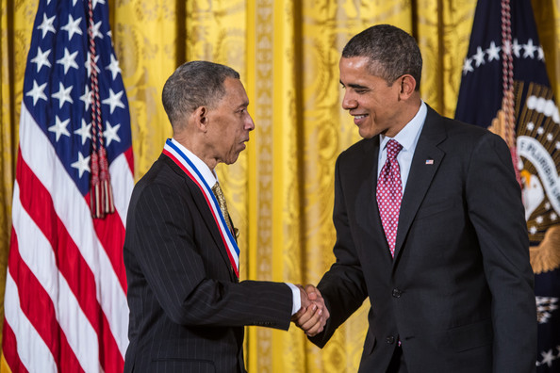
George Carruthers
Born on October 1, 1939
Bachelor’s Degree in physics in 1961
Master's in nuclear engineering in 1962
Ph.D. in aeronautical and astronautical engineering in 1964
All degrees obtained at the University of Illinois
Area of Study: Physics
George Carruthers, and African American male, is an inventor and physicist. He has been interested in science from very early on in life, building his first telescope at age 10. It was constructed from cardboard tubing and mail-order lenses he purchased with his own money, saved from being a delivery boy. His father, being a civil engineer in the U.S. Army Air Corps, supported his sons early interest in science. After obtaining his Ph.D. he went on to work at the U.S. Naval Research Laboratory. He made great advanced as an inventor and there his telescope and image converter provided the first proof of molecular hydrogen in space. His ultraviolet camera/spectograph was even used by Apollo 16 during the flight to the moon. His inventions enabled scientists to view the Earth's atmosphere for concentrations of pollutants, and see UV images of more than 550 stars, nebulae and galaxies for the first time in history! For this he received NASA's, well deserved, Exceptional Scientific Achievement Medal. He later went on to invent a camera in 1991 that was used in the Space Shuttle Mission. Later in life he went on to create a program for high school students called the Science and Engineers Apprentice program which provides students with the ability to work within the Naval Research Lab. As a young boy being minority African American, competing in science fairs, and winning might I add, Carruthers has been able to make an astonishing name for himself as both an inventor and Physicists. He is currently teaching at Howard University.

