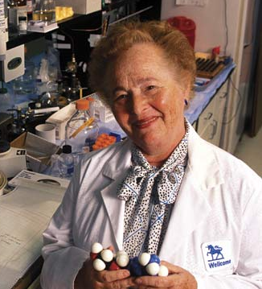
Gertrude Elion

January 23, 1918 - February 21, 1999 (age 81)
Field: Biochemistry, pharmacology
Education:
- B.S., summa cum laude, Chemistry, Hunter College, 1937
- M.S., Chemistry, New York University, 1942
- Honorary Ph.D., New York University Tandon School of Engineering (then Polytechnic University of New York), 1989
- Honorary SD, Harvard University, 1998
Biography:
Gertrude Elion was born in New York, New York to immigrant parents in 1918. She lived in various New York City suburbs throughout her childhood. She had an “insatiable thirst for knowledge.” The death of her grandfather due to cancer when she was 15 pushed her to pursue a career to help find a cure for a terrible disease. After attending Hunter College, she had several jobs before pursuing her master’s degree, including teaching and working in laboratories as an assistant. After receiving her master’s degree, she was able to take a job as a chemist in an industrial laboratory but not in research. When she became restless of this job, she applied for research positions. She was offered many positions in research labs but took the position as George Hitchings assistant. During this time she was eager to get her doctorate and became a part time student. She was later informed she would who have to go to school full time to continue her education and give up her job. She decided to stay with her job and stop pursing her doctorate. Her career only skyrocketed after that decision. She has been associated with numerous cancer societies.
Research:
Gertrude Elion and George Hitchings created medicines in an odd way. They would study the chemical compositions of diseased cells, meaning they looked closely at the cells to see what they were made up of. Instead of relying on trial-and-error methods, they compared the differences between normal human cells and pathogens (the bacteria that causes diseases). Using these differences, they would design medicine to block viral infections. This method allowed them to develop drugs to assist with fighting leukemia and other bad diseases. They also discovered treatments to reduce the rejection of foreign tissue in kidney transplants between unrelated donors. This means that people can get kidney transplants from people other than their relatives.
Awards:

- Lemelson-MIT Achievement Award (1997)
- National Inventors Hall of Fame (1991)
- National Medal of Science (1991)
- Nobel Prize in Medicine (1988)
- Garvan-Olin Medal (1968)

