Inge Lehmann

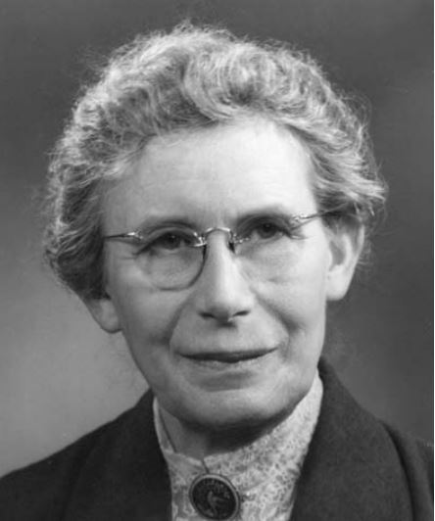
1928 State Geodesist at the Danish Geodetic Institute
1925 Assistant to Niels Erik Norlund at Gradmaalingen, a Danish Geodetic Institution
1923 Assistant Professor to Wilhelm Blaschke in Actuarial Science at Copenhagen University

1968 Honorary Doctor of Philosophy Degree at Copenhagen University
1964 Honorary Doctor of Science at Columbia University\
1928 Magister Scientarum Degree in Geodesy at Gradmaalingen
1920 Received Magisterii degree in mathematics and physical science, Copenhagen University
1918 Continued Studies at Copenhagen University
1910-1911 Newnham College in Cambridge
1907 Studied Mathematics at Copenhagen University

Biography
Inge Lehmann was born in Copenhagen Denmark on May 13th of 1888. Both of her parents were from prominent, educated families in Copenhagen. Her grandfather was the first to lay telegraph cable in the area and her father was the first professor of experimental psychology in Copenhagen. Her aunt was very involved with women’s rights and her cousin was the Danish minister of commerce in the 1950’s. Lehmann had one younger sister who was an actress.

Lehmann’s parents sent her to a private coed school run by the aunt of Niels Bohr. There, boys and girls were treated equally and both sexes learned to do needlepoint and soccer alike. No one was given special privilege due to societal status. In essence, Lehmann grew up with no restrictions based on class or sex and therefore had very little hurdles to overcome while in Copenhagen.

When Lehmann moved to Cambridge, she discovered a different world full of restrictions based on sex. After two years in Cambridge she experienced educational burn out and returned to Copenhagen to a life of work in mathematics. After seven years of working, she continued her studies in Copenhagen. After graduating with a master’s degree in mathematics she worked as the assistant to her math professor and two years later switched to working with Professor Niels Norlund in the seismology department. She became fascinated with seismology and at age 40, earned her master’s degree in geodesy. This was perhaps the greatest turning point of her life. She was able to use mathematics to figure out how energy through waves travels through the earth during earthquakes and use that data to discover the solid inner core of Earth.

Lehmann chose to devote her life to seismology instead of the tradition of marriage and family. Her friends and colleagues described her as quiet and shy. Although she maintained many relationships, she seemed to prefer the company of her studies and her summer cabin. Lehmann enjoyed mountain climbing during the summer and skiing in the winter. After she retired, she actually had many more articles published. She died on February 21st of 1993 at the age of 104.

Research Description
From 1911-1918 Lehmann took a break from school and worked at an actuary office. After receiving her master degree in mathematics and physical science, she worked as an assistant in actuarial science to her mathematics professor. Lehmann’s career focus of mathematics turned more toward science in 1925, when she began assisting a geologist. Because of her intense attention to detail, she was put in charge of setting up and interpreting data from seismograms at seismological stations all around Europe. She quickly found out that many of the seismograms were inaccurate and needed to be calibrated. With the earthquake of 1929 in New Zealand, Lehmann was able to compare seismographic data from several different seismological stations and found that waves were passing through Earth’s core at different velocities. Because of her studies with physics, Lehmann knew that waves travel at different velocities through different mediums. Lehmann used her knowledge of waves and her analytical abilities to discover that there are two parts to the Earth’s core – an outer portion (and an inner portion. Lehmann discovered Earth’s inner core is a solid and the outer core is a liquid.

Awards, Honors, & Special Recognitions
1997 – Inge Lehmann Medal established by the American Geophysical Union;1977 – Received The Medal of the Seismological Society of America; 1971 – Awarded the American Geophysical Union’s Bowie Medal; 1965 – Awarded the Gold Medal from the Royal Danish Academy of Sciences and Letters; 1964 – Received the Emil-Wiechert Medal from Deutsche Geophysikalische Gesellschaft’s; 1963-1967 Vice President of the Executive Committee of IASPEI; 1959 – Honorary Fellow of the Royal Society, Edinburgh; 1957 – Associate of the Royal Astronomical Society, London; 1951-1954 & 1957-1960 – Member of the Executive Committee of the International Association of Seismology and Physics of Earth’s Interior (IASPEI); 1951 – Member of European Seismological Commission; 1950-1951 President of European Seismological Federation; 1950 – Helped establish the European Seismological Federation (ESF); 1941 & 1944 Chair of the Danish Geophysical Society; 1938 & 1967 Received the Danish Tagea Brandt Travel Award; 1936 – 1948 Member of Executive Committee of the International Seismological Association; 1936 One of the founders of Danish Geophysical Society

