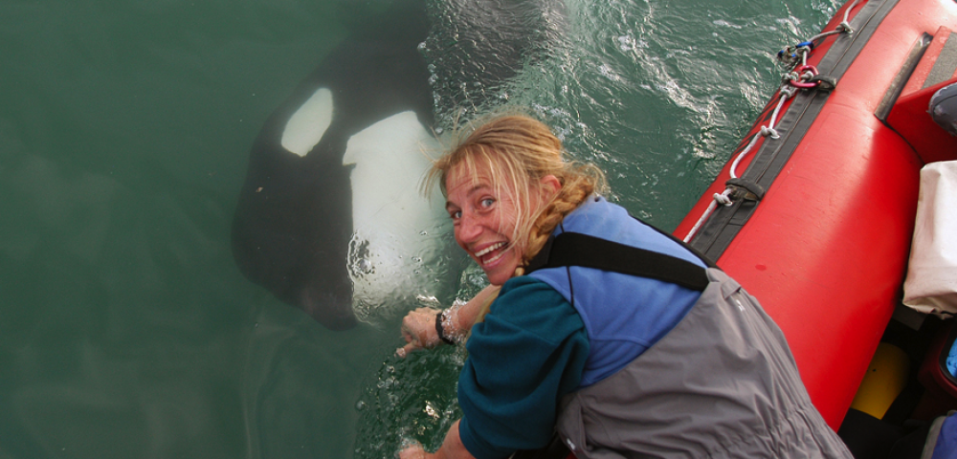
Ingrid Visser is an animal biologist from New Zealand whose research is solely on Orca whales. Born and raised in New Zealand on February 20th 1966, Dr. Visser had a fascination with wildlife at a very young age. Her parents took her and her younger sister, Monique, on a trip around the world between June 1982 and November 1986 in their 56-foot yacht. They visited more than 40 countries and Dr. Visser’s interest in marine life grew.
She holds three degrees: Her first is Bachelor of Science, which she received at Massey University. The second is a Masters of Science, and a Doctorate of Philosophy, which she both received at Auckland University. She completed her PhD in 2000 and her dissertation was the first scientific study on the orcas of New Zealand who have since then been identified as their own subspecies.
She has done an enormous amount of research on the New Zealand Orca and has even created a special trust designed to help orcas around the world. Her research has been published in various scientific journals since 1998 and her findings have proved successful in educating people about orcas behavior, as well as being able to place the New Zealand orca on the critically endangered list. She has created organizations such as the Orca Research Trust, the Antarctic Killer Whale Identification Catalogue and is the co-founder of the Punta Norte Orca Research non-profit organizations, which all focus on orca research. She is an advocate for freeing captive orcas and started the Free Morgan Foundation to help free captive killer whales.
One of her main research points has been whether or not aquariums with rescue programs are effective. Her main argument being that many of these whales just stay captive for years for no reason at all. She fights for rights for all cetaceans that are being held captive for ‘educational purposes.’ The argument she poses is that you learn more about these creatures out in the wild then in tank where they are trained to do tricks for public amusement.
She has been featured in various documentaries that highlight the behaviors and habits of the killer whale. Her most recent documentary entitled “The Woman Who Swims with Killer Whales,” showcases how hands on her research is—she gets in the water with wild orcas and has developed a bond with each individual New Zealand orca. Her website orcaresearch.org catalogues all her sightings and findings through out the day. She has contact information for civilians to call her and let her know of sightings and she also travels on cruise ships in Antarctica showing her research and providing insight for passengers regarding orcas.

